


Financial
Service Provider
How-to
Guide
Table of Contents

COUNSELING PROCEDURES 6
Counselor and Client Safety 6
Phone Calls 6
Walk-in Clients 6
Financial Counseling Procedures and Techniques 7
BUDGETING 8
Completing the EFPW 8
Net Worth 9
Income Page 11
Second Active Income Page 12
Living Expenses 13
In Debt 14
FullSteam 15
Action Plan 17
Spending 18
Record Keeping 19
Pay Scale 20
Final Note 20
Preparing a Budget 20
SCREENINGS 21
Basic Housing Allowance Screening 21
Navy and Marine Corps 21
Marine Corps 23
Army 23
Coast Guard 24
Overseas Screening 24
Navy Expert from MILPERSMAN 1300-302 25
Coast Guard: 25
CREDIT REPORTING 26
Disputing Incorrect Items on Credit Report 26
Identity Theft 29
Ordering a Credit Report: Annual Credit Report 30
Ordering a Credit Report Using SaveAndInvest.org 33
CREDIT AND DEBT MANAGEMENT 38
Clients and Letters of Intent 38
Navy Specific 38
Coast Guard Specific 40
Personnel Reliability Program 43
PERSONNEL RELIABILITY PROGRAM (PRP) REPORTING (Navy) 44
SCRA or MLA Issues 46
STUDENT LOANS 47
Post 9-11 GI Bill 47
Yellow Ribbon Program 47
Transfer Post 9-11 GI Bill to Spouse and Dependents 48
NAVADMIN 006/20 Post 9-11 Update 48
Student Loans and Repayment 49
Government Student Loans 49
Traditional Repayment Plans 50
Income Driven Repayment Plans 51
Government Forgiveness, Cancellation, or Discharge 51
Private Student Loans 52
TAXES 53
Tax Obligations 53
Federal Taxes 53
Other Income 53
State Taxes 54
Military Spouses 54
Tax Withholding 55
Filing Deadline 57
Tax Glossary 57
RETIREMENT PLANNING 58
Blended Retirement System: Continuation Pay 58
CP Eligibility 59
United States Army 59
United States Marine Corps 59
United States Navy 60
United States Coast Guard 61
CP References 61
TSP Funds: Contribution Allocation 62
TSP Funds: Interfund Transfer 63
Looking up Social Security Benefits 66
REPORTING CONTACTS 69
FFSMIS Reporting for Navy PFM 69
Entering One-on-One Appointments 70
Entering Command Briefs and Trainings 70
Entering I&Rs 71
Scheduling/Outcome I&Rs 72
Scheduling an Individual Appointment or Command Brief 72
Outcomes 73
FINANCIAL LITERACY 74
Financial Literacy Touchpoint Training 74
Military Lifecycle Touchpoints 74
Email Notification 74
What to Do When a Sailor Needs Touchpoint Training 75
Where Do I Find the Checklists? 76
What Other Materials Meet Touchpoint Requirements? 76
Recording Completion of Required Training 76
Touchpoint Requirements from DTM 19-009 77
MilSuite 79
Adding Your CFS Class Participants to the PFM MilSuite Site 80
Navy Financial Literacy App 82
Updating Slides and Creating Curriculum 83
CFS Refresher 84
CFS Recertification Requirements 84
Waiver Requests 86
CFS Waiver Request (US Coast Guard) 87
CFS Waiver Request (Marine Corps) 87
CFS Waiver Request (Navy) 88
Child and Youth Program Waiver Request 91

COUNSELING PROCEDURES

Counselor and Client Safety
Suicidal/homicidal people are those who are expressing intent to harm themselves or others or manifesting other self-destructive behavior, which endangers their lives or others. If you believe that a person is potentially suicidal or homicidal, stay calm and follow the procedure outlined below. Privacy Act considerations do not apply.

Phone Calls
- Remain calm. You may be the only person who can help.
- Listen. Keep the caller engaged in conversation. Use verbiage: I am listening. This is important. Let’s talk about this. Do not put them on hold. Try to develop rapport and build trust by using active listening skills. Expand on what the caller is sharing by reflecting their feelings to keep them engaged. Be compassionate.
- Try to ask another staff member off-line (Remember, do NOT put caller on hold) to notify a counselor, or if absent, the chain of command.
- If you cannot pass the phone call to a counselor, you must handle the call yourself until an appropriate referral can be made.
- Obtain the caller’s, name, location and the phone number as soon as possible. Ask other questions gently about what steps, if any, the caller has taken (i.e. How many pills, what poison, what weapon they have). Write all the information down as you obtain it. Keep the caller talking.
- Have another staff member call 911 and give the dispatcher as much information as possible.
- Encourage the caller to discard or remove the lethal element.
- Keep the caller talking until security has arrived on the scene.
- Once security arrives, you may hang up. Immediately call the Navy or civilian medical services and give them the information you were able to obtain from the caller.
- If the individual is a Service member, his/her Command needs to be informed.

Walk-in Clients
- Remain calm.
- Send for a counselor. If absent, send for the chain of command.
- You may be directed by the counselor or chain of command to call security, medical service, or a family member. If a counselor or the chain of command is not available call installation security.
- Be compassionate and supportive.
- Do not leave the client alone at any time.
If you would like to further develop an understanding of suicide or suicide related behaviors, ask your manager about safeTalk & ASIST training (Applied Suicide Intervention Skills Training). SafeTalk is a 3 to 4-hour training that prepares participants to recognize thoughts of suicide and how to connect a person with thoughts of suicide to intervention resources.
ASIST is a two-day workshop is designed for members of all caregiving groups.

Financial Counseling Procedures and Techniques
- Initial contact should start with a smile and warm greeting. Recognize that people may be apprehensive. It is important to make small talk or use humor to help them relax. Compliment them on their willingness to work with you, for being on time, for bringing their spouse, etc.
  - “I want to congratulate you on your willingness to work with me to improve your financial situation.”
  - “Thanks for being on time and for bringing your spouse.”
- Privacy Act Statement – Explain the privacy act statement and have them sign it or offer them a copy depending on the policy for your Service.
- Normalize the client’s feelings and past experience with personal finance.
  - “Most of us have experienced a financial crisis at some time in our lives.”
  - “I understand it can be uncomfortable to discuss personal finances with others, however, we will need to take a close look at what’s going on in order for both of us to understand your financial situation. Once we know exactly how things stand, we can then focus on solutions to improve your situation.”
- Expectation Question — This is used to find out what the client wants or expects.
  - “What would you like to accomplish in the time we have available?”
- Cost Question – Help the client to see how their presenting financial problem/s is/ are affecting their life.
  - “I’m wondering what (problem) has cost you already, not just in terms of dollars, but also in terms of your ability to concentrate on your work, your job performance, your relationship with other key people in your life, in terms of self-confidence and self-respect, or in terms of peace of mind.”
  - After they respond to the question follow up with what they want to change.
  - Compliment clients on identifying what’s going on and their desire to want to make some changes in how they manage their personal finances. This is a good time to introduce the financial planning worksheet.
- Data gathering — Use the EFPW to begin the financial planning process once you feel the client is ready. Avoid any judgments or assessments. Just gather or review the information provided. Avoid verbally or non-verbally confirming clients self-limiting beliefs and statements.
- Miracles and Exceptions — For clients who are “stuck” on their problem, or who are particularly negative, now is an appropriate time to ask the miracle questions.
  - “If a miracle were to happen tonight and the (problem) went away, what would your life be like – what would be different in the morning?” This question enables the client to view their future without the problem. Give the client some time to reflect on this question.
- Discussion Options – This is problem-solving time where the focus is on the options and solutions to the client’s financial situation. Now is a good time to ask the client about options they have been thinking about and to compliment them or validate their ideas for changing their financial situation. Get at least three options or contemplated actions. This is an opportunity to get the client involved in solutions to their own problems.
- Complete the projected column on the three pages of the EFPW including income living expenses and indebtedness. Enter new dollar amounts in the projected column based on the effect of implementing the various options discussed.
- Spending Plan — Next, show the client how to set up a spending plan based on their new spending targets using the projected column figures. It’s important to point out to your clients that the spending plan concerns how they spend their take-home pay and does not include any expenses or creditors paid by allotment.
- Monthly Spending Record — At this time you will want to introduce the monthly spending record which is a method of tracking their actual spending in the various categories on a daily basis.
- Closure — Ask about the client’s expectations and bring closure to the session. Ask clients what they see themselves doing first when they leave the office. Look for opportunities to reinforce and compliment your clients’ willingness to take action. Establish a can-do mindset.

BUDGETING

Completing the EFPW
This is a guide to help you complete the financial planning worksheet with your client. It is important that your client receive a copy of the worksheet which includes the net worth page, income page, living expenses page, in debt page, and the action plan. You can also send them an electronic copy but be sure to encrypt your email for privacy compliance. When using the worksheet, it is important to have an up-to-date LES along with financial statements to review.
Most yellow cells are calculated. Pay close attention to the red cells; they may require input.
- Save the eFPW to your computer.
- Open the eFPW. If you see the “Security Warning” below, click on “Enable Content.”
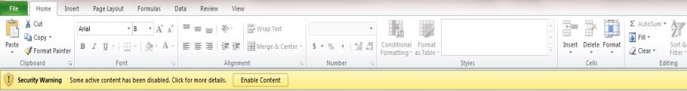
- If you get, “Security Warning: Application add-ins have been disabled,” “Enable Content” so all numbers will calculate properly.
- Be sure to put your information at the bottom. Save it as your master file before you see a client and create client files.
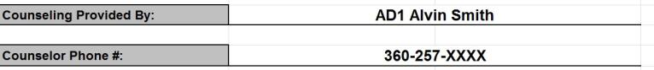

Net Worth
As you prepare to start this worksheet you will notice there are two sides — an actual side and a projected side. The actual side should encompass everything the client is doing right now; their current financial situation. The projected side helps us make changes/recommendations and view them side by side.
- Each pink tab on the net worth page is a drop-down menu that corresponds to the income page.
- When filling out the worksheet, use the tab key on your keyboard to move between columns. Sometimes the enter key can cause issues with the worksheet.
- Be sure to enter your client’s ZIP code in row 13 for both actual and projected (use the tab key to move between columns). The ZIP code relates to the BAH status you selected and will show a dollar amount on the income page.
- Rows 19 and 21 are for traditional and Roth TSP contribution percentages. If you attempt to enter any TSP amount for bonus, incentive, or special pay (rows 20 and 22) it will show as a dollar amount, not a percentage.
- Enter all your client’s assets including mortgage balance due, mortgage/real estate market value, and personal property estimations.
- You cannot enter anything in the liabilities section. Those numbers will come from the in debt page once you fill it in.
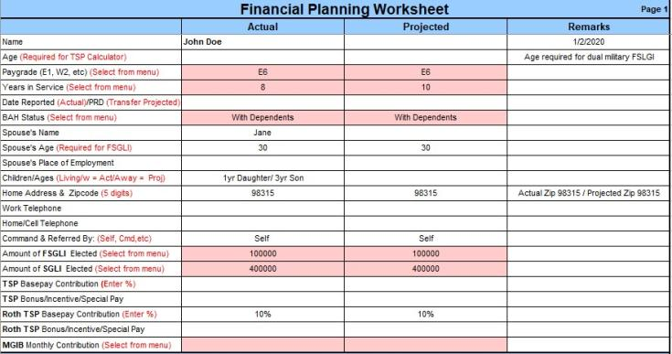
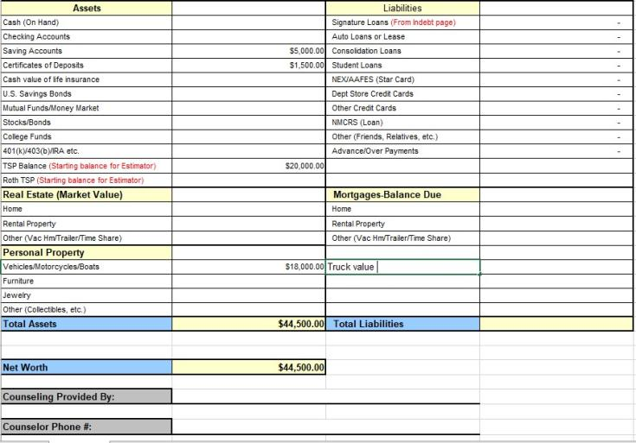

Income Page
- Base pay and basic allowance for housing will be auto filled from your selections on the net worth page.
- Use the pink drop-down boxes to get dollar amounts for basic allowance for subsistence, family separation allowance, and sea and sub pay.
- If your client has another type of pay that isn’t in the worksheet, include that dollar amount under any of the rows that say pay, then write in the actual pay category in the remarks section.
- If your client has any allowances that are not auto populated on the worksheet, enter the dollar amount under row 13, other tax exempt/allowances. Be sure pays and allowances are entered in the correct rows to avoid issues with the worksheet’s tax calculations.
- If you enter any allotments into the deductions section, be sure to account for those allotments later in the worksheet under living expenses (i.e. a $1,900 allotment for housing should be entered as rent under living expenses).
Allotments: If you are going to recommend your clients use the Spending Plan page, be sure to check the boxes below; otherwise that money is not available for them to allocate.
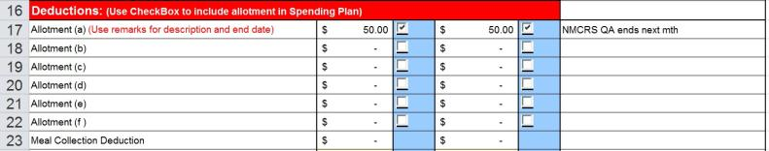

- Check all the deductions that auto populated against the LES to ensure accuracy.
- Review the client’s LES to determine their Federal Income Tax Withholding status (row 29) and use the pink drop down to update withholdings (married, single, or exempt). You can find the dollar amount of FITW under the deductions section of the LES. Enter that dollar amount into the fillable box.
- If your client is paying state income taxes, enter the dollar amount in row 32 and note the state and withholding status in the remarks column.
- Use the drop down in row 34 to account for your client’s monthly TRICARE dental expense.
- If your client has received any advance payment or overpayment from the government, enter the amount of the monthly repayment and include the total amount and reason in the remarks section. Once entered, this information will appear on the indebt tab.
- There are two pages within the worksheet to enter details of your client’s spousal income, the second active page and the second income page. You can use those pages, or you can input spousal monthly income after taxes in row 40. This eliminates the need to enter spousal income on the other pages.
- There are additional spaces for secondary income (row 41) or enter the details of secondary income on the second income page, as well as child support (row 57) and other income (row 58).
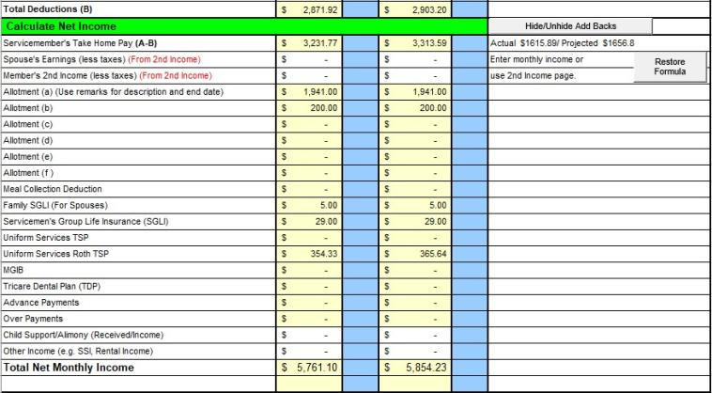

Second Active Income Page
1. For dual Active Duty couples, use the second active page. Please read the instructions on the page to complete. The net income for the second Service member will forward to the primary income page near the bottom. Remember to select Standard from the drop-down menu for BAS. If there are any allotments, remember to carry them over to the appropriate section (savings, living expense, debt) and note in the remarks section that it is paid by allotment.
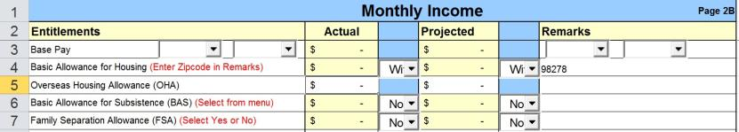
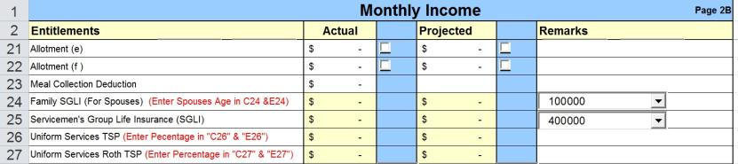

Living Expenses
- Enter monthly amounts under savings. Do not forget to include any savings allotments you entered on the income page.
- Ideally 10% or more of your client’s income will go toward savings. Row 9 on this page shows what percentage (actual and projected) your client is setting aside.
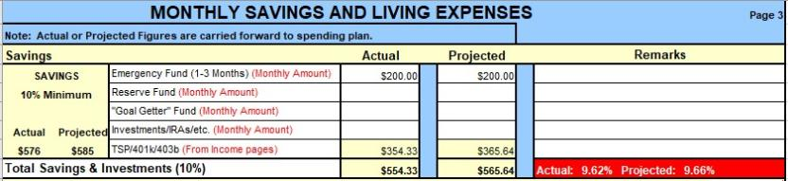
- Enter the living expenses as monthly amounts even if they are periodic (i.e. your client spends $1,200 each Christmas, convert that amount to $100 per month).
- Once all the expenses have been entered, you can check the monthly living expense ratio. Ideally your client will be under 70%.
- Use the projected side to provide your client with spending changes and recommendations.
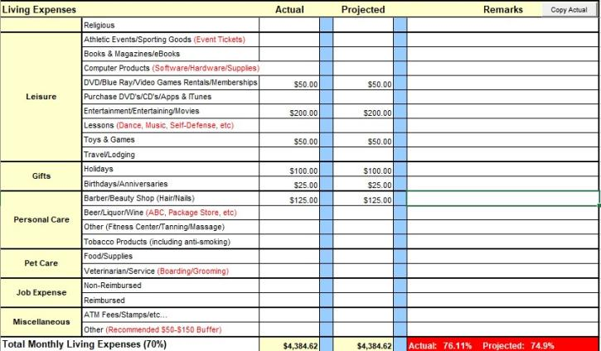

In Debt
- Enter your client’s debts including monthly payments, balances, proposed payments (you can re-enter the minimum payment if there are no changes), and the interest rates for all accounts with balances.
- Do not enter mortgage information on this page.
- If any debts are scheduled to take more than 30 years to pay based on entered payments (such as student loans with income-based or graduated payments, or debts with low promotional required payments), FullSteam will not be able to calculate payoff.
- This page provides you with a full look at the client’s financial situation including their debt-to-income ratio. Debt to income should be less than 20%.
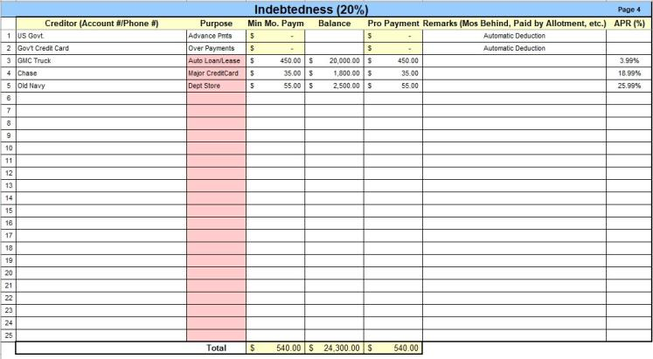

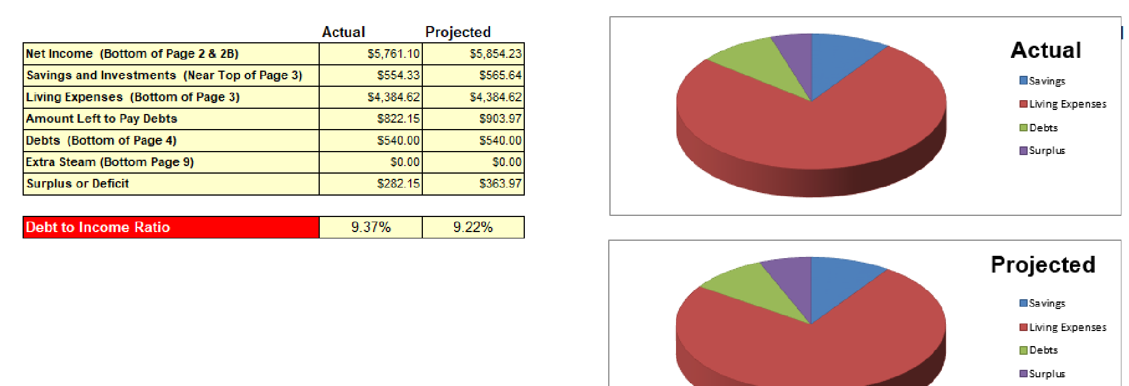

FullSteam
- If you want to switch between minimum payment and proposed payment information, click on minimum payment in row 1 and a drop down will appear to change to proposed payment.
- To use the FullSteam function, right click anywhere on the page and repayment options will pop up, including: shortest term, smallest balance, highest interest, greatest savings, and compare all methods. Talk to your client about which they would prefer to view.
Before FullSteam:
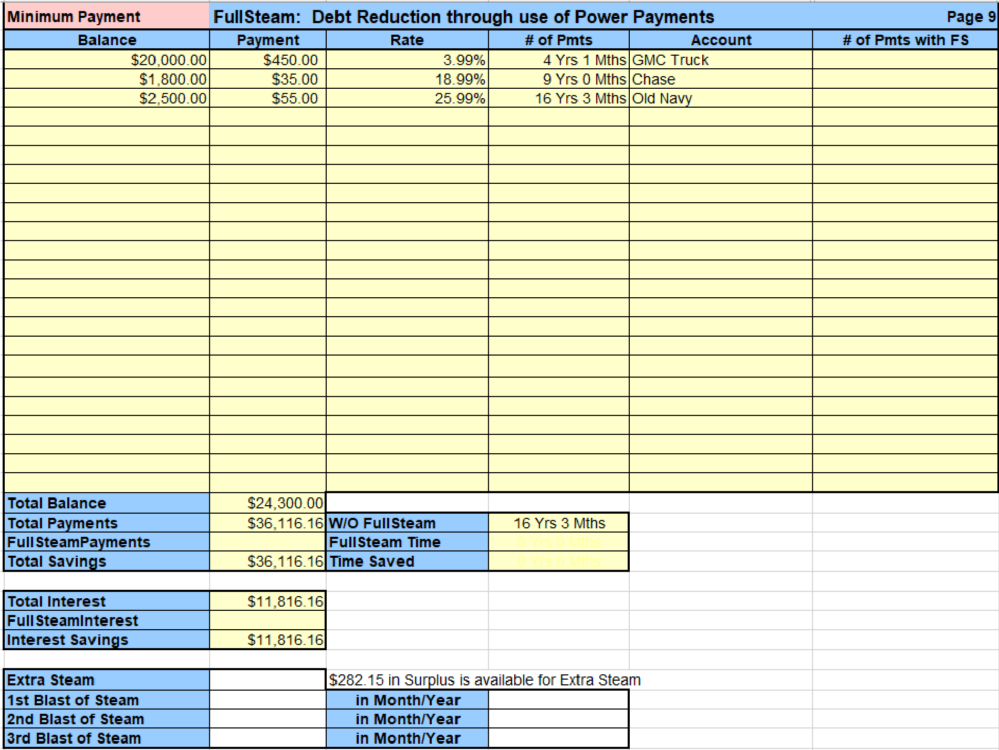
After FullSteam:
The client’s payoff went from 16 years and 3 months down to 4 years and 8 months, saving $6,035 in interest payments. The right side of the spreadsheet shows the number of individual payments and payoff dates for all accounts.
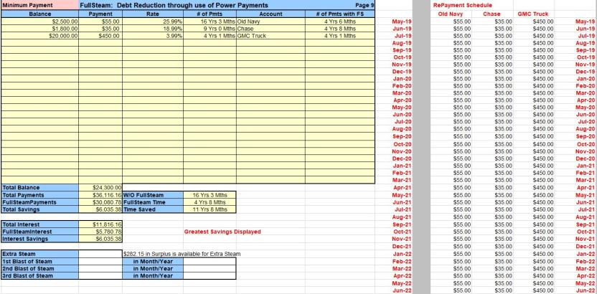
- If your client has any additional funds remaining you can add the dollar amount under Extra Steam to determine how much more interest and time these added payments will save. Right click again to bring up options once you have added the dollar amount.
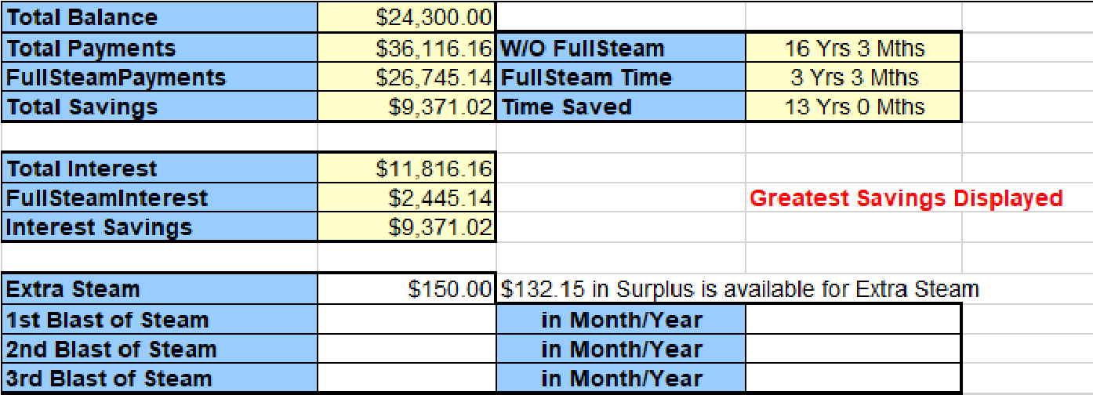
- If your client is expecting a bonus or some other large amount you can enter that dollar amount as a Blast of Steam. Use the tab key and enter the month and year the large payment is expected. Then right click again to pull up your repayment options and make a selection.
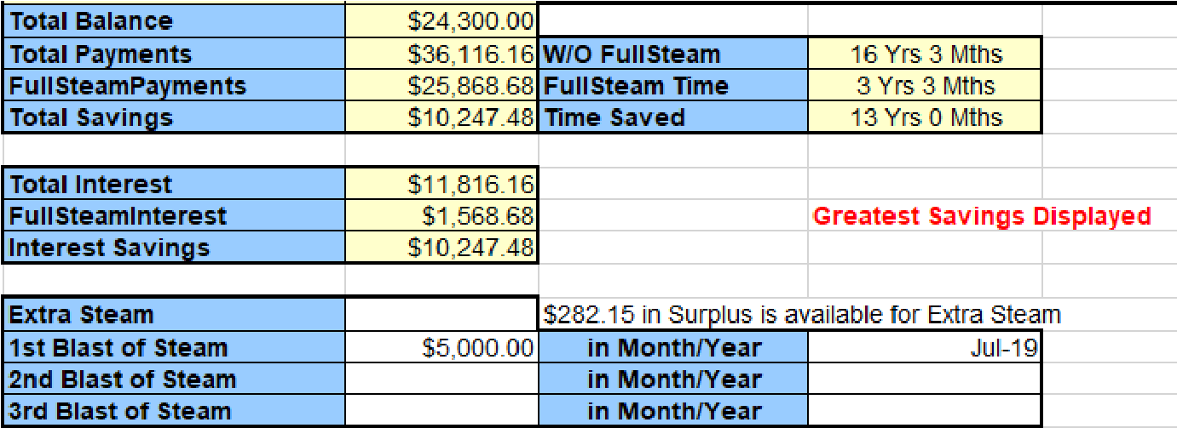

Action Plan
The action plan advises the client of expectations and details the recommendations you went over during your counseling session.
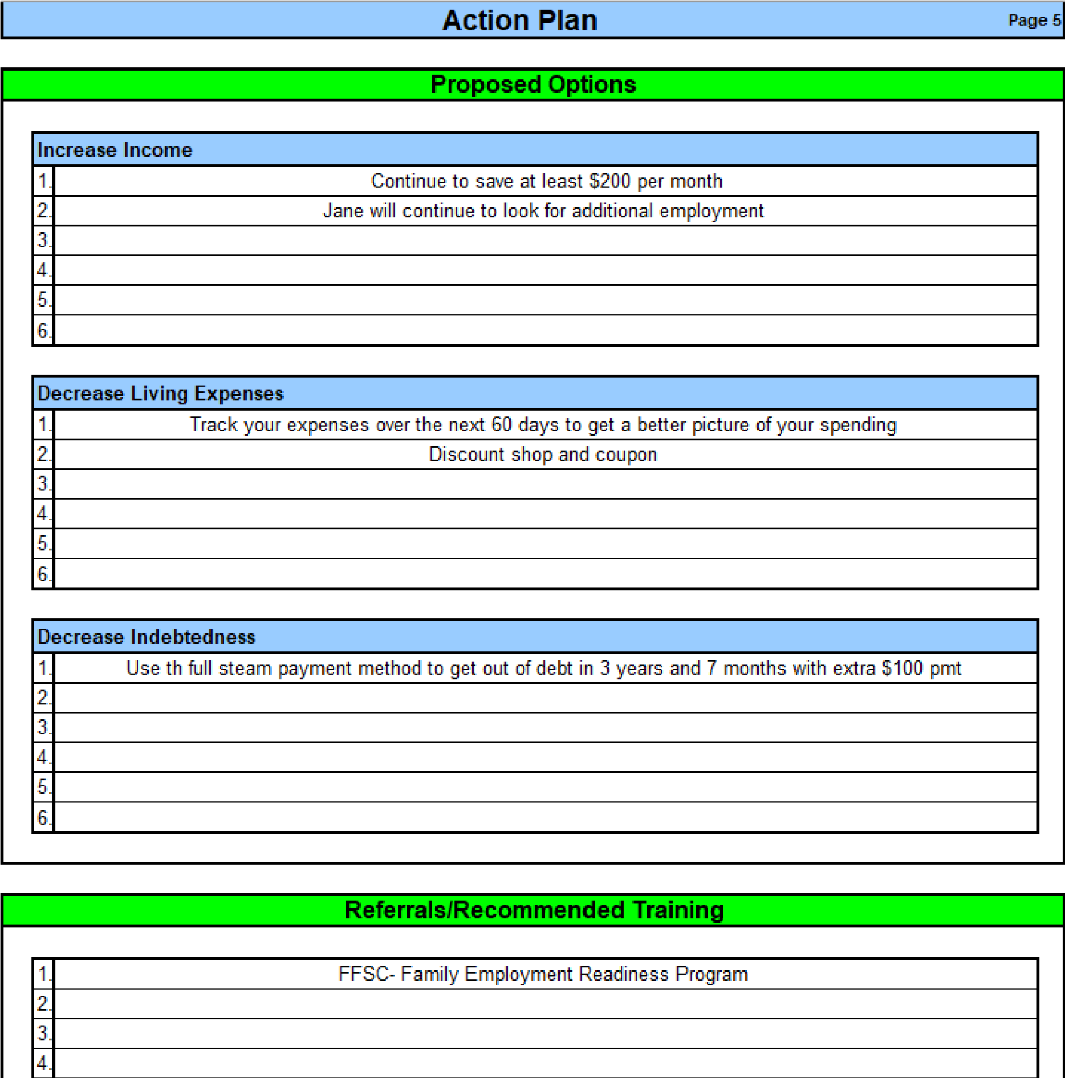

Spending
The spending plan page enables you to separate your client’s expenses per paycheck. The page has a projected and actual column for the 1st paycheck and for the paycheck received on the 15th. This page is perfect if you have a client that is struggling to get bills paid on time.
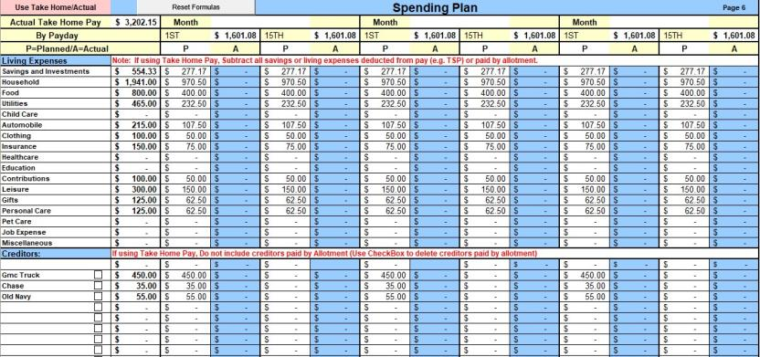

Record Keeping
- The record keeping page can help your client track their daily purchases in order to create an accurate budget.
- Your client can write in daily purchases and tally everything up every two weeks.
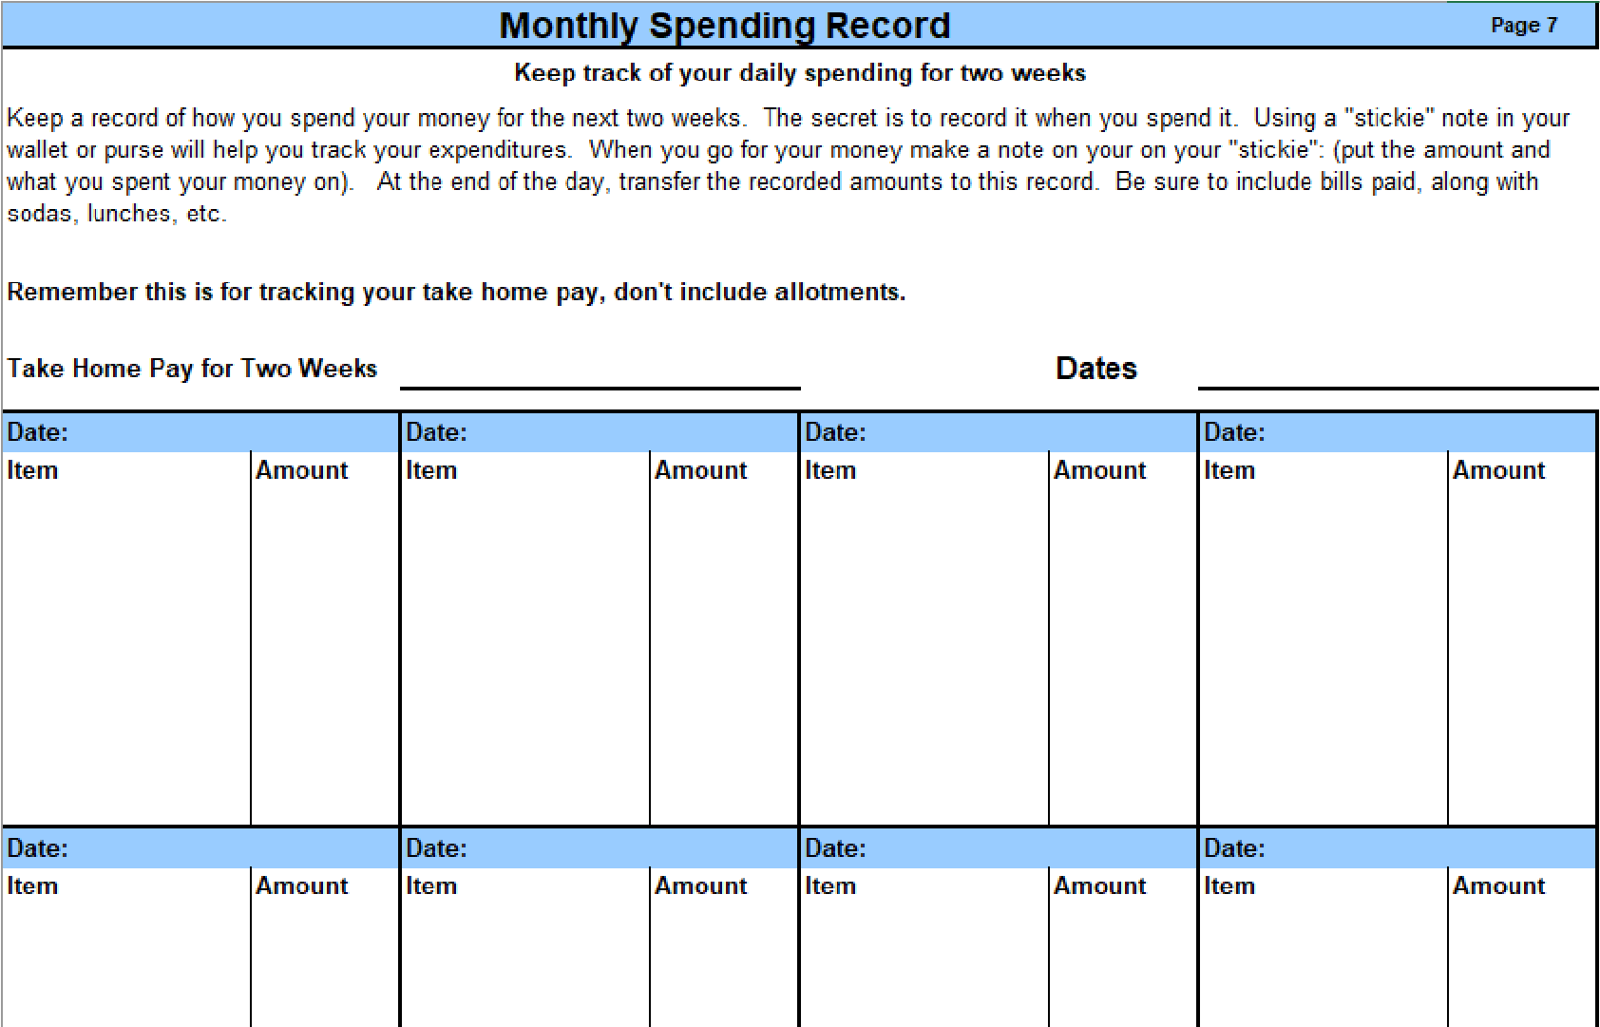

Pay Scale
- The pay scale page provides the pay and allowances for all active duty and reservist paygrades. Each year the worksheet is updated with current information.
- Any changes that you make to the pay table will be reflected on the income page.
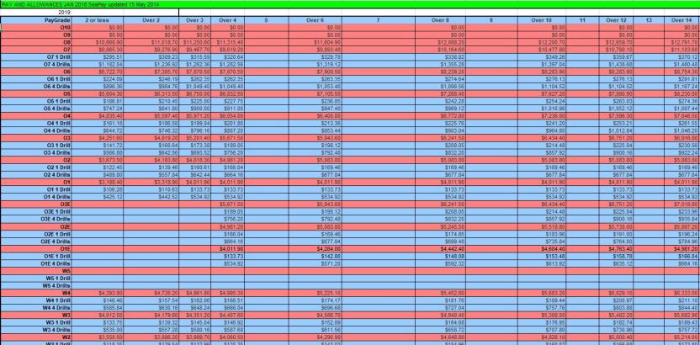

Final Note
- Be sure to provide your client a copy of the financial planning worksheet. Print a copy of the net worth, income, living expenses, in debt, and action plan pages at minimum.
- To print all pages in one PDF, hide all tabs you won't be printing, then save the file as PDF, with the option to publish the entire workbook. (Note that this will only work on the Microsoft Word version of this How-to Guide).

Preparing a Budget
You don't have to use the electronic Financial Planning Worksheet (eFPW) or some online program to figure out your budget. Preparing a budget can be as easy or as difficult as you want. It can be done with pencil and paper or a fancy Excel spread sheet. There are all sorts of software available for those computer-savvy types who like to work with their computers.
A budget consists of basically 4 steps:
- Determine how much money you have coming in. Look at your net income. That means the money that you have to work with after taxes (federal and state), insurance and all those various withholdings that you have no control over.
- Determine how much it costs you to live each month. These are your living expenses. They include rent, utilities, car insurance, various expenses for those things that you like to do like eating, going to movies, paying for those monthly expenses like internet and cellphone. Also, add in an amount for those annual expenses. By this, I mean, holidays, birthdays, and summer vacation. Divide this number by the number of months in a year (12) and that is how much you need to set aside each month so you can afford to pay for these events without charging them to your credit card. Don’t forget things like haircuts, vet bills for Fido and Kitty, car repairs (those new tires you have to purchase every 3 years). What are they per month? If you are not sure what you are spending in these areas, look at old bank statements or old credit card statements to see what you have spent in the past. Also, make sure you are paying yourself first by including in this total the amount you put into savings each month. This could be your emergency fund, retirement savings, or your special savings goal.
- Total up your monthly debt payments: All those credit card payments, student loan payments, and furniture payments. And, of course, don’t forget the car, boat, motorcycle or plane that you purchased on the monthly installment plan.
- Final step: Get the total of your debts and living expenses and subtract them from your income. Hopefully, you will balance out or maybe even have some left over. The problem occurs when you end up in a deficit. Your next step will be fixing that.

SCREENINGS

Basic Housing Allowance Screening

Navy and Marine Corps
Depending on your installation, a BAH screening may be required for junior Marines and Sailors to move off ship or out of the barracks. Typically, Marines and Sailors E4 and below with less than four years in service require this screening. It is the responsibility of the Command Financial Specialist (CFS) to complete this screening. If for some reason the Sailor/Marine is unable to complete the screening with the CFS, the PFM can provide this service. See the tips below for completing the screening.
- Complete a financial planning worksheet. The projected side of the worksheet should reflect the income (including anticipated amount of BAH) and expenses expected off base.
- Review their current income using current LES and expenses through bank statements to determine actual income and expenses. Highlight possible causes for concern.
- Determine projected rent (first and last month’s rent may be necessary to move in), security deposit, and utilities. Ideally rent will account for no more than 25% of their monthly income. Percentage could increase if the Service member is in a high-cost area and depending on the Service member’s personal circumstances. If possible, try to pay less for rent and utilities than the BAH received.
- Include the full amount of rent in a projected budget, even if the member plans to have a roommate to split costs to show that the Service member can afford to maintain housing costs on their income.
- Access a credit report to determine credit score. A low credit score (less than 650) might hinder your client from renting in a particular area or complex.
- Compare actual Debt to Income (DTI) to projected (DTI).
- Determine financial stability.
- If favorable, sign the documents your client provides (the form will have some verbiage that requires you to mark “yes” or “no” as your recommendation for BAH), then give them a copy of the financial planning worksheet to turn in with their screening packet. (Process may differ depending on installation and command requirements)
- Resources for renting can be found in the Personal Financial Management Standardized Curriculum. Also, you can refer your client to your installation’s Housing Office for information about on or off-base housing though the RPP (Rental Partnership Program).
Excerpt from OPNAVIST 7220.12 CH-1 (Navy only)
- Background: Except as otherwise prescribed in law, local base housing authority dictates the eligibility requirements for E-6 and below members requesting to live in off-base private sector housing. The law also allows the Secretary of the Navy to develop additional regulations governing the housing entitlements of E-4 and E-5 shipboard Sailors. Single shipboard E-3 and below Sailors, including those who are claiming dependents solely for the purpose of paying child support, are prohibited by law from receiving BAH/OHA
- Policy: Navy policy restricts eligibility to berth ashore for single shipboard Sailors E-5 and E-4 (with greater than four years of service), contingent upon the approval of their commanding officer. This approval, however, does not constitute an authorization to receive a housing allowance, but simply allows the member to reside off the ship.
- The shore-based facility commander shall make the determination whether the member will be berthed in single bachelor quarters or entitled to draw an off-base housing allowance. It should be noted that full utilization of BQ spaces should be ensured prior to authorization of BAH for shipboard E-4s over four years of service without dependents. However, senior personnel residing in the BQ will not be involuntarily displaced to provide berthing for single shipboard E-4 Sailors.

Marine Corps
Marine Corps housing policy is governed under MCO 11000.22 Ch 1 (22 Jan 2018) and Installation Order for BAH. You can find the MCO on https://www.marines.mil/Marines/ under “Publications,” and you can check with your base IPAC Adjutant office for the installation order. For E5 and below, BAH without dependents is only authorized in certain situations such as:
- Bachelor housing occupancy rate of 95% or greater
- Loss of spouse (death, divorce, or legal separation — 90-day exemption from government quarters, can be exempted from on-base residency if they own home in local area)
- Pregnancy
- Pre-owned home or pre-existing lease in the local area
- Members with dependent child custody
- Or, to preclude undue hardship on individual Marines Authority for entitlement to BAH rests solely with the Installation Commander.
PFM/CFS should consult with the installation order to see if there are any specific financial planning requirements to granting BAH without dependents. We recommend that the PFM/CFS assist the Marine with a financial plan to ensure that the Marine is financially stable to live in town. Follow financial planning steps under Navy process.

Army
The BAH screening for the Army is a little different. Army wide, any Soldier without dependents and between E-1 and E-5 will reside in the barracks.
There are a few exceptions to this policy:
- When barracks are not available
- When overall barracks utilization for the entire installation is at 95%
- If a Soldier has purchased a home before notification of this policy
- When a Soldier is in her 24th week of pregnancy
Upon receiving one of these exceptions to policy, there is no mandatory financial review involving the PFM. The approval process is through the Soldier's chain of command only.

Coast Guard
The Coast Guard has its own internal processes, and Service members E4 and below with no dependents, will be directed to their own commands for evaluations on BAH suitability.
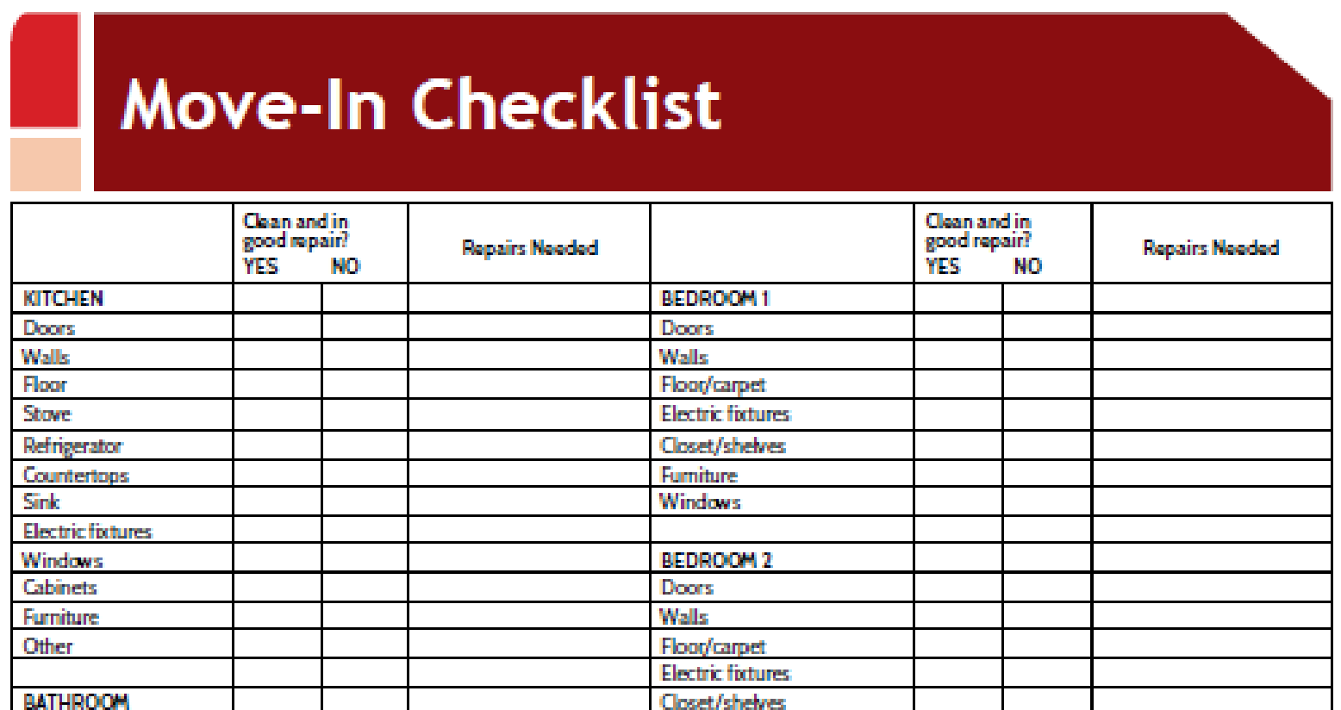
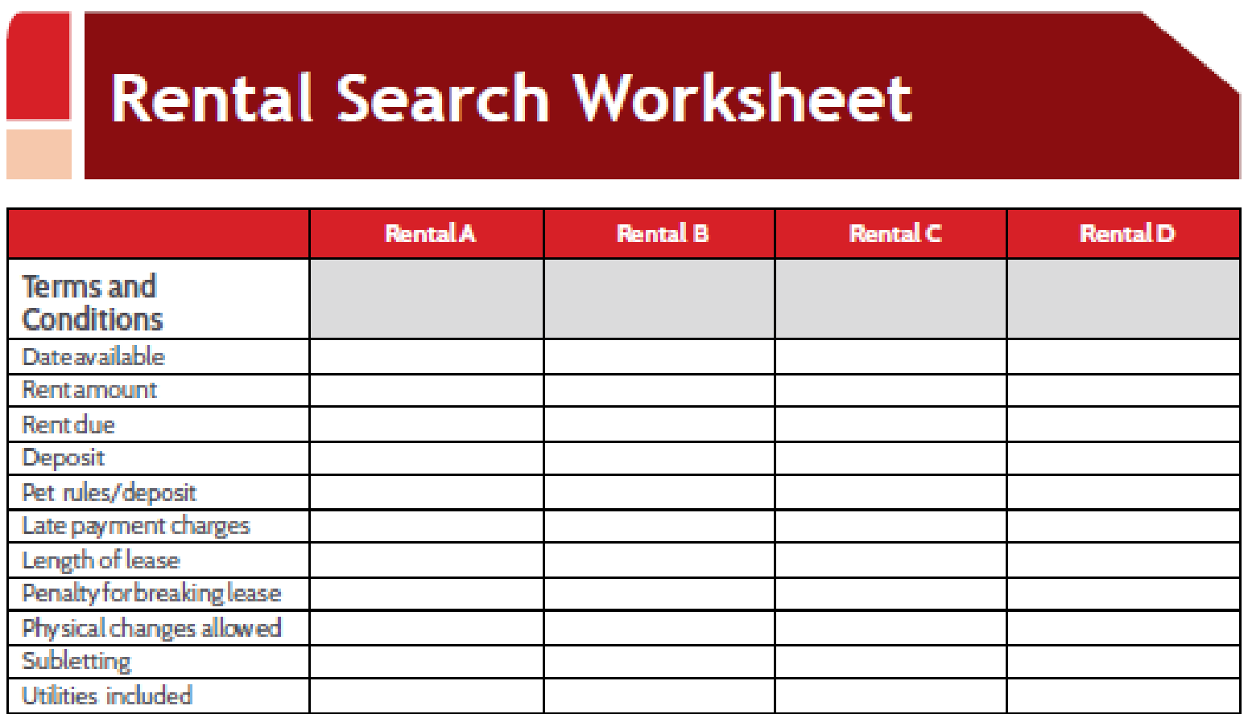

Overseas Screening
You may have a Service member who comes to you to complete the financial portion of his/her overseas screening. An overseas screening is required for Service members designated to PCS (Permanent Change of Station) to foreign locations. It is the responsibility of the Commanding Officer of the transferring command to determine suitability of overseas service. The CO will determine whether the member or family members possess any performance, disciplinary, financial, psychological, medical or other attributes that would prohibit them from conducting themselves as suitable representatives of the United States.
It is the duty of the Command Financial Specialist or Personal Financial Management Specialist to aid in the determination of financial stability. Follow the steps below to complete your financial assessment.
- Complete a financial planning worksheet. The projected side of the worksheet should reflect the income and expenses expected in the new location.
o Be sure to advise your client of allowances including overseas housing allowance, move-in housing allowance, cost-of-living allowance, and dislocation allowance. Visit militarypay.defense.gov for allowance calculators based on location.
- Pull a credit report to ensure you have a full understanding of your client’s financial situation. This will also ensure you have an accurate debt-to-income ratio.
- Determine financial stability. If your client has a debt-to-income ratio of more than 30%, they are considered unfit for an overseas PCS (based on instruction). The CO will make the ultimate determination.
- Your client will likely provide you with paperwork requiring the signature of the CFS/PFM.

Navy Expert from MILPERSMAN 1300-302
n. Financial Stability
- E-5 and above. Serious financial problems or indebtedness which have not been reconciled, or a documented history of indebtedness over a period of the last 3 years, may be considered disqualifying (i.e., bankruptcy).
- E-1 – E-4. A debt-to-income ratio shall be performed by the Command Financial Specialist, or Family Service Center Counselor to ensure the economy in the host nation of the proposed overseas activity will not pose an undue hardship on the member’s financial circumstances. Based on limited employment opportunities, the spouse’s current income cannot be used to determine future debt to income unless the spouse can provide proof of employment in the overseas location. If debt-to-income ratio is 30% or greater, member is unsuitable for overseas assignment.

Coast Guard:
The debt-to-income form should be completed and returned to the Services member.
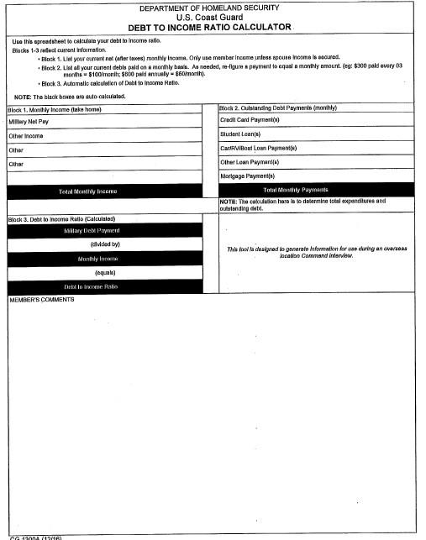

CREDIT REPORTING

Disputing Incorrect Items on Credit Report
If your client has incorrect information on their credit report(s), they can dispute online through the credit reporting agency(ies) or to the creditor directly. Your client can communicate directly to the creditor first to advise of the error and request removal from the credit report(s) the creditor uses. While communicating with the creditor, the client can explain the issue and inquire about the procedure and process to have the inaccurate information removed.
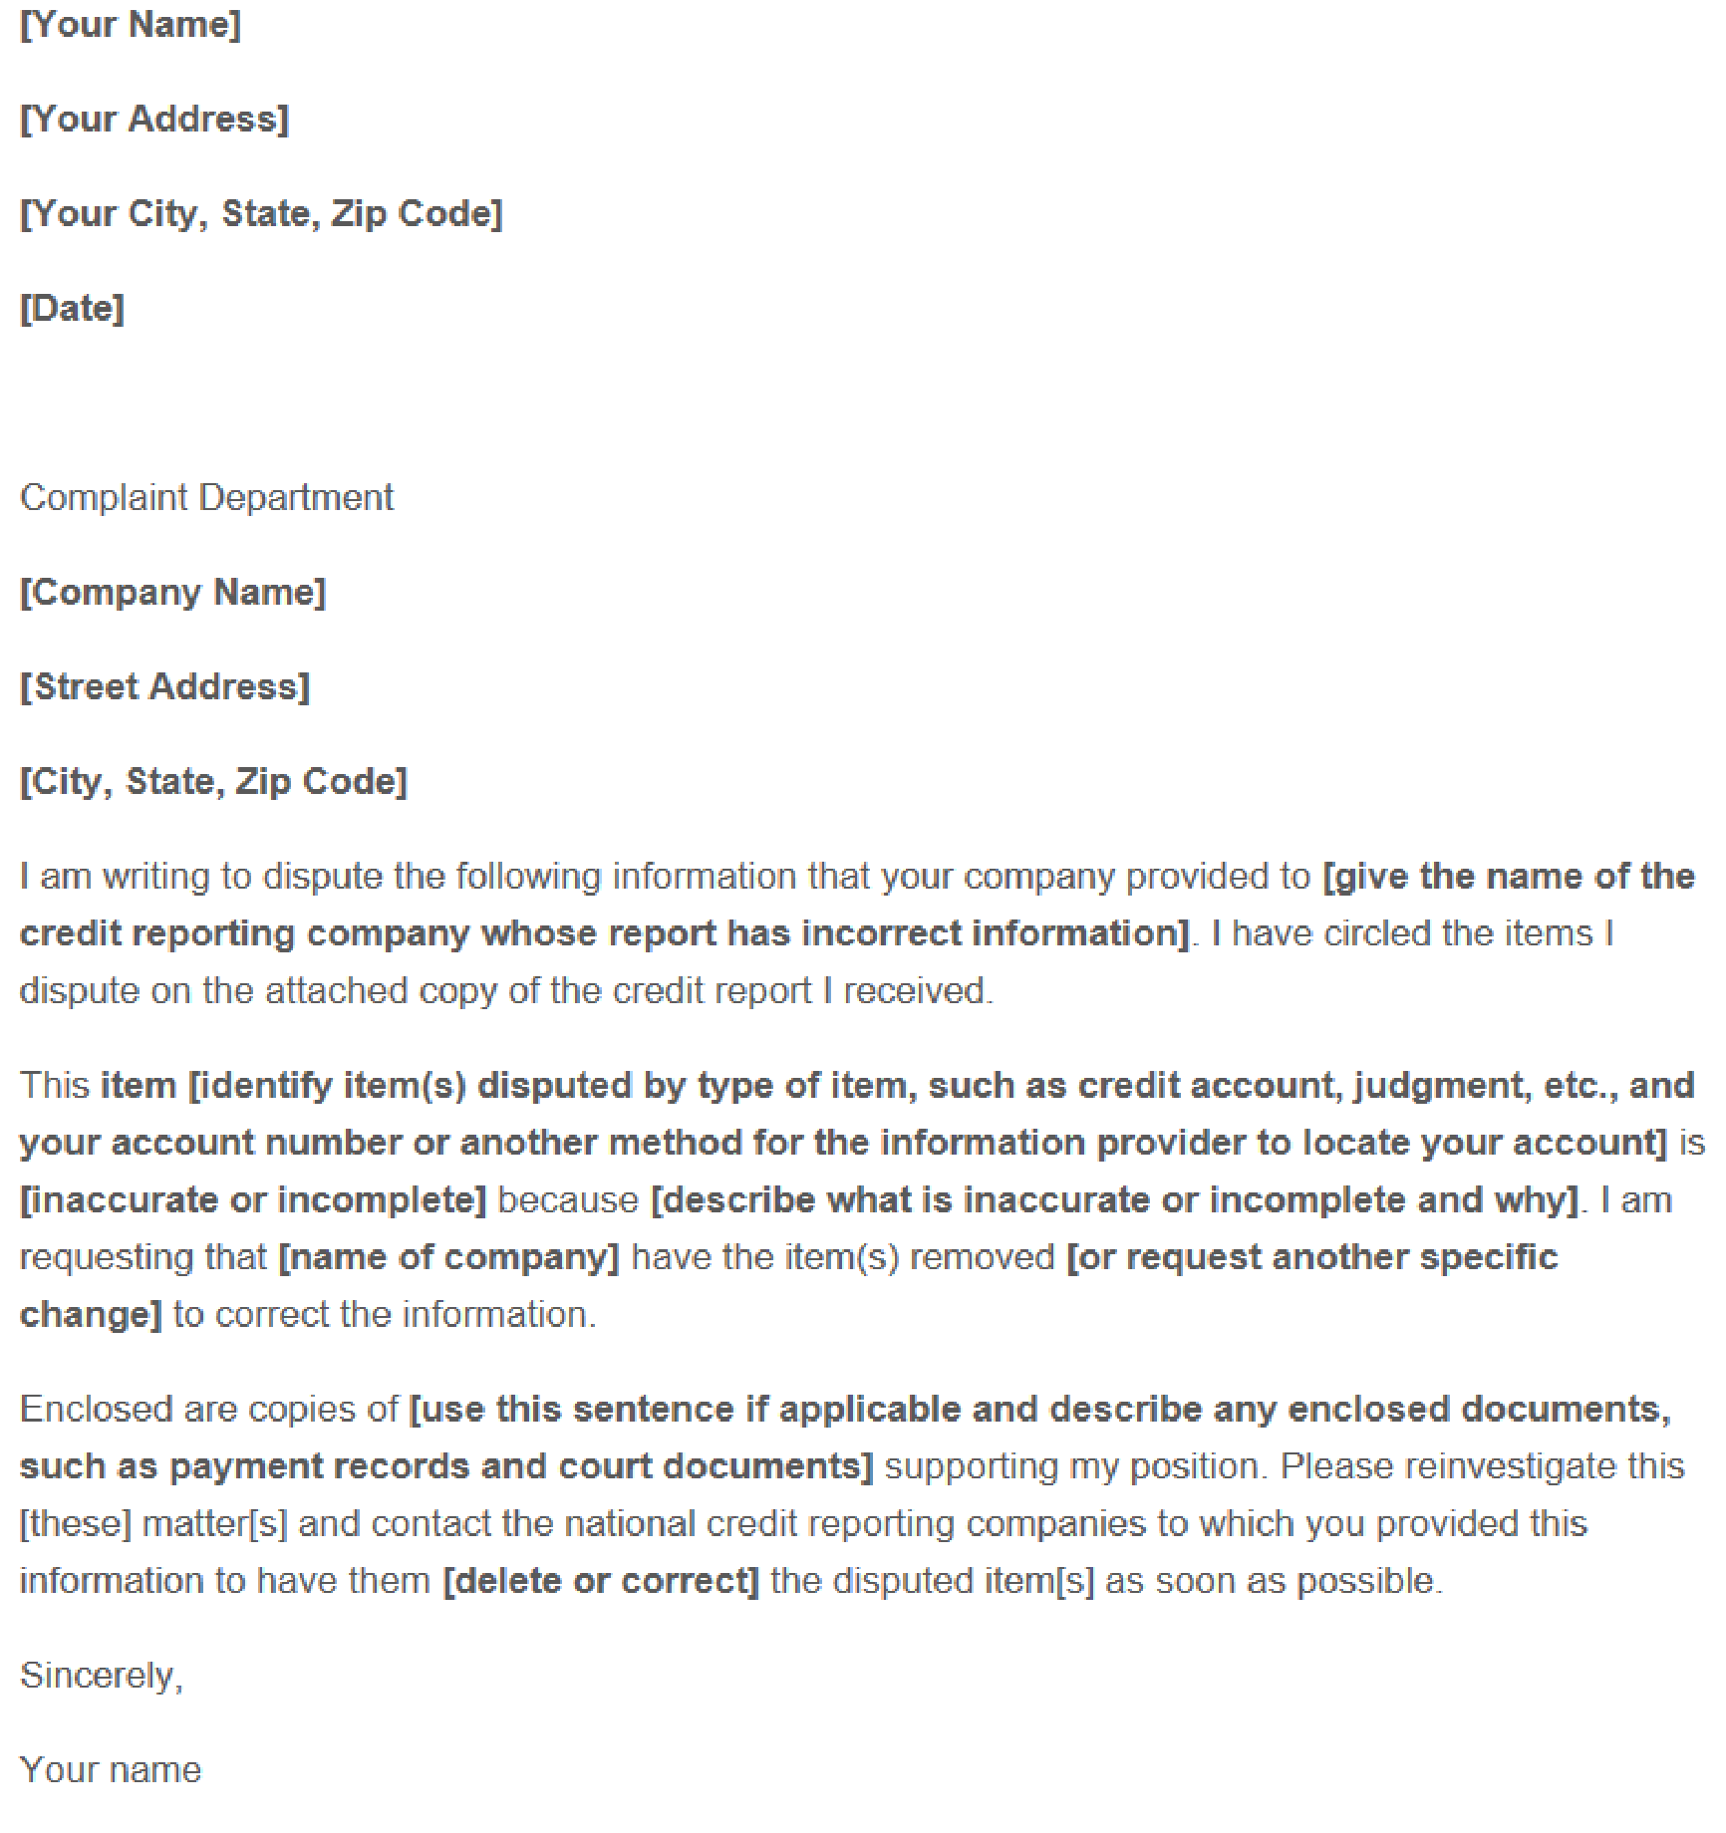
Your client may opt to do this request in writing for documentation. Here is a sample letter template from the Federal Trade Commission https://www.consumer.ftc.gov/articles/0485-sample-letter-disputing-errors-your-creditreport-information-providers. The client will need to provide the details of the account, specific information regarding the error, and any documents (copies) supporting their position.

If your client opts not to work with the organization which reported the error, they can elect to work directly with the credit reporting agencies to get the issue resolved. The client can send a dispute letter with account information, detailed reason why they believe there is an error and any supporting documents (copies) supporting their position. This letter should be sent to each of the credit reporting agencies which show the error. A sample letter on FTC.gov website https://www.consumer.ftc.gov/articles/0384-sample-letter-disputing-errors-your-credit-report
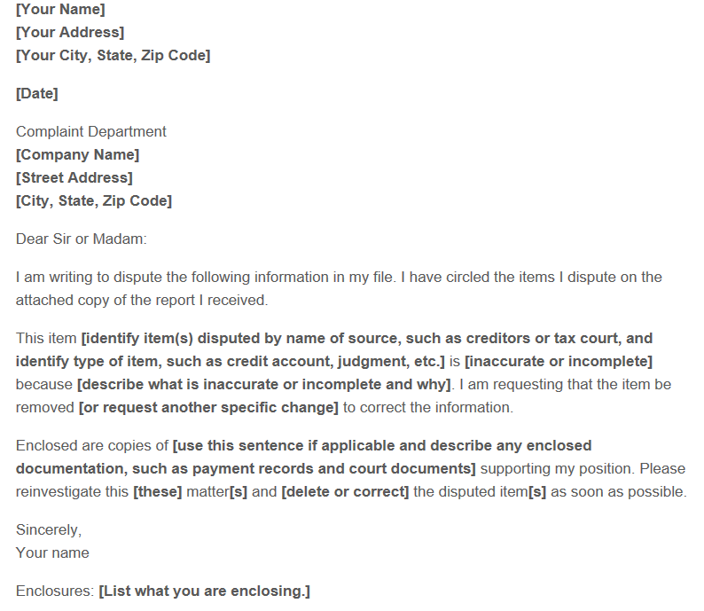
AND what happens if the credit reporting agencies find legitimate errors: If the credit reporting agencies find legitimate errors through their investigation, the errors will be corrected. The client can ask each credit reporting agency to send the corrected report information to any agency (creditor, employer, landlord etc.) who requested their credit information in the last 6 months and was denied due to errors. Finally, your client can submit an electronic dispute through the credit reporting agencies. Be sure to advise your client to dispute the account with each credit reporting agency that has the error. The links below will take the client to each agency’s website.
https://www/equifax.com/personal/cred-rep-serv/credit-dispute/
https://www.experian.com/disputes/main.html
https://www.transunion.com/credit-disputes/dispute-your-credit

https://www.annualcreditreport.com is another website the client can utilize to pull all three of their reports and complete the electronic dispute process.

Identity Theft
If a client has discovered they are a victim of identity theft, please advise them to act immediately to repair the damage that has been done and prevent further damage. The Federal Trade Commission’s https://www.identitytheft.gov website provides a step-by-step process to help the client through this difficult situation. The primary steps in dealing with identity theft include:
- Call the companies where fraud occurred.
  - Call the fraud department. Explain someone has stolen your identity.
  - Ask them to close or freeze the account so no one can add new charges unless you agree.
  - Change logins, passwords, and PINs for your accounts.
- Place a fraud alert and get your credit reports.
  - Place a free, one-year fraud alert by contacting one of the three credit bureaus. That company must tell the other two.
  - Go to annualcreditreport.com to get your free credit reports.
- Report identity theft to the Federal Trade Commission (FTC).
  - Complete the online form or call 877-438-4338.
  - If an account is created a representative of the FTC will walk you through each recovery step.
  - If you do not create an account, you must print and save your identity theft report and recovery plan right away. Once you leave the page you won’t be able to access or update them again.
- You may choose to file a report with your local police department or installation police department. Make sure your Command is informed you will be making a report before filing the report with police. It is an important step in the identity theft process. Download the police affidavit from the FTC website before filing a police report so the police department can sign the form saying you have filed. You will submit that with your FTC complaint and credit bureaus to fix your credit report. Go to your local police department with:
- A copy of your FTC identity theft report
- A government-issued ID with a photo
- Proof of your address (mortgage statement, rental agreement, or utility bills)
- Any other proof you have of the theft
For more information, please visit https://www.identitytheft.gov/Steps. The client may also visit the Consumer Financial Protection Bureau’s website: https://www.consumerfinance.gov/ask-cfpb/what-do-i-do-if-i-think-i-have-been-a-victim-of-identity-theft-en-31/.

Ordering a Credit Report: Annual Credit Report
If you have a client who would like to get a copy of their credit report, advise them to use https://www.annualcreditreport.com/index.action to retrieve their credit reports from Equifax, Experian and TransUnion. Click on, “Request your free credit reports.”

Click on, “Request your free credit reports.”
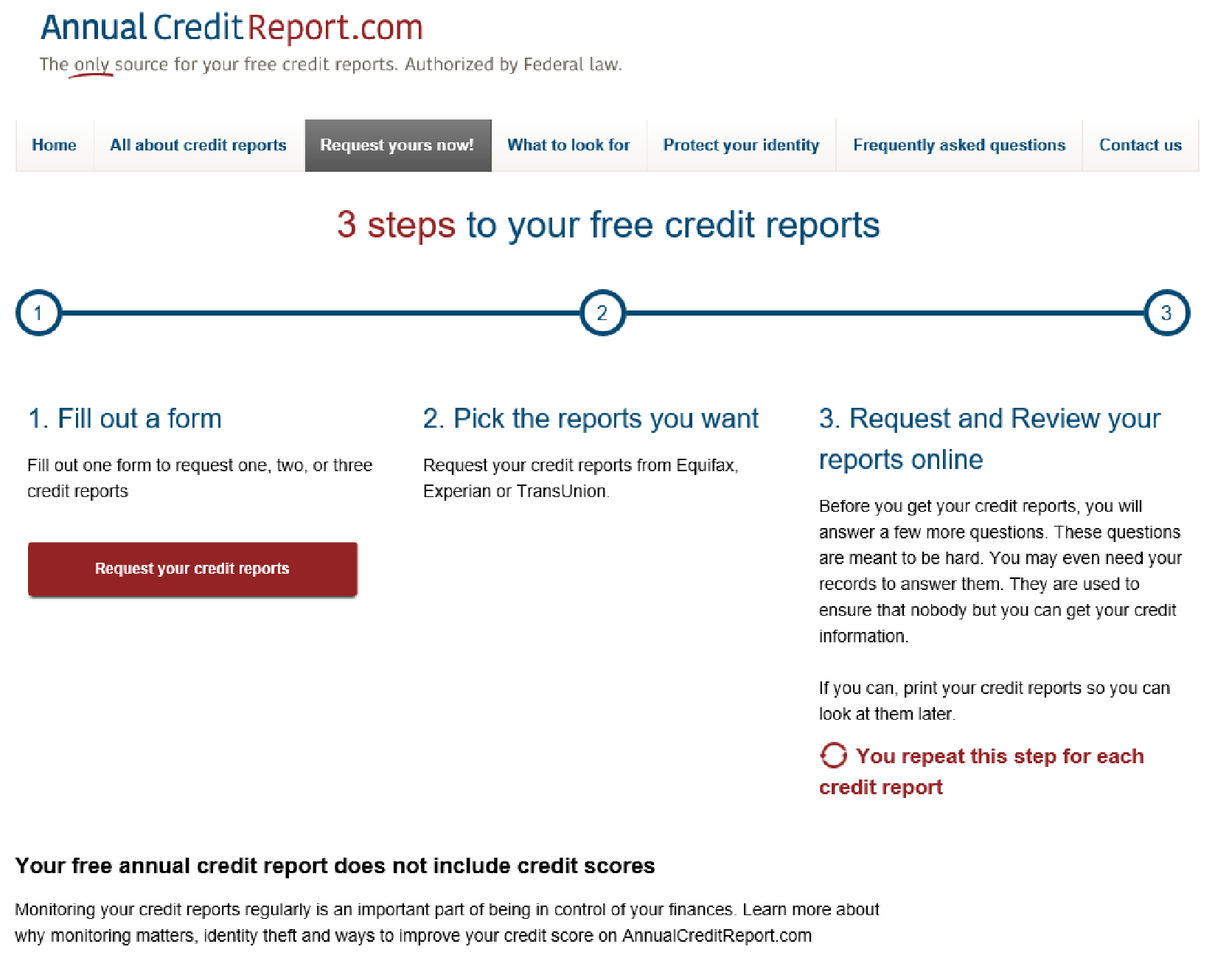
Fill out the form with your legal first, middle initial and last name, along with your date of birth and address. If you have not lived at your current address for more than 2 years, you will need to continue to fill out the form to provide the prior address used. Click on the “Continue” button.

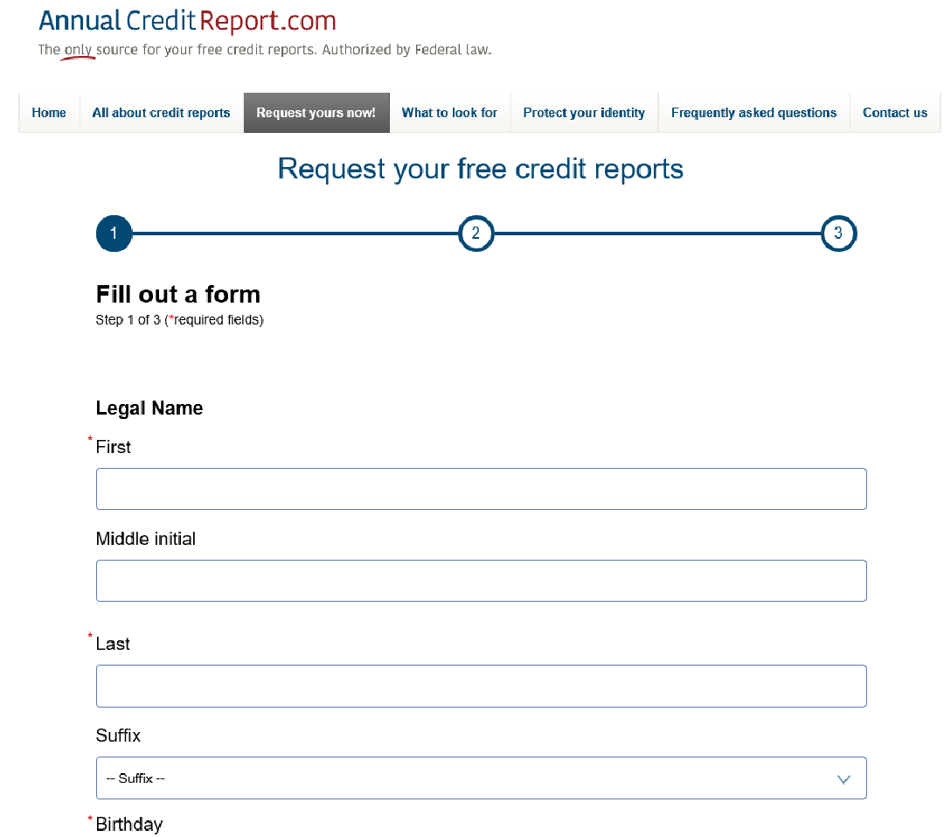
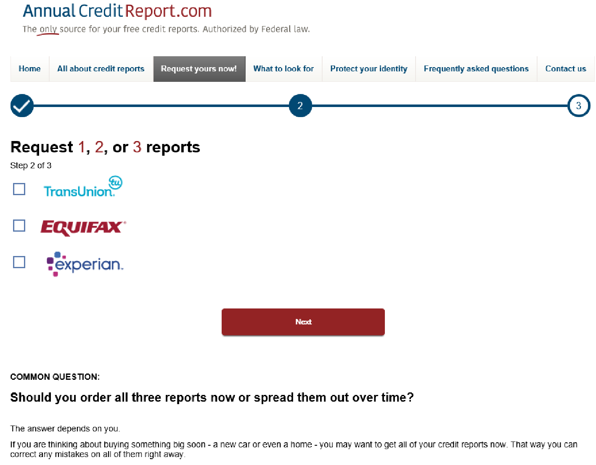
The following will prompt you to choose which report your client would like to see. Encourage the client to get all three for free to verify each credit report has correct information.

Choose 1, 2 or 3 reports to view. Once your client has made their choice, click on “Next.”
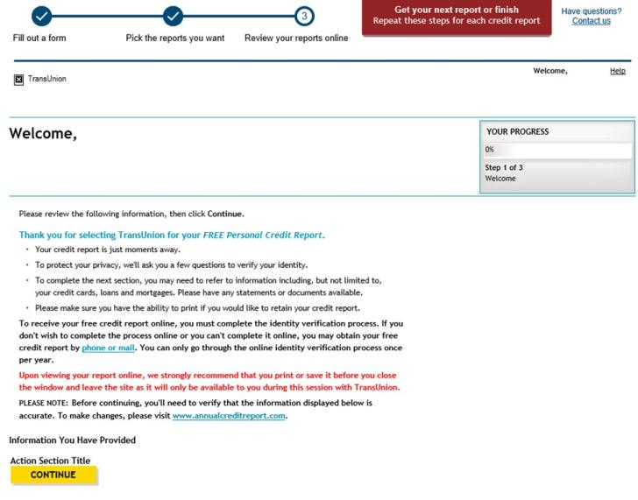
Click “CONTINUE.” The client will then need to verify their information and then be directed to answer questions regarding their history. These questions will be unique to each client. If the client answers the questions correctly, per the credit reporting agency, the client will then be able to view their credit report. If they need to dispute, they will be able to make a dispute with the credit reporting agency and submit online. If the client would like to see their next report — if they elected to see 2 or all 3 — advise to click on, “get your next report” located at the top right of their report. With each report, the client will need to answer any questions related to their information. They may also have to give the last four of the Social Security number.

Ordering a Credit Report Using SaveAndInvest.org
If you are a PFM, coordinate with your WFL Program Lead or Regional WFL Coordinator to ensure you receive the Financial Educator Code (FEC) to provide free credit score and analysis tools for the clients. Save and Invest’s website: https://www.saveandinvest.org/free-credit-score-and-analysis-tool will allow you as an educator to pull credit reports and scores for the clients. Once on the website, click on, “Register for Your Free FICO Credit Score” to begin process.

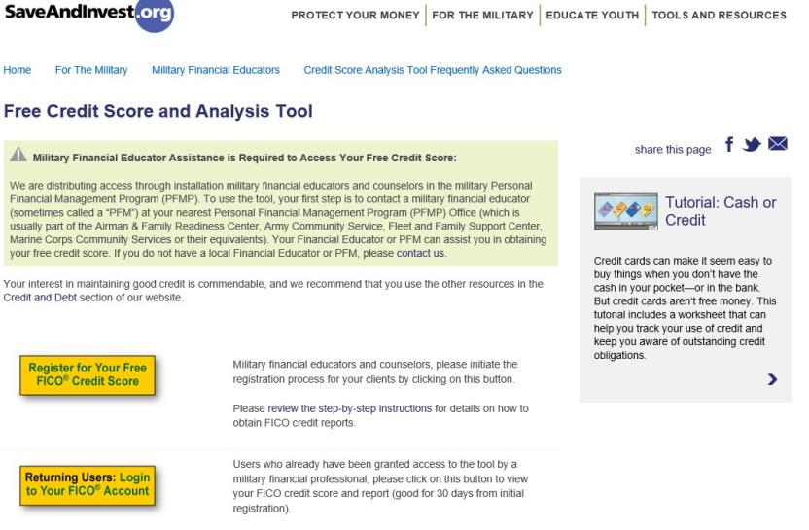
Enter your Financial Educator Information (code) as well as the client’s information. Once all required fields have been completed, click on, “Submit My Registration.”
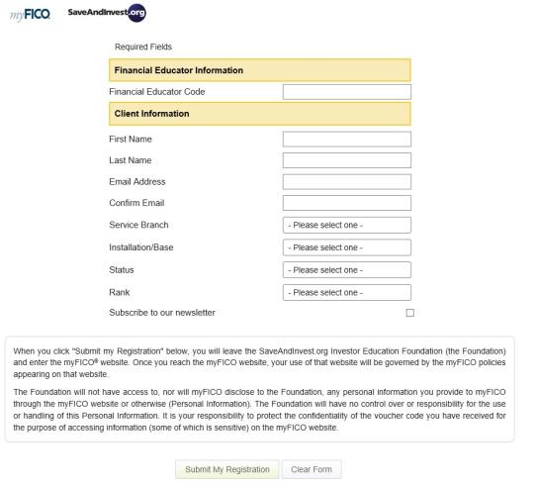
After submitting registration information, the client can choose the credit report and score they prefer to review: TransUnion, Equifax or Experian. Once they choose the report, they will be prompted to create an account.
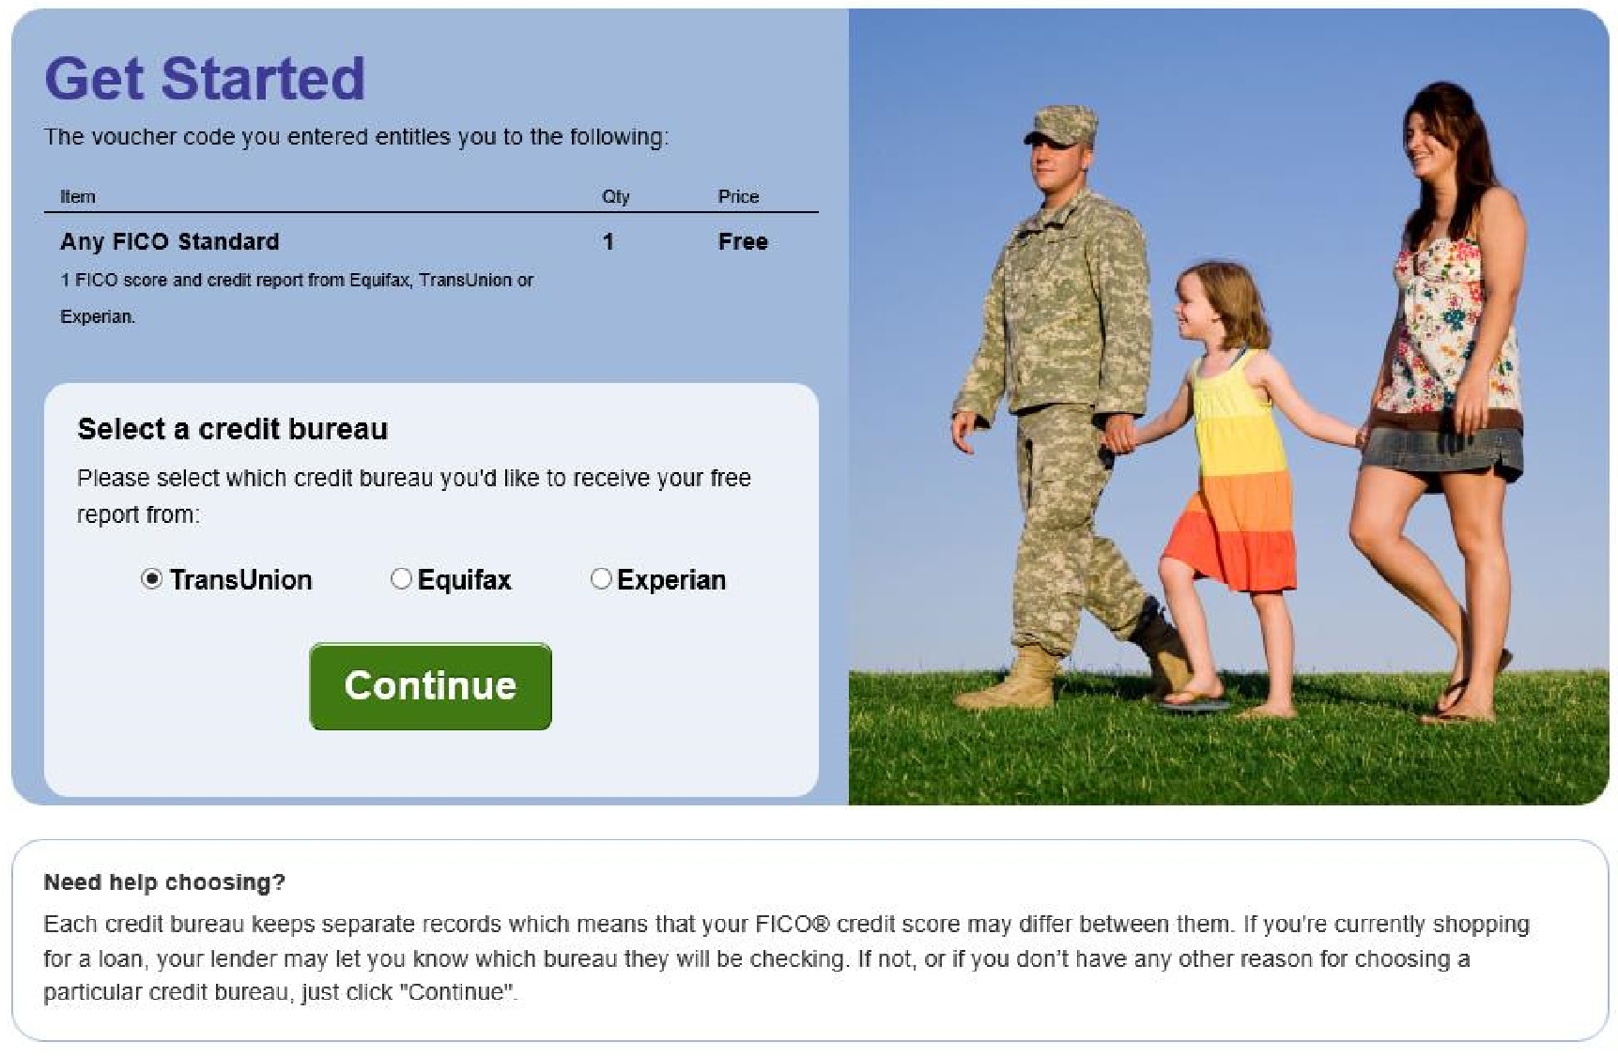
Have the client complete the information to the best of their ability.
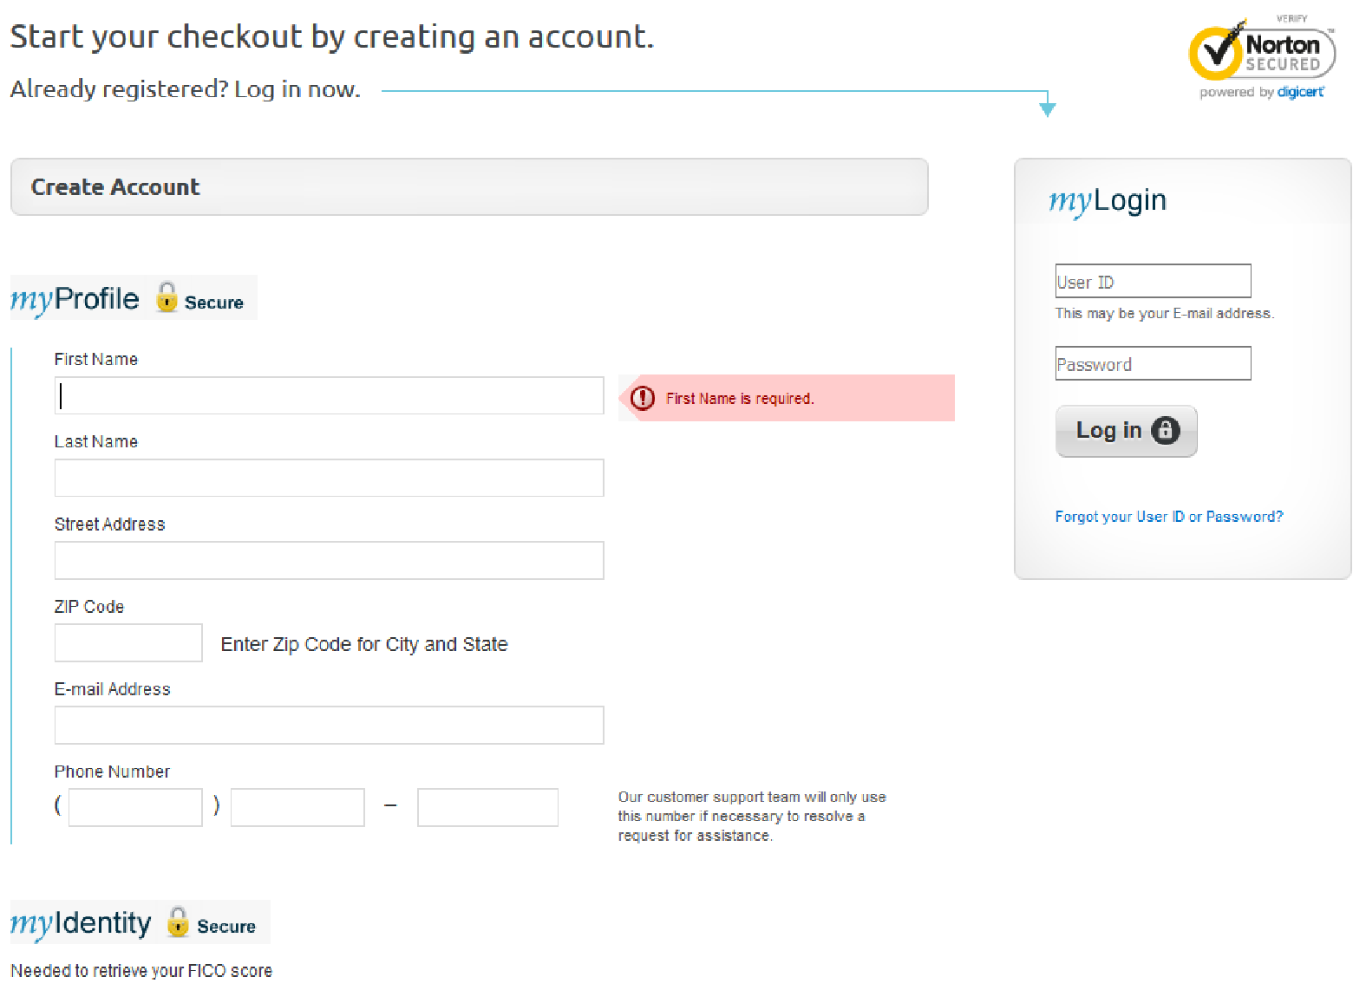

Next, the client will need to click on the box to agree to the FICO Customer Agreement. You may advise this agreement is allowing the client to have FICO obtain their information to provide a credit report and score from each of the three credit reporting agencies.
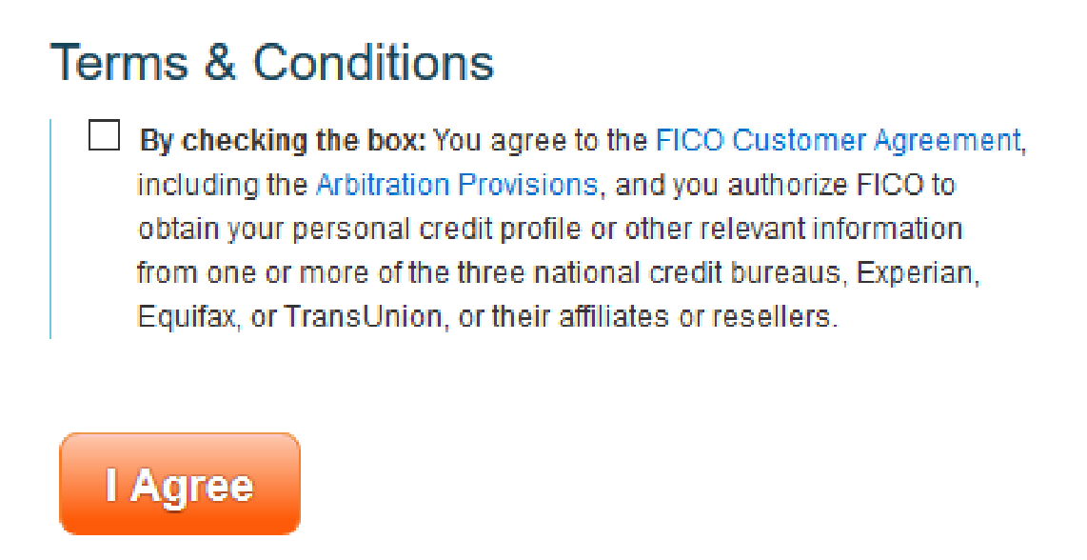
The client’s final step before receiving their chosen credit report is to prove their identity by completing the security questions. To prove identity the Service member will have to answer a few questions.
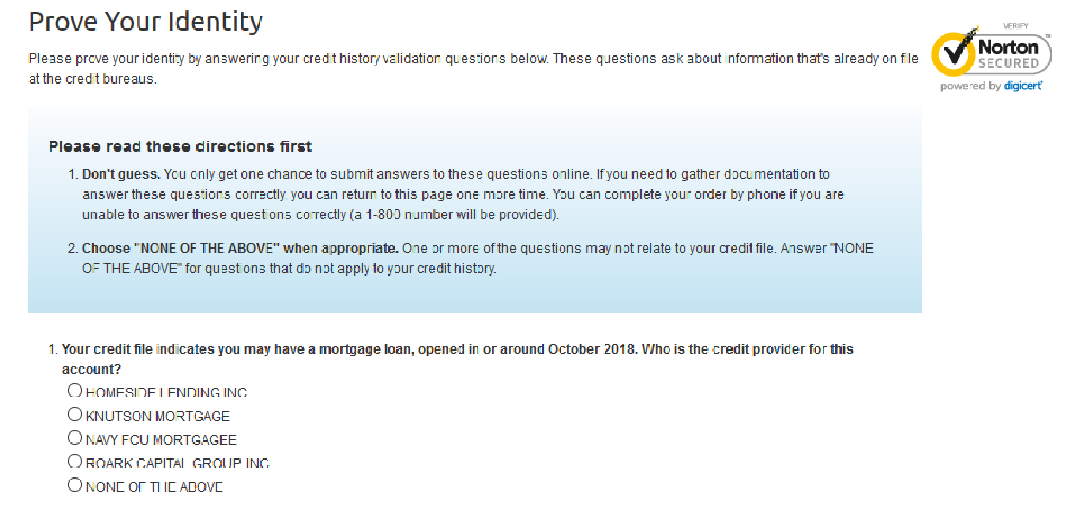
If the client answers the 4 questions correctly, the order will be completed, and the client can review their credit report and score after clicking on, “Go To Your Purchases.” If the client is unable to provide correct answers to the security questions, they will be prompted to call Customer Service at 1-800-848-1133 (Monday-Friday 0600 – 1800 or Saturday 0700 – 1600 PT). This is a much better option than calling the credit bureaus when you cannot answer questions correctly because you will be able to talk to an actual representative with this number.

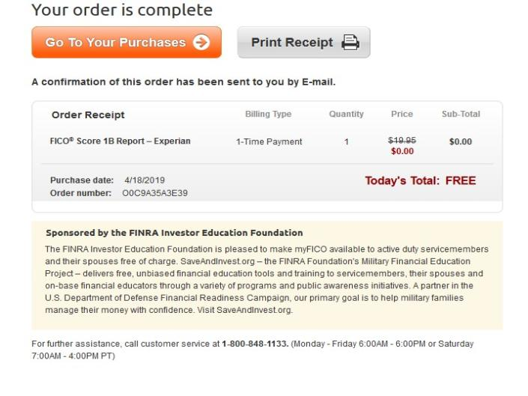

CREDIT AND DEBT MANAGEMENT

Clients and Letters of Intent

Navy Specific
If a client brings in a Letter of Intent (LOI) supplied by Department of Defense Consolidated Adjudications Facility (DODCAF) (https://www.dodcaf.whs.mil/), it is important you explain the process of appeals and assist them in establishing a plan of action which will satisfy DODCAF. The notification the client receives will include a Statement of Reason (SOR) describing the issues which need to be mitigated before the security clearance can be granted or reinstated. The client must respond to the letter as soon as possible to avoid unfavorable actions. Your job as the PFM or CFS is to:
- Review the LOI to determine the primary issues.
- Get a detailed account of the client’s financial situation.
- Review the client’s credit report to identify current account information.
- Complete a financial planning worksheet which details the actions the client is/will take to mitigate the issues addressed in the SOR.
- If necessary, help the client complete their response to the LOI.
- Help the client determine the supporting documents that need to be enclosed within the response.

See the example response letter below:
15 Apr 19
From: Rate, Name, USN, XXX-XX-1111
To: Director, Department of the Navy Central Adjudication Facility Via: Commanding Officer,
Subj: INTENT TO DENY ELIGIBILITY FOR SECURITY CLEARANCE
Ref: (a) Director, Department of Navy Central Adjudication Facility
Encl: (1) Financial Personal Worksheet dated
Encl. (2) JPMorgan Student Loan Statement of payment
- In response to ref (a), request review and reconsideration of my security clearance based on the enclosed additional information.
- All the identified financial concerns were acquired prior to my enlistment in the US Navy on ## January 2014. Since reporting to my first duty station, I have been working diligently with Personal Financial Manager, (Name of Counselor) at Fleet and Family Support Center, Naval Base (installation). Together, we have established a working Financial Planning Worksheet, Encl (1) to maximize available cash flow. Over the last eight months, I have been able to completely resolve 66% of the delinquent accounts and rehabilitate my student loans to begin repayment.
- Below includes each item listed on the Statement of Reasons, including date, company, amount, reason, and status. Several payments have been made via telephone debit.
a. ACS/ JPMORGAN (STUDENT LOAN) - /commercial student loan, $2,637
STATUS: PENDING RESOLUTION. Due to the amount owed, this is one of the last accounts to address. I have planned to pay this debt upon return from deployment from the funds set aside each month in savings.
CIRCUMSTANCES:
- History
These debts I incurred prior to entering the Navy are due to my immaturity, poor money management and a lack of financial understanding at the time. I am distinctly aware how paramount good credit is as well as paying bills on time and staying good on my word.
- Plan of Action
Continue working with the financial specialist to pay off my debts and save money for emergencies by following the Financial Planning Worksheet. I will be attending the Fleet and Family Support Center’s Million Dollar Sailor class on (Date) to expand my personal financial knowledge.
- I have initiated efforts in good faith to get my responsibilities in order.
……………………FILL IN YOUR STATEMENT………………………….
I am committed to positive change and constant improvement; therefore, I request reconsideration for my security clearance.
See the infographic below which details the appeals process.
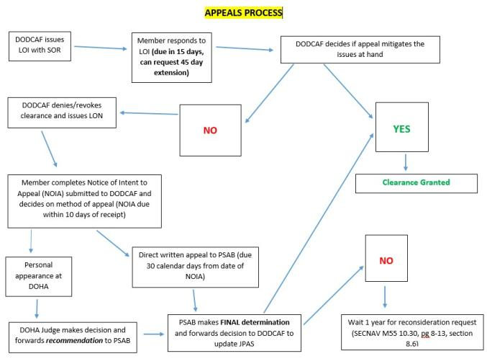

Coast Guard Specific
If a client brings a Letter of Intent (LOI) to Revoke or Deny Security Clearance supplied by the US Coast Guard Security Center (SECCEN) (SECCEN is the Coast Guard’s Central Adjudication Facility), it is important that you explain the process of appeals and help them to establish a plan of action that will satisfy SECCEN. The notification your client receives will be in the form of an LOI describing the issues that need to be mitigated before the security clearance process can move forward. Your client must respond to the LOI as soon as possible to avoid unfavorable actions. They can (and should) request a copy of their credit report from SECCEN (FIN-SMB-SecHelpDesk@uscg.mil). Your job as the PFM is to:
- Review the LOI to determine the primary issues.
- Get a detailed account of the client’s financial situation.
- Review the client’s credit report to identify current account information.
- Complete a financial planning worksheet that details the actions the client will take to mitigate the issues addressed in the LOI.
- If necessary, help the client complete their response to the LOI.
- Help the client determine the supporting documents that need to be enclosed within the response. (*)
See the example response letter below:
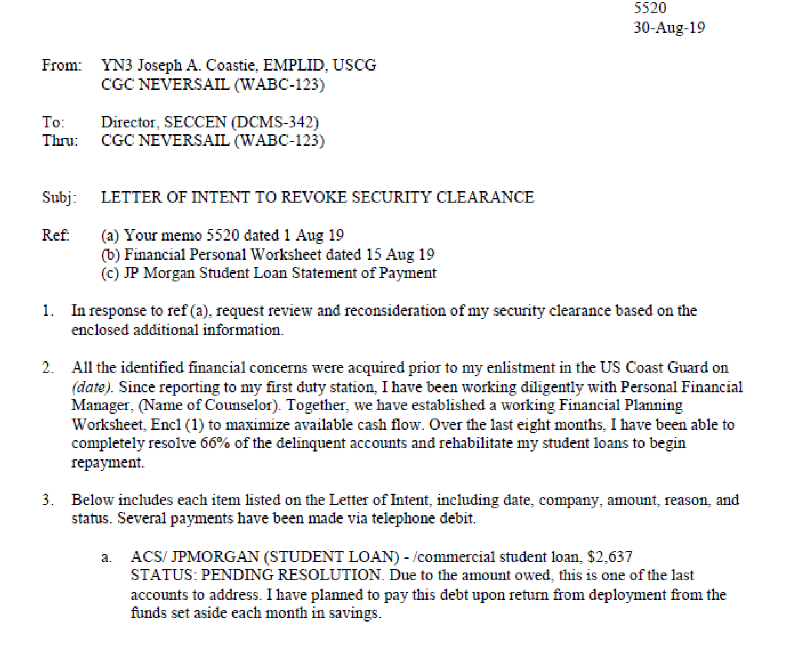
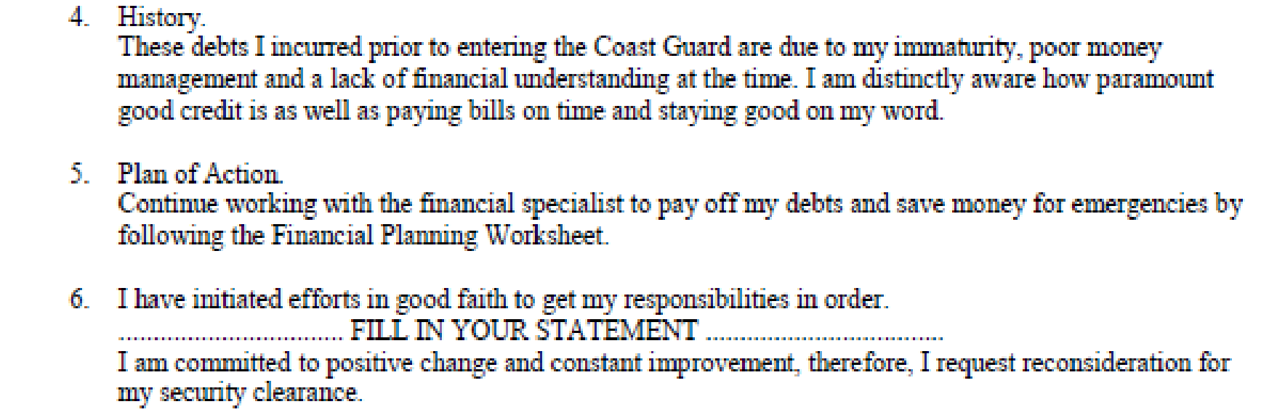
(*) Most common supporting documentation sought by SECCEN to mitigate financial considerations:
- Canceled checks that prove payments have been processed and deducted from the member’s bank account
- Bank and/or creditor statements that reflect account standing; to include account balance, transaction dates, transaction amounts and methods of payment
- Receipts that reflect types, amounts and dates of financial transactions between the member and creditor/debtor
- Court dispositions that reflect dismissal or satisfaction of civil suits, fines, or other financial obligations
- Official correspondence on company letterhead that otherwise communicates the status of the account and/or debt owed (i.e. settlement acceptance letters, hardship program/ payment plans, loan deferments, letters disputing the legitimacy of past-due debt, etc.)
- Bankruptcies require submission of court documentation that reflects the schedule of payment and discharge information. The response should also include a personal statement from the member that explains the circumstances which led to bankruptcy.
- Foreclosures require submission of bank, court and other documentation that summarizes details of the foreclosure to include status, amount owed to lender and terms of repayment. The response should also include a personal statement from the member that explains the circumstances which led to foreclosure.
See the infographic below, which outlines the Personnel Security Appeals process:
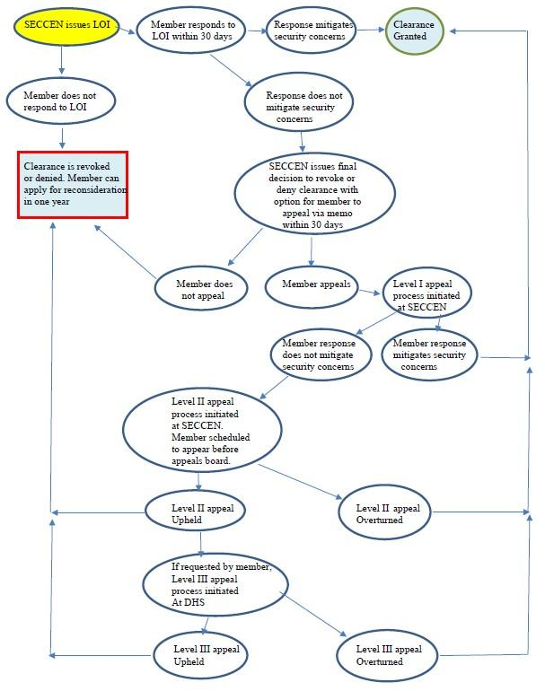

Personnel Reliability Program
The Personnel Reliability Program sets forth the guidelines for Service members working with, or who have access to nuclear weapons. Nuclear weapons require special considerations because of their policy implications, military importance, destructive power, and the political consequences of an accident or an unauthorized act. If you are working at an installation that has nuclear weapons the PRP personnel have already signed documentation acknowledging that they have given up some rights to privacy for this program.

PERSONNEL RELIABILITY PROGRAM (PRP) REPORTING (Navy)
The authority for soliciting and maintaining information is found in 5 U.S.C. Sect. 301, which allows Secretary of the Navy to make regulations for the Department of the Navy. In addition, there are 10 U.S.C. 6161 and 10 U.S.C. 2774 as added by Public Law 92-453. Personnel Reliability Program information can be found in SECNAVINST 5510.35D and OPNAVINST 1754.1B.

Although the only unequivocal duty for PFM is to report PRP with financial concerns that may need to be further investigated considering their security clearances (per OPNAVINST 1754.1B, Enclosure 5, paragraph 8(a)(2) which cites SECNAVINST 5510.35A — now D), PFM may receive approval from their FFSC Director to report other security cleared Sailors whose financial situation may pose a risk that should be investigated further by the appropriate authorities.
They would use the same PRP Notification memorandum updated 27 Nov 2019 (below) to capture this for notifying the Command and that memorandum should be retained as Personal Identifiable Information (PII) since it contains the member’s Rank/Rate, Name, and Command via the FFSC correspondence files. This would be filed in the normal correspondence system according to your FFSC, and not kept in PFM Case records. Privacy and confidentially shall be maintained/stored in accordance with SECNAVINST 5211.5E and SECNAV M-5210.1.
The Notification Memorandum will be sent from the FFSC Director to the Command, should a Personal Financial Manager (PFM) have serious concerns about someone. As PFMs do not investigate the Sailor’s threat to security or determine keeping a clearance status, notifying the Sailor’s Command is the extent of their responsibility.
When working with clients who are governed by the PRP, it is important that they understand that they have surrendered some privacy in exchange for PRP certification. Before you begin your counseling session, ensure they have reviewed the PRP statement and privacy statement Privacy Act Form (OPNAV 1754.1B Enclosure 6). If you feel that your client has significant financial issues that warrant review by their Command, communicate with your supervisor and your FFSC Director. If all agree that the client’s reliability is diminished or seriously threatened, a form letter (see example below) will be sent to the Commanding Officer by the FFSC Director.
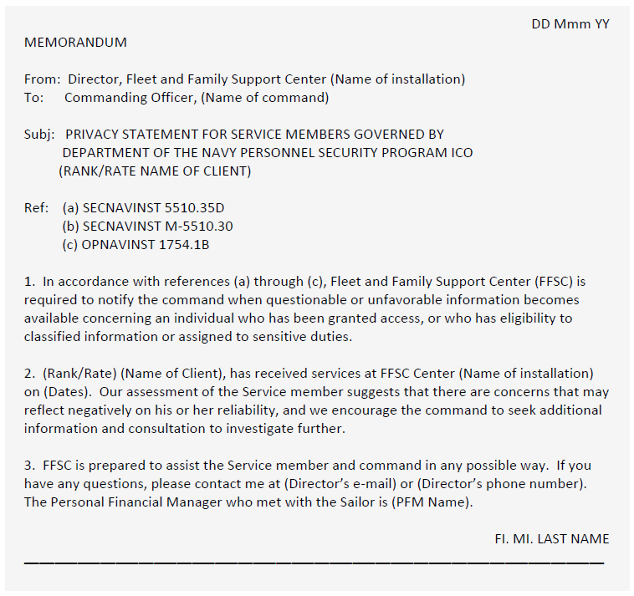
Sample Memorandum:

The Commanding Officer or Certifying Officer will review the client’s financial situation and determine if further action is necessary. See the guidelines below to gain a better understanding of what the Certifying Officer is looking for.
Exert from DoDM 5210.42:
c. Financial Considerations. An individual who is financially overextended is at risk of having to engage in illegal acts to generate funds. Unexplained affluence is often linked to proceeds from financially profitable criminal acts.
(1) Conditions that the certifying official should carefully consider include:
  - A history of not meeting financial obligations.
  - Deceptive or illegal financial practices such as embezzlement, employee theft, check fraud, income tax evasion, expense account fraud, filing deceptive loan statements, and other intentional financial breaches of trust.
  - Inability or unwillingness to satisfy debts.
  - Unexplained affluence.
  - Financial problems that are linked to gambling, drug abuse, alcoholism, or other
(2) Conditions the certifying official might consider mitigating reliability concerns include:
- The behavior was not recent.
- It was an isolated incident.
- The conditions that resulted in the behavior were largely beyond the person’s control (e.g., loss of employment, a business downturn, unexpected medical emergency, or a death, divorce, or separation).
- The person has received or is receiving counseling for the problem and there are clear indications that the problem is being resolved or is under control.
- The affluence resulted from a legal source.
- The individual initiated a good-faith effort to repay overdue creditors or otherwise resolve debts.

SCRA or MLA Issues
The Servicemembers Civil Relief Act is a federal law that provides protections for active duty military members. This law covers issues including rental agreements, security deposits, prepaid rent, evictions, installment contracts, credit card interest rates, mortgage interest rates and foreclosures, civil judicial proceedings, automobile leases, life insurance, health insurance and income tax payments. For details regarding these protections visit https://www.justice.gov/servicemembers/servicemembers-civil-relief-act-scra.
The Military Lending Act is another law that offers protections to active duty members. This law caps interest rates at 36%, your clients cannot be charged more than a 36% Military Annual Percentage Rate (including finance charges, credit insurance premiums, add-on products sold in connection with credit, and other fees like application or participation fees), no mandatory waivers of consumer protection laws, no mandatory allotments, and no prepayment penalty. Your clients might find the PDF regarding the MLA provided by the Consumer Financial Protection Bureau helpful in understanding their rights. The PDF can be found at https://files.consumerfinance.gov/f/documents/cfpb_military-lending-act-know-your-rights_handout.pdf.
If you are working with a client who feels their rights have been violated, they should:
- First contact their nearest Region Legal Services Office to see if the SCRA or MLA applies to their particular situation. Dependents of Service members can also contact or visit local RLSOs where they reside.
- In order to have their SCRA/MLA matter reviewed by the Department of Justice (DOJ), they must first seek the assistance of their military legal assistance office.
- If that office cannot resolve the complaint, it may choose to forward the complaint to the DOJ.
- The DOJ then will review the matter to determine whether DOJ action is appropriate. For more information visit https://www.justice.gov/servicemembers/servicemembers-civil-relief-act-scra.

STUDENT LOANS

Post 9-11 GI Bill
The Post-9/11 GI Bill provides the most comprehensive education benefits package ever offered. In addition to the benefits for the Service member, it also allows career Service members the opportunity to share their educational benefits with immediate family members with certain service obligations. You can transfer all benefits to one individual or distribute them among eligible family members under certain conditions. Family members must be enrolled in the Defense Eligibility Enrollment Reporting System (DEERS), and you must apply for the transfer of the benefits through the VA website.
If you have at least 90 days of aggregate, active duty service after Sept. 10, 2001, and are still on active duty, or if you are an honorably discharged Veteran or were discharged with a service-connected disability after 30 days, you may be eligible for this VA-administration program.
The Post 9-11 GI Bill offers the Yellow Ribbon Program and the ability to transfer the entitlement.

Yellow Ribbon Program
The Yellow Ribbon Program can help you pay for out-of-state, private school, or graduate school tuition that the Post 9-11 Bill does not cover. If the Service member qualifies, the educational institution (must also offer the Yellow Ribbon Program) will contribute a certain amount toward your extra tuition and fees through a grant, scholarship, or similar program. To qualify, the Service member must meet at least one of the criteria listed below.
- Served at least 36 months on active duty (either all at once or with breaks in service), or
- Received a Purple Heart on or after Sept. 11, 2001, and were honorably discharged after any amount of service, or
- Received a Fry Scholarship on or after Aug. 1, 2018, or
- Served for at least 30 continuous days (all at once, without a break) on or after Sept. 11, 2001, and were discharged after 60 days with a service-connected disability, or
- Are a dependent child using benefits transferred by a Veteran or a Service member who has served for at least 36 months on active duty and qualifies at the 100% level, or (Find out about transferring Post-9/11 GI Bill benefits)
- Are receiving the Fry Scholarship (beginning Aug. 1, 2018)

Transfer Post 9-11 GI Bill to Spouse and Dependents
The transferability option under the Post-9/11 GI Bill allows Service members to transfer all or some unused benefits to their spouse or dependent children. The request to transfer unused GI Bill benefits to eligible dependents must be completed while serving as an active member of the Armed Forces. The Department of Defense (DoD) determines whether or not you can transfer benefits to your family. Once the DoD approves benefits for transfer, the new beneficiaries apply for them at the VA. While in the Armed Forces, transferors use the Transfer of Education Benefits (TEB) website to designate, modify, and revoke a Transfer of Entitlement (TOE) request. After leaving the Armed Forces, transferors may provide a future effective date for use of TOE, modify the number of months transferred, or revoke entitlement transferred by submitting a written request to the VA. Benefits can be transferred to:
- Spouse
- One or more children
- Any combination of spouse and child

NAVADMIN 006/20 Post 9-11 Update
NAVADMIN 006/20 announces a change in the Post 9-11 GI Bill transfer of education benefits (TEB) eligibility announced in DODI 1341.13, allowing Service members over 16 years of service to continue eligibility and transfer education benefits to dependents.
Section 574 of the FY20 NDAA includes language that prohibits the Department of Defense (DOD) from limiting Service member eligibility to transfer unused education benefits to family members based on a maximum number of years of service in the U.S. Armed Forces. NAVADMIN 178/19 is canceled effective immediately. All other Post 9-11 GI Bill and TEB policies remain in effect. For more information, visit https://milconnect.dmdc.osd.noclick_mil/milconnect/public/goto/teb.
Eligible Service members who have served 6 or more years may transfer their unused Post 9-11 GI Bill benefits to their eligible dependents. Service members transferring their Post 9-11 GI Bill benefits must serve an additional 4-year service obligation on active duty or in the Selected Reserve.
Members who will still be ineligible for TEB:
- Enlisted members within four years of the high year tenure gate for their current pay grade.
- Officers within four years of the statutory limit for their current rank.
- Members in a limited duty status or undergoing medical or physical evaluation board processing and found not fit for duty.
All Sailors applying or reapplying for TEB who have not previously completed the online self-service Statement of Understanding. First complete it at the MyNavy Education website at https://myeducation.netc.navy.mil/webta/home.html#nbb. Once members complete the Statement of Understanding, they will receive a link to go to MilConnect to submit their benefits transfer request.
For Post 9-11 GI Bill and TEB questions, contact the following:
- Mr. Jim Johnson, Education Policy Branch, at (703)604-5256/DSN 664 or via email at james.p.johnson@navy.mil.
- Active duty and full-time support Service members may submit inquiries to MyNavy Career Center at 1-833-330-6622 or via email at askmncc@navy.mil.
- Selected Reserve Service members may submit inquiries to Commander, Navy Reserve Forces Command, Post-9/11 GI Bill Manager, at 1-800-621-8853 or email at nrfc_post911gibill@navy.mil.

Student Loans and Repayment

Government Student Loans
If you have a client who has government student loans, there are a few different ways to find their balances. You can pull a credit report, direct them to contact the Department of Education and speak to a representative, or refer them to the National Student Loan Data System. Have your client visit www.annualcreditreport.com to pull credit reports from all three credit reporting agencies to ensure accuracy. Once the reports have been pulled, your client can use the contact information found in the reports to communicate directly with their lender. If your client prefers not to pull a credit report, they can call the Department of Education Debt Resolution Group at 1-800-621-3115 to learn more about their outstanding accounts. The National Student Loan Data System is another good way for your client to get the details of their government loan accounts. The National Student Loan Data System (NSLDS) is the U.S. Department of Education's central database for student aid. NSLDS receives data from schools, guaranty agencies, the Direct Loan program, and other Department of ED programs. More details about NSLDS can be found on their website at https://nslds.ed.gov/nslds/nslds_SA/.
There are several types of repayment plans for individuals with government student loans. See the spreadsheet below for repayment types. For more information visit https://studentaid.ed.gov/sa/sites/default/files/repaying-your-loans.pdf to print out the PDF created by Federal Student Aid and the Office of the Department of Education.

Traditional Repayment Plans
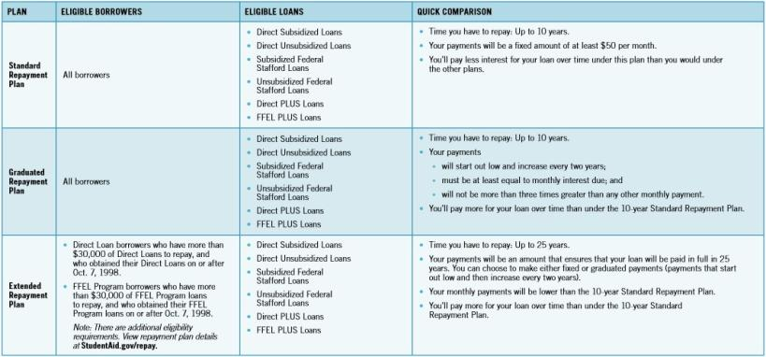

Income Driven Repayment Plans
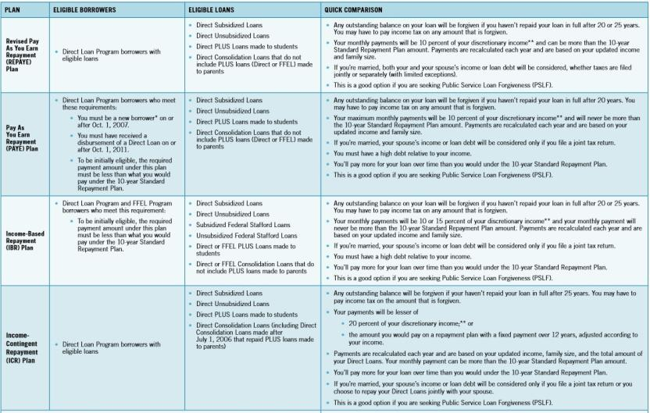

Government Forgiveness, Cancellation, or Discharge
If you are no longer required to make payments on your loans due to your job, this is generally called forgiveness or cancellation. If you are no longer required to make payments on your loans due to other circumstances, such as total and permanent disability or the closure of the school where you received your loans, this is generally called discharge. The details regarding types of forgiveness, cancellation, and discharge can be found at https://studentaid.ed.gov/sa/repay-loans/forgivenesscancellation.
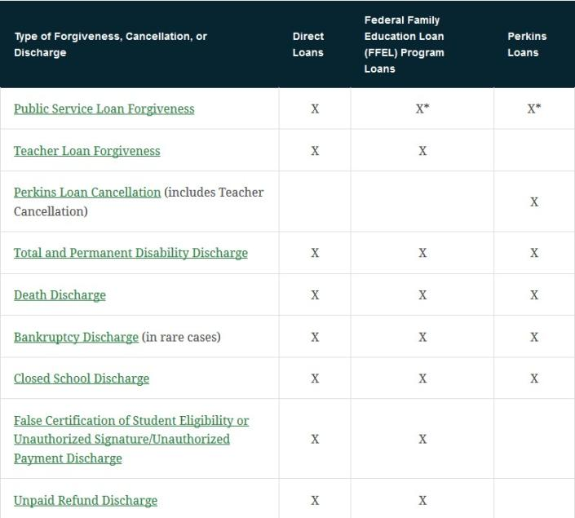

Private Student Loans
If you have a client with student loans issued by a bank, credit union, or some other financial institution, they typically have fewer options for repayment. Reviewing a credit report will help you to find the accounts, but it is up to your client to contact the creditors individually and inquire about repayment options. Private lenders may offer loan modifications to adjust the term, interest, balance on the loan, workout plans to make up missed payments, or temporary rate reductions. Your client may also be able to refinance their private loans with another lender for a better rate. Some nonprofit credit counseling agencies offer assistance with private and federal loans. To find an accredited agency near your client, visit the National Foundation for Credit Counseling at www.NFCC.org or the Financial Counseling Association of America www.fcca.org.
Be sure to advise clients of the importance of student loan repayment. These loans do not fall under the same rules as other credit or loan types. These loans cannot be discharged in a bankruptcy. Also caution them about the complexities about consolidating loans. It can affect your rights to 6% APR restrictions on loans before you entered the military under the SCRA. The consolidation is considered a new loan. Government student loan lenders typically have better forgiveness and loan policies than private lenders.

TAXES

Tax Obligations
Income earners must understand their tax obligations. Tax obligations can be extremely complicated, especially for the military, where different rules may apply. This How-to Guide is not meant be comprehensive but should provide some very general direction. Please remember that PFMs/CFSs do not give tax advice but help our clients to manage and understand their taxes. Clients can go to the legal office to find more about VITA Tax Center advisors available at their installation.

Federal Taxes
Federal income taxes are a progressive tax, where tax rates are higher for those who have more taxable income. Most income is taxed, certain incomes are not taxed, and special taxation may apply to some incomes. To be more accurate, within certain brackets of income, you pay different tax percentages. For instance, on the first $10,000 you may pay one amount of tax, and the next $10,000 a higher percent of tax. It is not that all of the income tax is paid at the higher percent.
Special tax rules apply to military Service members. Most (all except CONUS COLA) allowances are not taxed. Pay earned in a combat zone is not taxed. Deadlines may be extended. Please refer to IRS Publication 3, Armed Forces Tax Guide, for more information.

Other Income
If a taxpayer has other sources of income, such as self-employment, another job, investment income, rental property, etc., the taxpayer needs to make sure they are meeting all additional tax obligations.
Here are some general notes regarding some other income:
- Self-employed income: This includes income on which you are paid on a 1099-MISC or 1099-K. Income after expenses (usually filed on Schedule C) is subject to taxes. If this income is $400 or more, it’s also subject to self-employment tax (which is the employer AND employee portions of Social Security and Medicare taxes, filed on Schedule SE). Since there is no withholding on this income, a taxpayer may want to have some additional taxes withheld from their regular job paycheck to cover this additional tax, or they should make estimated quarterly tax payments. This income may also be subject to tax in the state in which it is earned, even if it’s not the Service member’s state of residency.
- Another job: Income earned by a Service member that is not their military pay may be subject to tax in the state in which it was earned, even if it’s not the Service member’s state of residency. Also, a second job may require more taxes be paid because the additional income may push the taxpayer into a higher tax bracket.
- Investment income not in a retirement account: Investment income often does not have taxes withheld when paid, so having taxable investment income may mean that the taxpayer may owe taxes when they file their tax return (or get a smaller refund). For large amounts of taxable investment income, a taxpayer should either have additional taxes withheld from their regular job income or pay estimated quarterly tax payments.
- Rental income: Rental income after expenses is generally filed on Schedule E. Many property owners have enough expenses deducted from rental income so that the rental income is not taxable or even generates a tax loss. Taxpayers should track income, expenses, and basis on their rental property and file taxes properly each year to ensure that they are minimizing taxes in the long-term (such as at sale of the property). Rental income may be taxed by the federal government, the resident state, and/or the state in which the rental is located.

State Taxes
State taxes are especially complicated in the military. Under the Servicemembers Civil Relief Act (SCRA), active duty Service members keep their state of residency (usually the home of record) when they are stationed in a different state or overseas on military orders. Some states have no state income tax, some have special state taxation for the military, and some states tax military members just like other taxpayers. The Service member should figure out what state taxes apply to them based on their state of residency and types of income they earn. The Navy JAG compiles an annual state tax guide that could help Service members understand what state tax obligations apply to them. (Search for “Navy JAG state tax guide” and find the current year PDF on the https://jag.navy.mil website.) The Navy JAG state tax guide is a starting point, but the taxpayer should check out the appropriate military information on the official state tax website.
If a military member has other income besides military pay, the state in which the Service member earns that income might also tax the Service member.

Military Spouses
Military spouses also have special state residency rules that could apply to them. Under the Military Spouse Residency Relief Act (MSRRA), a military spouse who is a resident of the same state as the Service member and is in the current state to accompany the Service member on orders may be subject to tax in the resident state (instead of the current state in which they earn income). The MSRRA is very fact-specific and some states have different guidance on applications of this law.
The MSRRA requires that military members and spouses be residents of the same state, but sometimes spouses are not residents of the same state. The Veterans Benefits and Transitions Act of 2018 (VBTA) now allows military spouses to elect to use the legal residence of the military member for purposes of filing their state and local taxes. Maj. Matthew E. Wright wrote a very helpful info paper on VBTA which can be found here: https://www.jag.navy.mil/legal_services/documents/Info_Paper_2018_SCRA_Amendments.pdf.
If a military family has split state residency, state taxation can be extremely complicated. Some states are community property states (Arizona, California, Idaho, Louisiana, Nevada, New Mexico, Texas, Washington, and Wisconsin) in which half the income earned by one spouse is deemed to be earned by the other spouse.
Military members and their spouses should find out what federal and state tax obligations apply to them and make sure they are paying the appropriate taxes timely.

Tax Withholding
The IRS Form W-4 2020 has simplified how taxes are withheld by focusing on the income earned and the way individuals file their tax returns. Visit www.irs.gov to obtain the recent version of the W-4.
Your W-4 should be revisited as your tax situation changes. Changes include additional income, marriage, addition of dependent, divorce, etc. To support the updated changes of the W-4 revisions, the IRS has created a user-friendly Tax Withholding Estimator. This estimator can be found on www.irs.gov IRS Tax Withholding Estimator.
To accurately use the withholding estimator the following documents are recommended:
- Most recent pay statement for yourself and if married, your spouse
- All other additional sources of income
- Most recent income tax return
Once you enter the Tax Withholding Estimator, answer the listed questions in each of the six sections.
- About You Section — Answer questions as they apply to your current year’s anticipated filing. The questions will range from how you plan to file your taxes, if you have dependents that you claim on your taxes, the type of employment you have and any additional income/tax payments.
- In the “Income” section, use your most recent pay statements of yourself and spouse (if applicable) to answer the questions.
  - The total wages that you enter are your gross pays from entitlements on your LES. Example: Base Pay + Sea Pay = Monthly Gross Pay. Multiply the monthly gross pay by 12 to receive yearly gross pay.
  - If you are aware that you would receive any Selective Re-enlistment Bonus (SRB), you can list the amount in the following boxes or leave blank.
  - Using your last pay statement, you would enter the Total Federal Income Tax withheld for year to date (YTD) as well as current monthly withholdings. These figures will be found on your end-of-month LES in the Fed Tax YTD box and the deductions box. These figures will be rounded to the nearest dollar.
  - If you contribute to a tax-deferred retirement plan (Traditional TSP/traditional 401(k)) you would enter your estimated total yearly contributions. To calculate this number, take your monthly traditional TSP contribution and multiply by 12. If your spouse also contributes to a tax deferred retirement plan, you will repeat the number on their income section. However, multiply the number of times they would make their contributions.
  - If you/your spouse contributed to a Health Savings Account (HSA), Flex Spending Account (FSA) or pretax child care credit account, you would enter the information here.
- Adjustments to Income — Select the next step unless you have any adjustments to income in the sections listed in the adjustment’s radius. Note: most common choice would be, “go to next step.”
- Deductions from Income — Select, “take the standard deduction,” unless you itemize your deductions. This choice is determined by the information you listed in the “about you” section. If you itemize, then list the estimated amounts in the boxes below.
- Tax Credits — Based on your inputs for dependents, you may qualify for dependent tax credit. One may either calculate the tax liability including their dependent deduction or choose to review results without including any tax credits. If one chooses to review tax credits, they would answer the questions in each dropdown section. The information in the sections is obtained from the “about you” section.
Note: For Child Tax Credit, the child must be 17 or younger on December 31 of the tax year in which you are reviewing.
Results: Once all questions are answered, the results will be populated. They will show either an estimated refund or resulting in owing a tax payment. If you are comfortable with the number shown, then keep your current tax withholdings. If changes need to be made there is a slider that can be used to approximate the refund. Once at the comfortable location download the prefilled W-4 for all members included in the “about you” section and provide to your employers.
Make sure to revisit your tax withholding as your tax situation changes. Changes include additional income, marriage, addition of a dependent, divorce, etc. Your filing status (single, head of household, married filing jointly, or married filing separately) is determined as of Dec. 31 of the year. Also, if you change your tax withholding in the middle of the year, you should revisit the inputs before January of the next year.

Filing Deadline
The tax filing deadline is usually April 15 of the following year. It may be extended to the next business day if April 15 falls on a weekend or holiday.
You will need form W-2 and any other tax forms you receive (such as forms 1099 or 1098) to complete your tax return (form 1040). You can find your military W-2 forms on MyPay or Direct Access.
Tax Resources: Where/How to File Your Taxes
- If you prefer filing taxes on your own, you can file for free using free file (search IRS.gov for free file). If you create an account on MilitaryOneSource.mil, you can download MilTax software for free. (MilTax is the H&R Block premium software.) MilitaryOneSource (1-800-342-9647) also provides free phone support for filing your taxes.
- VITA (Volunteer Income Tax Assistance) is available on many military installations to help Service members file taxes for free. Volunteers are trained on how to file tax returns and can file your taxes if you meet certain criteria. Please consult with your base directory to find the VITA service near you. You can also find VITA location information on militaryonesource.mil or call Military OneSource at 1-800-342-9647.
If you have a simple tax situation, one of the free services may meet your needs. If you have a more complicated situation, you may want to consider paying a professional to file your taxes. You should make sure that the tax professional is familiar with military taxes, specific to the state(s) in which you need to file, and understands your concerns.

Tax Glossary
Allowance: Each allowance is worth a certain amount each year, and taxpayers claim allowances to indicate that less of their income is subject to withholding, to account for tax benefits. Each allowance is worth $4,200 in 2019 and $4,300 in 2020. Allowances for withholding are no longer being used as of 2020, but some withholding systems are still using the old system with allowances/exemptions.
Exemption: Each exemption is worth a certain amount each year, and taxpayers claim exemptions to indicate that less of their income is subject to withholding, to account for tax benefits. Each exemption is worth $4,200 in 2019 and $4,300 in 2020. Before 2018, an exemption was allowed for each person in a household. Starting in 2018, exemptions no longer applied to the tax calculation. Exemptions were removed from the withholding calculation in 2020, but some withholding systems are still using the old system with allowances/exemptions. In a different context, exemption can also mean being exempt from taxes.
Head of Household (HOH): An unmarried taxpayer who pays more than half the cost of keeping up a home for yourself and a qualifying individual.
MSRRA (Military Spouse Residency Relief Act): The law that allows for the spouse of active duty military members to claim exemption from state taxation in the state in which they are present, if they meet certain conditions. The spouse and military member must be residents of the same state (which is not the state where they are currently stationed) and the spouse is only in the current state to accompany the Service member on orders. The spouse may still have to pay taxes to the resident state, if the resident state levies taxes. Eligibility and application of rules under MSRRA is very fact specific and may be complicated.
SCRA (Servicemembers Civil Relief Act): The law that allows active duty Service members to keep their state of residency while physically stationed in another state. The MSRRA provides similar protection for military spouses.
VBTA (Veterans Benefits and Transitions Act): The law that fixes the “same state rule” issue for military families with split state residency. Under VBTA, the spouse can now elect to have the same residence for state and local tax purposes as the Service member.
Withholding: An amount that an employer takes from a worker’s pay to submit to the government as a credit for the worker’s tax liabilities.

RETIREMENT PLANNING

Blended Retirement System: Continuation Pay
- Continuation Pay (CP) is a one-time, midcareer retention bonus payable between 8 and 12 years of service based upon a Service member’s Pay Entry Base Date (PEBD) and is utilized to manage the size of the forces. Service members who elect CP are required to serve additional years as directed by their branch of Service; the minimum is 3 years.
- CP is a bonus, in addition to, any other career field-specific incentives or retention bonuses Service members are eligible to receive.
- Some of this information for CP will change regularly (e.g. the dollar amount of compensation). Most of the information remains consistent from year to year (i.e. when to elect for Continuation Pay). It is essential that the CFS keep current on changes occurring on this subject.

CP Eligibility
- ONLY Service members enrolled in the Blended Retirement System (BRS) are eligible to elect Continuation Pay.
- Active Component (AC) — Service members are eligible to elect to receive for CP between the 8 to 12-year mark based upon their Pay Entry Base Date (PEBD), in accordance with their specific service. Please see the Uniformed Branch of Service Directives for Continuation Pay for branch specifics.
- CP is NOT an automatic bonus. Service members MUST elect to receive CP.
Uniformed Branch of Service Directive for Continuation Pay — Each branch has its own provision for the Active Component (AC) and Reserve Component (RC) for when Service members are eligible for CP and calculating CP, which is subject to change. The range for AC is 2.5x-13x monthly basic pay. The range for RC is 0.5x-6x monthly basic pay.

United States Army
- Service member must elect to receive their CP 30 days before the completion of their 12th year of service as deemed by the Pay Entry Base Date and no earlier than 180 days before completing their 12th year of service. In exchange for receiving CP, they enter into an agreement to serve 4 additional years.
- CP through the United States Army varies year to year.
  - The CP range for AC (including Active Guard Reserve) is 2.5x – 13x monthly basic pay, based upon the current pay grade and years of service at the time CP is approved.
  - The CP range for RC is 0.5x-6x monthly basic pay, based upon the current pay grade and years of service at the time CP is approved.

United States Marine Corps
- Must sign a statement of understanding (SOU) accepting or declining CP BEFORE completing 12 YOS and submit the SOU to their unit admin via Electronic Personnel Action Request (EPAR) or email if EPAR is unavailable. If the SOU is signed or witnessed on or after reaching 12 YOS the Marine is not eligible to receive CP.
- Payment is disbursed via Electronic Funds Transfer during the normal monthly pay cycles. The goal is to disburse payment within 30 days of completing 12 YOS.
- If 12 YOS month is reached while not entitled to Combat Zone Tax Exclusion, CP payments are subject to federal and state income tax withholding.
- For details and payout for the AC vs RC please reference MARADMIN 716-18 or most updated MARADMIN regarding Continuation Pay for Blended Retirement.

United States Navy
- The deadline to elect CP is prior to the 12 years of service mark from the Sailor’s PEBD. The Navy Personnel System will send up to 3 notifications to the BRS-eligible Sailor as a reminder for the CP deadline election. First at the 6-month mark, second at the 90-day mark. If the CP election is not in a complete status, another notification one month prior to the CP date based upon the member’s PEBD. CP payment occurs after 12 years of service. The pay scale for CP is based upon “over 12 years of service” monthly basic pay.
- Primary election is requested via the Navy Standard Integrated Personnel System
(NSIPS) BRS (Continuation Pay tab) and before you complete 12 YOS (based on your PEBD).
- ***It is VITAL to ensure the Sailor’s email address in NSIPS is updated.
- *** The alternative method to submit the CP request outside of the Navy Personnel System is to submit a NAVPER 1070/613 (Page 13) through the Sailor’s Command and uploaded via TOPS to the CP desk at PSD Memphis.
- AC (including Full Time Support), FTS — SM must elect CP prior to the 12th year of service date from the SM’s PEBD. In exchange for receiving CP, the SM agrees to enter into an agreement to serve 4 additional years of service in the AC or FTS.
- RC — SM must be a member of SELRES or the Ready Reserve in a status the member is eligible to receive basic pay or inactive duty pay for 4 years. SM must submit a request for CP prior to reaching 12 years of service from the member’s PEBD. In exchange for receiving CP the SM agrees to enter into an agreement to serve 4 additional years of service in a SELRES status as computed from the member’s PEBD
- CP through the United States Navy varies year to year.
  - The CP range for AC (including Full Time Support) is 2.5x – 13x monthly basic pay, based upon the current pay grade and 12 years of service at the time CP is approved.
  - The CP range for RC is 0.5x – 6x monthly basic pay, based upon the current pay grade and 12 years of service at the time CP is approved.
- There are three CP payment options to choose from: a. Single lump-sum payment. b. Two annual payments (50%, 50%) c. Four annual payments (25%, 25%, 25%, 25%).
- If the CP election deadline is missed (passed the 12 YOS mark based on PEBD) the Sailor will have to submit a Board for Correction of Naval Records (BCNR) request.

United States Coast Guard
- The deadline to elect CP is prior to the 12 years of service mark from the SM PEBD.
- Please reference Memorandum COMDT CG-133, Blended Retirement System Continuation Pay Decision Memorandum.
CP Calculations
- Estimate your CP by entering your service specific details in the following equation.

(Note: 2.5 for active component, .5 for reserves)
- Disbursement options of CP
  - Service members in all branches of service will receive CP payments via Electronic Funds Transfer during the normal monthly pay cycles.
  - CP, along with other specialty pays, bonuses and incentives, can be invested into your Thrift Savings Plan (TSP) account, up to the annual maximum allowed by the IRS. Note that if you hit the maximum before the end of the year, you could lose out on government automatic and matching contributions which only matches your monthly contributions from basic pay.

CP References
  - United States Army: SAMR Blended Retirement System (BRS) Continuation Pay Implementation Guidance — Calendar Year 2018 (CY18)
  - United Stated Marines: MARADMIN: 543/17 SPECIAL PROCEDURES FOR THE CONTINUATION PAY PROGRAM FOR BLENDED RETIREMENT SYSTEM (BRS) PARTICIPANTS REACHING 12 YEARS OF SERVICE IN THE FIRST TWO MONTHS OF THE CALENDAR YEAR 2018 (OCT2017)
  - United States Marines: MARADMIN 716-18 CONTINUATION PAY PROGRAM FOR CALENDAR YEAR 2019 FOR BLENDED RETIREMENT SYSTEM PARTICIPATION
  - United States Navy: MILPERSMAN 1810-081 Continuation Pay for members enrolled in the Blended Retirement System (20DEC2017)
  - United States Coast Guard: Memorandum COMDT (CG-133) Blended Retirement System Continuation Pay Decision Memorandum

TSP Funds: Contribution Allocation
The purpose of a contribution allocation is to determine which fund you want your future TSP contributions to go to. IT DOES NOT AFFECT WHERE THE PRESENT BALANCE IS INVESTED. In order to move your account balance to a different fund, you must also complete an interfund transfer.
To complete a contribution allocation, the Service member must be able to log into their TSP.GOV account. If a Service member does not have their user ID or account number and password to log onto TSP.gov, the Service member can call the ThriftLine (1-877-968-3778) and choose option 3 to speak with a rep (M-F 0700 to 2100). Once the caller is verified by the rep, the caller can make changes to the TSP contribution allocation and interfund transfer over the phone.
Once the Service member has logged in, you will see a chart with all of the available funds and you will see where the Service member is currently contributing. On the left side, you will see the “Contribution Allocation” option.
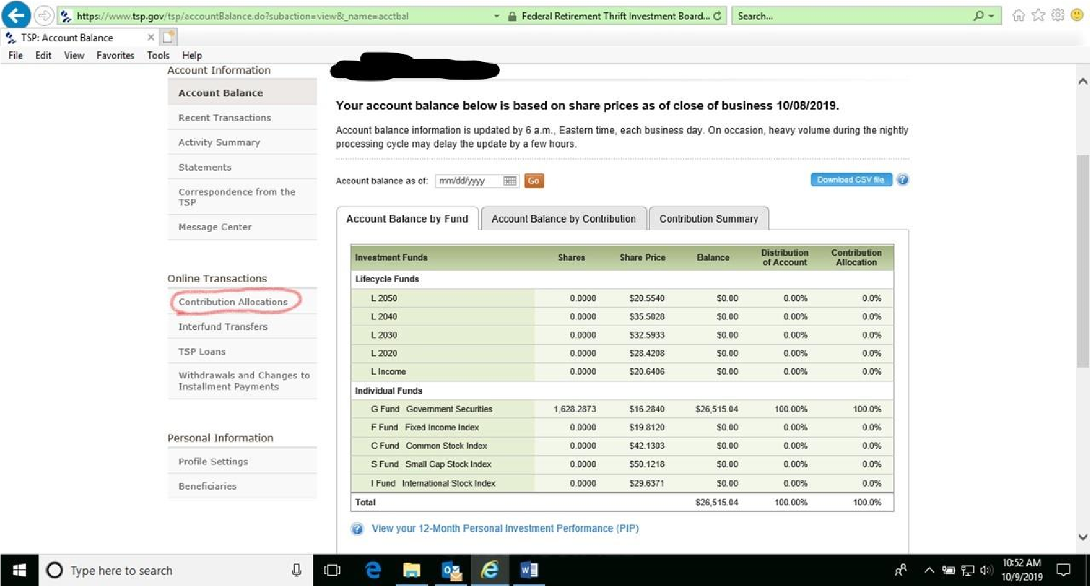
Click on the “Contribution Allocation” option and then on the next page click on “Request Contribution Allocation.”
Next enter the percentage of future monthly contributions the Service member would like to contribute and to which fund(s) they would like to contribute to. The chart below will show where they are currently.
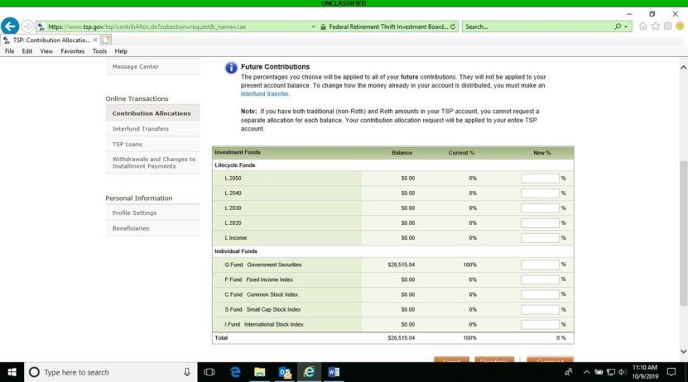
Once the changes are made, the next page will ask you to review and submit. If the Service member is sure of the changes that they have made, click “submit.” The next page will be a confirmation page.

TSP Funds: Interfund Transfer
Help your client play a more active role in retirement planning by showing them how to complete an Interfund Transfer on the TSP.gov website. Your client will need their user ID and password to log into their account. If they don’t have their information, they can contact TSP directly to have the information mailed to them. If they have not communicated with TSP since starting their retirement account, the documents will be mailed to the address on file. TSP representatives will not update the mailing address over the phone for active duty Service members. Your client will have to log into MyPay and update their address under the TSP tab. The updated address will be sent from DFAS to TSP, then new documents can be mailed to that address upon request.
If a Service member does not have their user ID or account number and password to log onto TSP.gov, the Service member can call the ThriftLine (1-877-968-3778) and choose option 3 to speak with a rep (M-F 0700 to 2100 ET). Once the caller is verified by the rep, the caller can make changes to the TSP contribution allocation and interfund transfer over the phone.
Once your client has logged in, they will see an overview of their account balances. On the left-hand side of the screen under Online Transactions you will find Interfund Transfers.
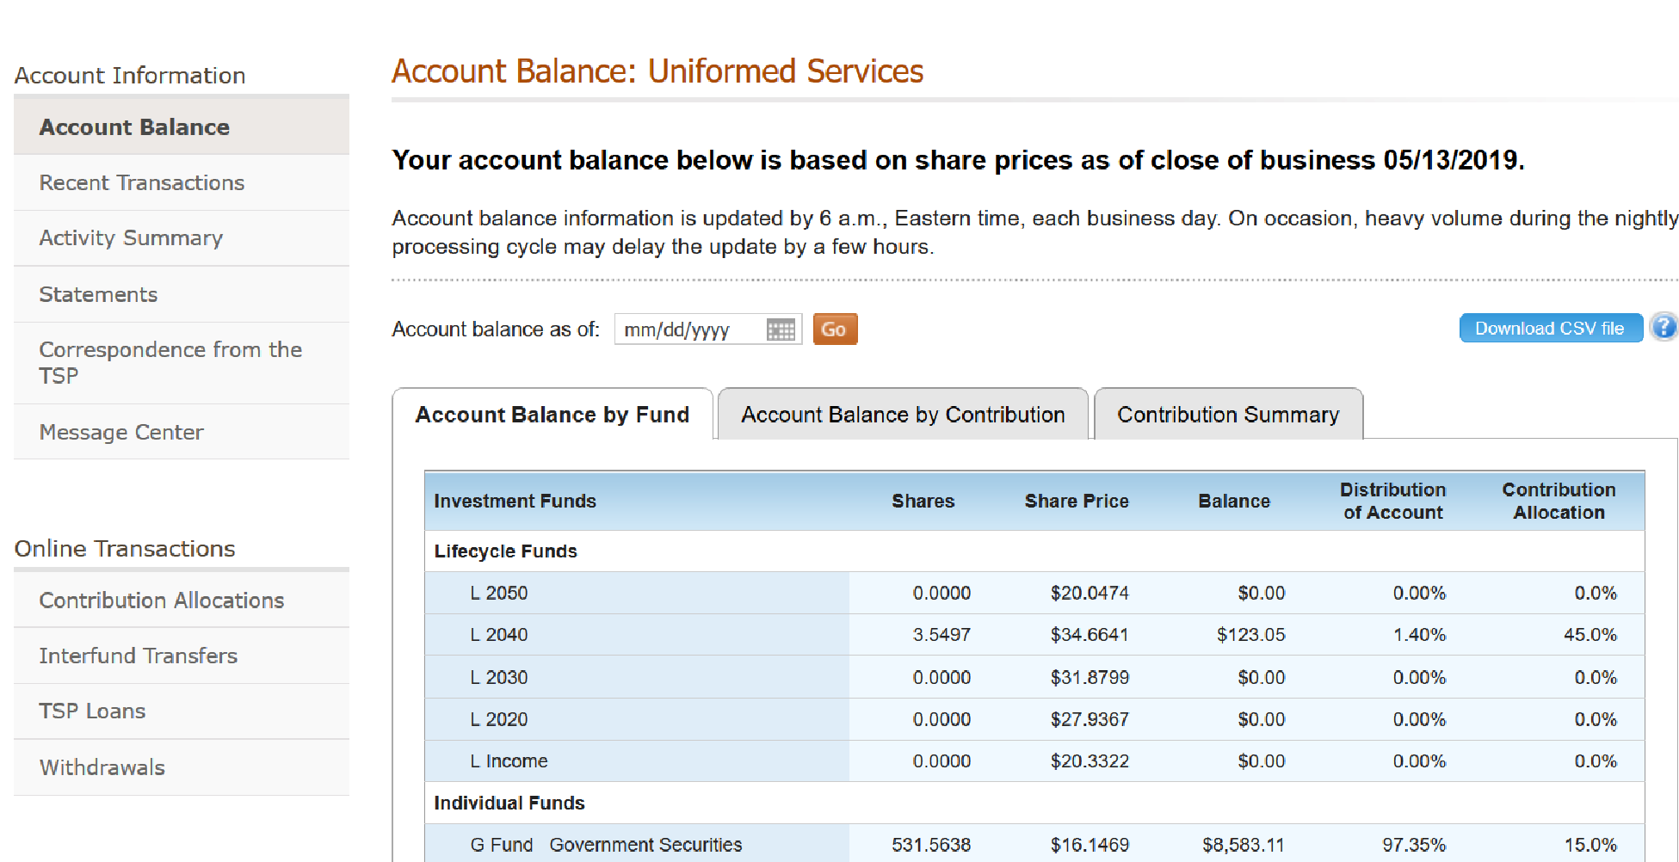
Click on Interfund Transfers and you will be provided a summary of how the client is currently investing. Click Request Interfund Transfer to change the fund percentages.
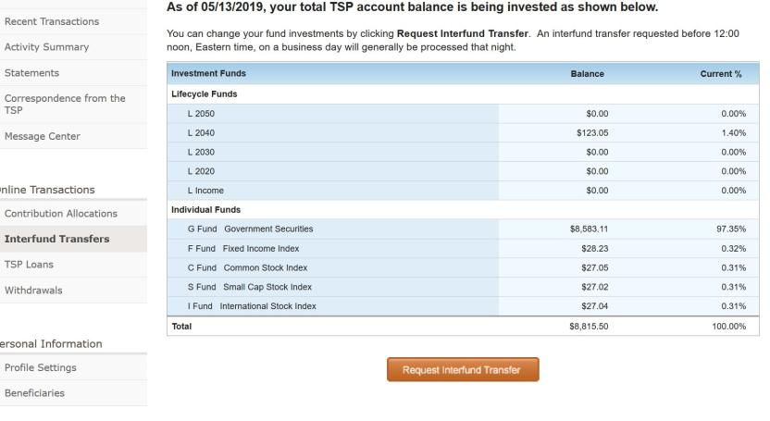
Fill in the allocations under New %. Then Continue.
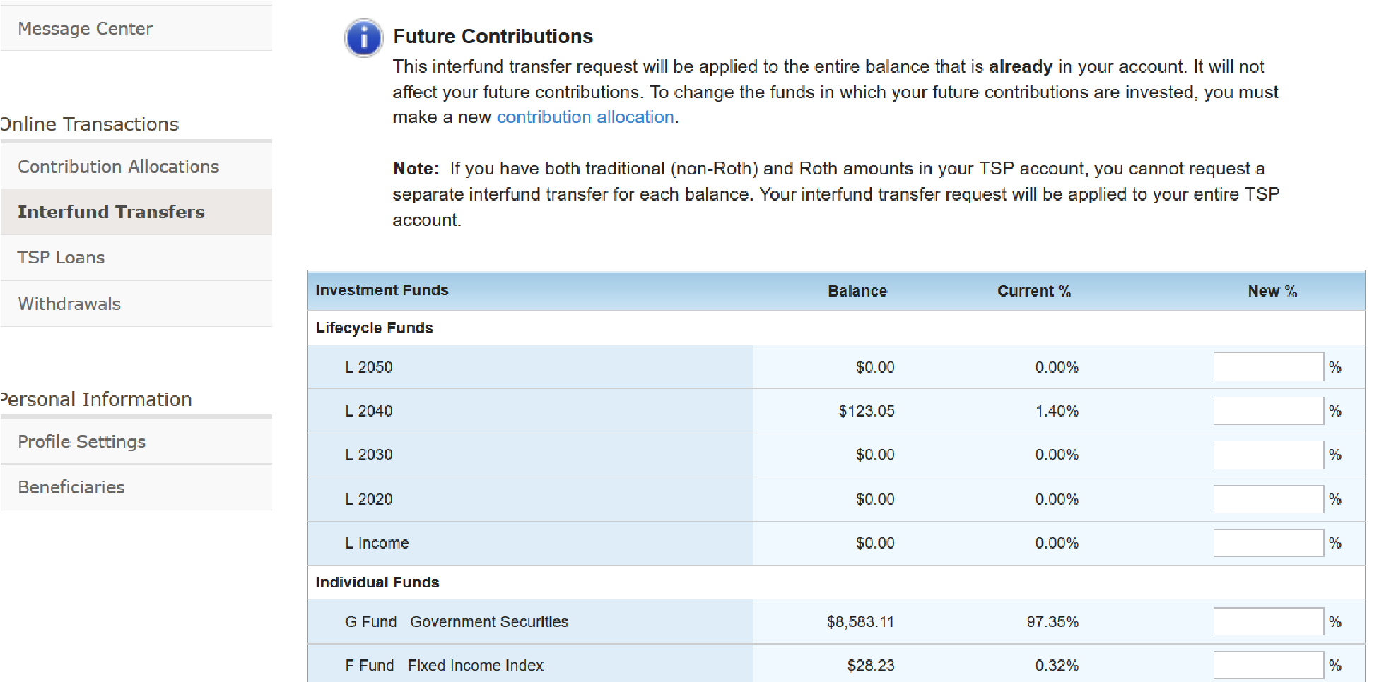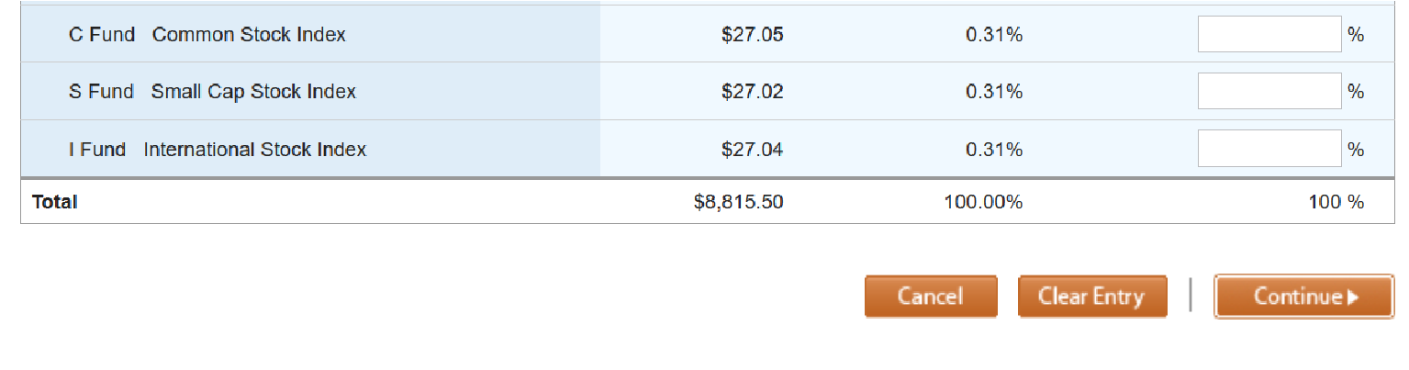
You have another opportunity to review the information before you click Submit.
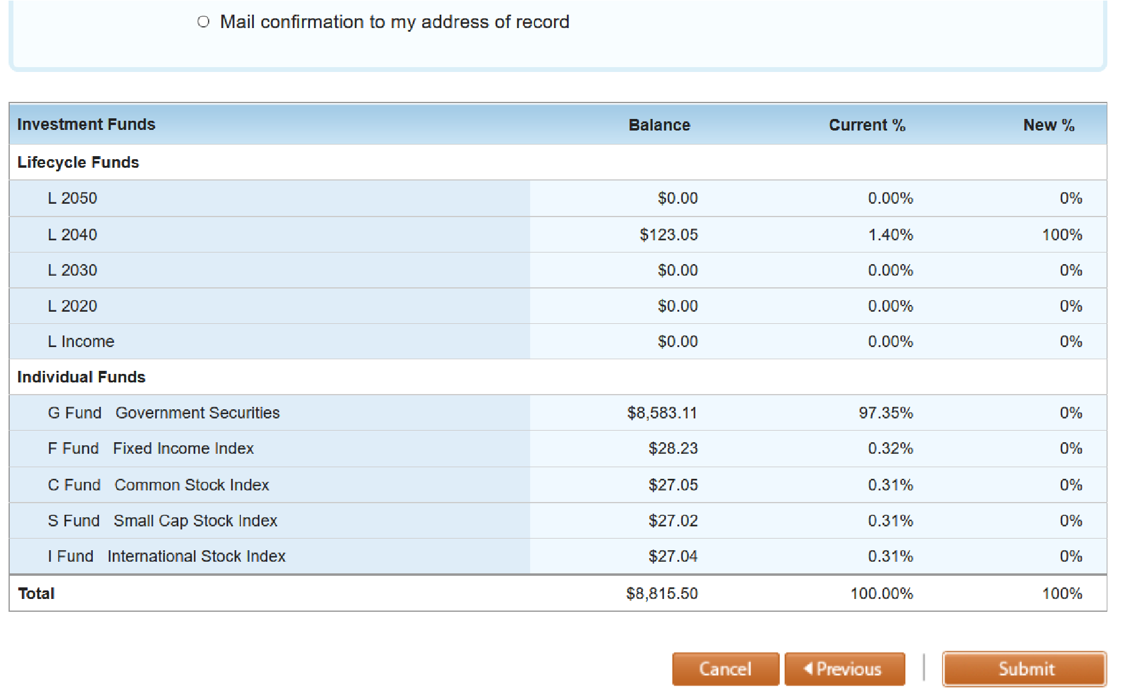
Click Submit to finalize your actions.
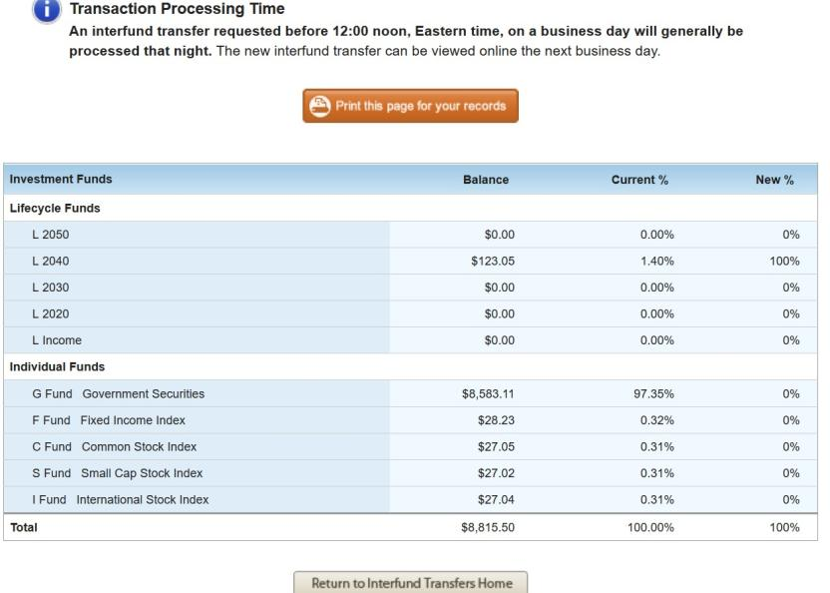

Looking up Social Security Benefits
If you have clients who are interested in looking up their Social Security benefits as a function of retirement planning, they can visit www.ssa.gov to gather their information.
For a Sailor or Retiree who is not currently receiving Social Security, the website will enable them to:
- Request a replacement Social Security card.
- Check the status of their application.
- Get their Social Security statement to:
  - Estimate their future benefits
  - Verify their earnings
  - View the estimated Social Security and Medicare taxes paid
- Get a benefit verification letter.
For a Retiree or disabled Veteran who is already receiving Social Security benefits, an account can help them:
- Request a replacement Social Security card.
- Report wages they work and receive Social Security Disability Insurance and/or Supplemental Security Income benefits.
- Get their benefit verification letter.
- Check benefit and payment information.
- Change their address and phone number.
- Start or change direct deposit of their benefit payment.
- Request a replacement Medicare card.
- Get a replacement SSA-1099 or SSA-1042S for tax season.
Go to www.ssa.gov to create an account.

In the upper right-hand corner click SIGN IN/UP, then click on my Social Security.
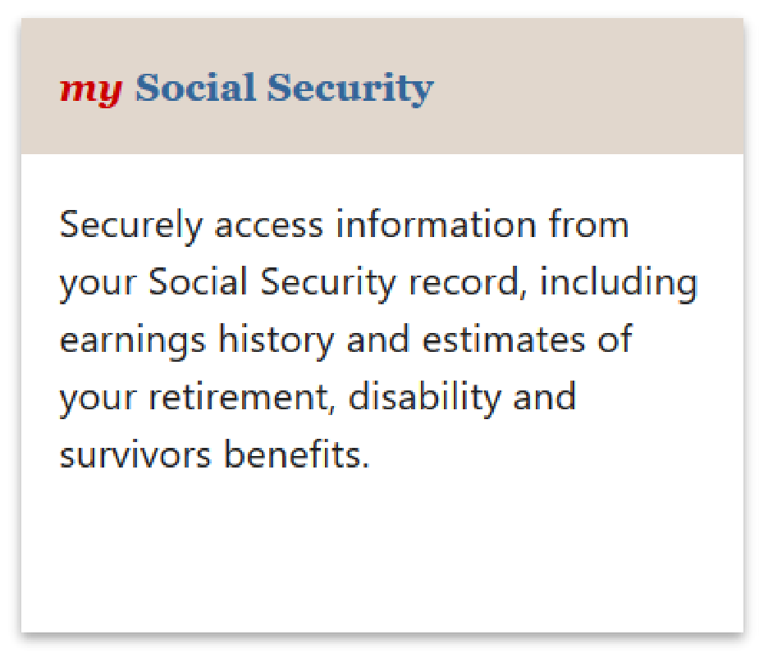
Next, click Create Your Account and agree to the terms of service.

Complete the required personal information.
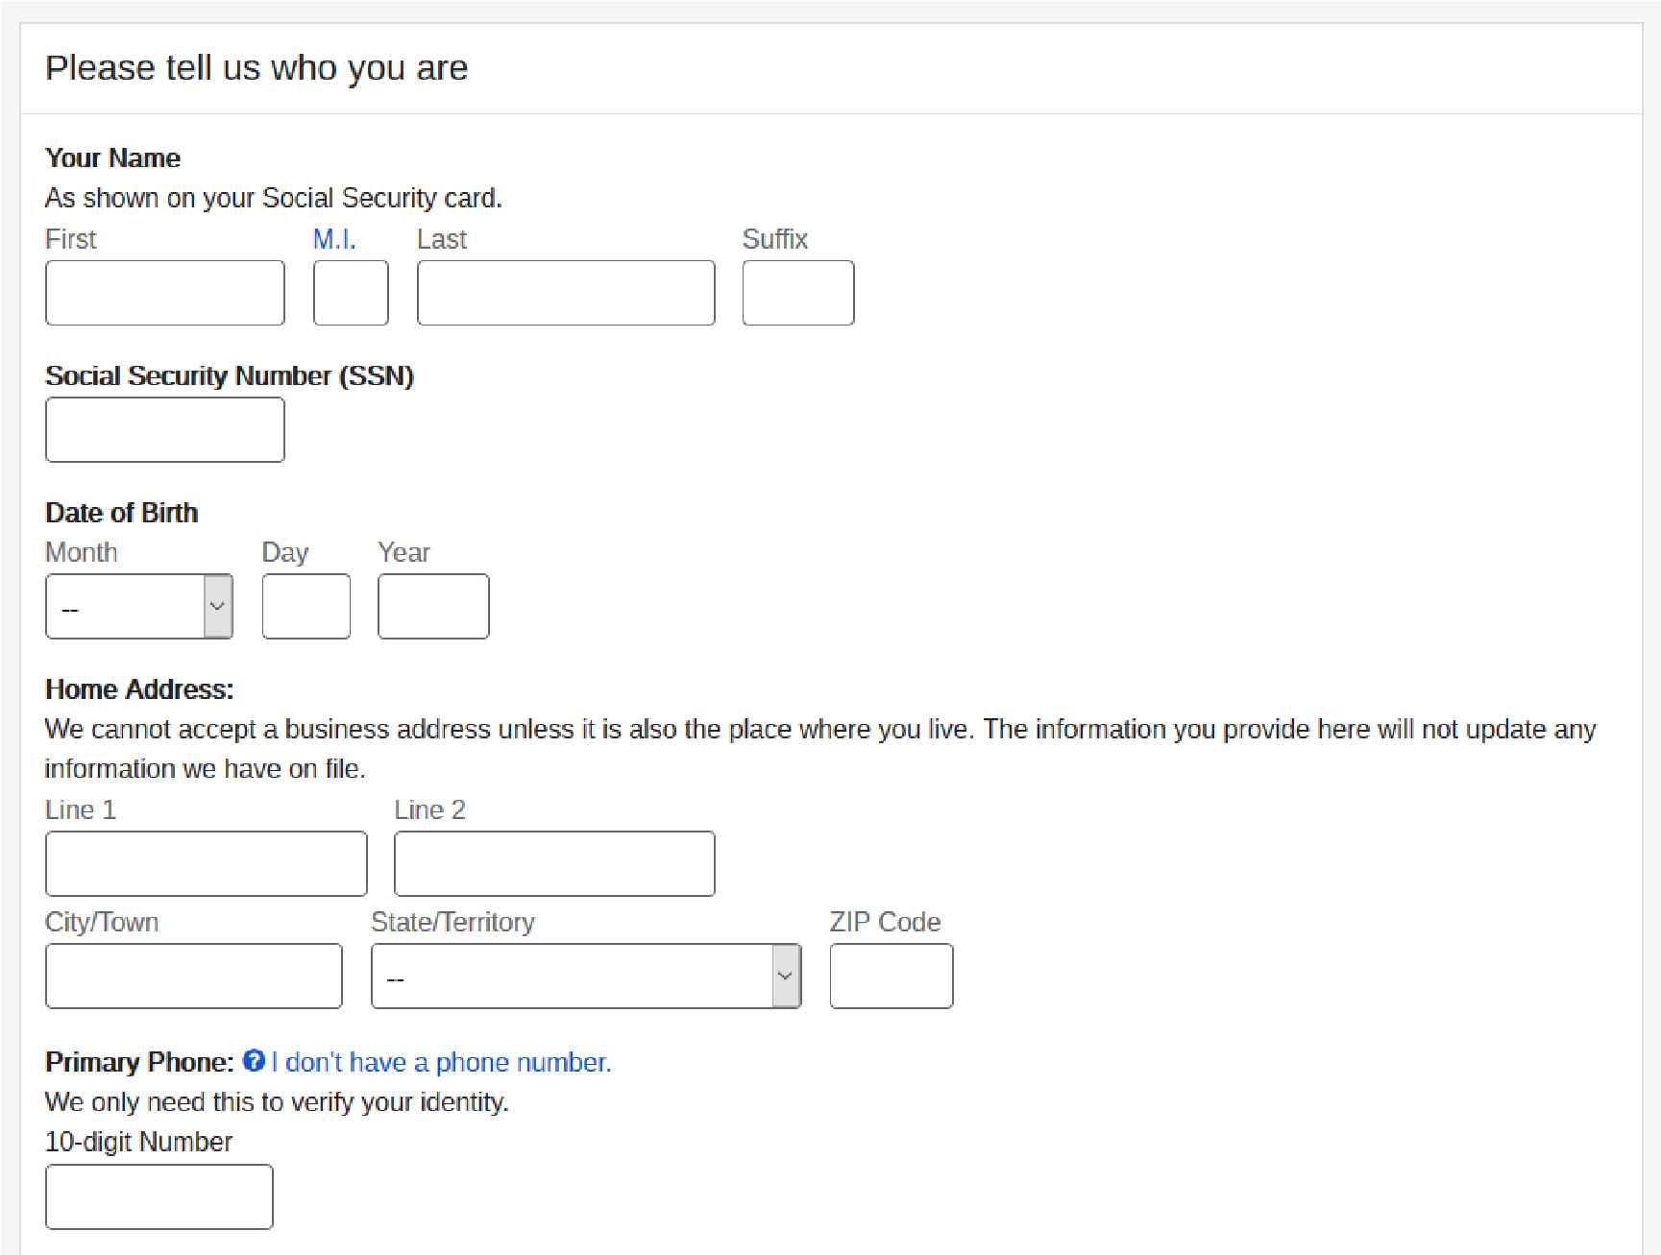
Once you have completed your entry click next to create your username and password. You will be sent a verification email which will allow you to log into the website with your username and password.
After logging in, you will see your Social Security statement, estimated benefits, earnings record, and options to order replacement documents.
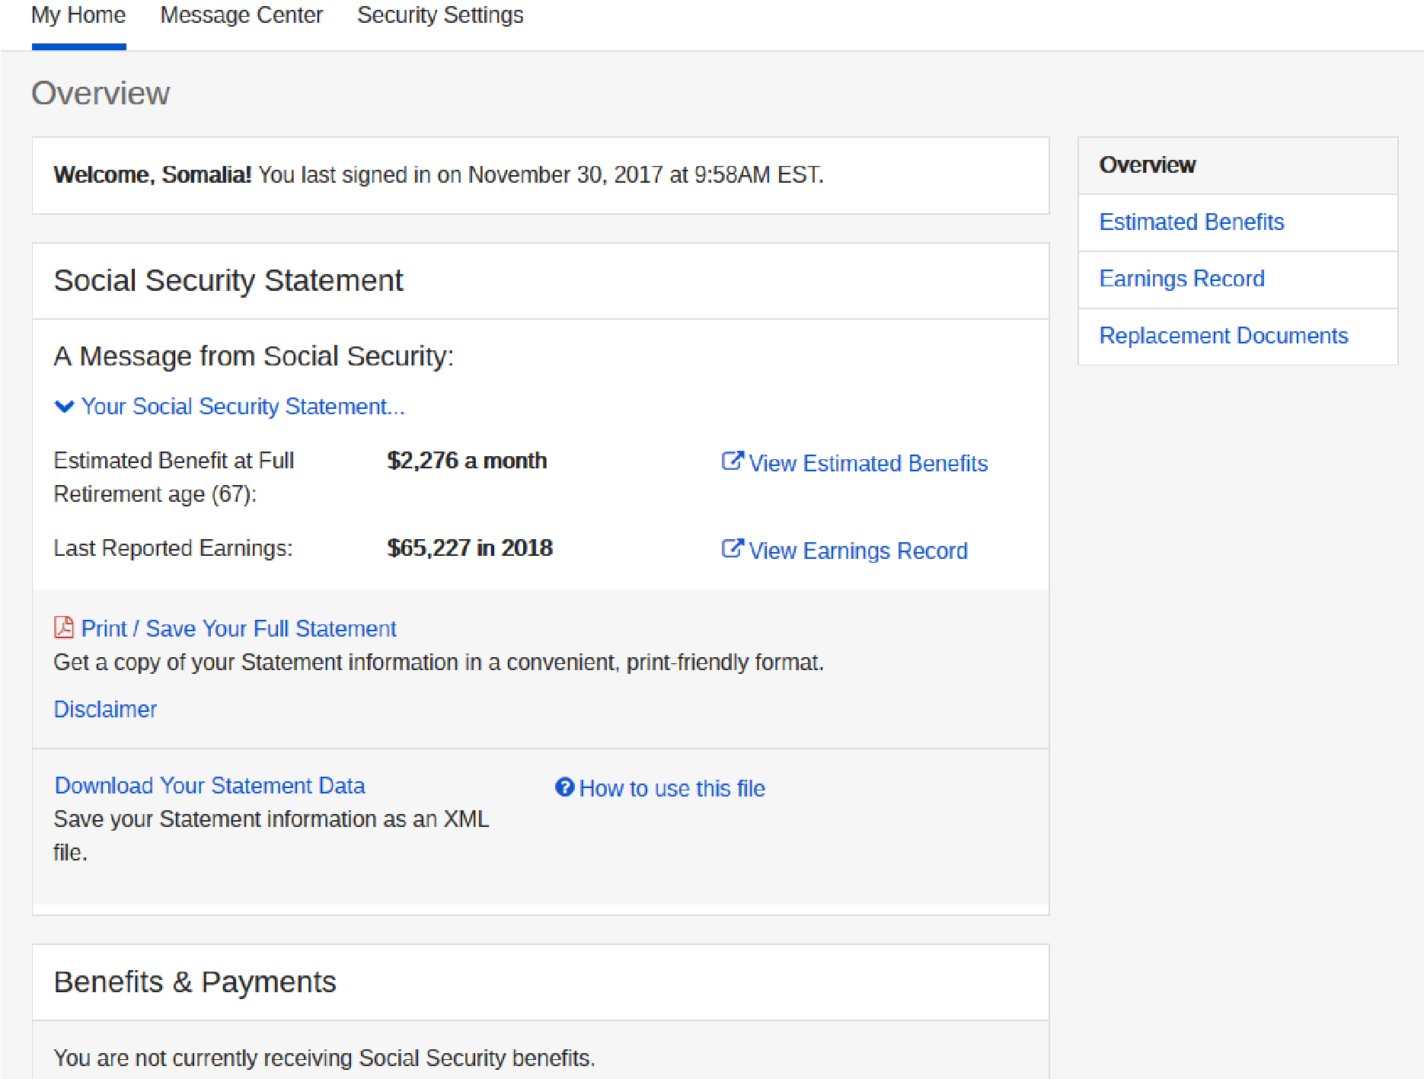

REPORTING CONTACTS

FFSMIS Reporting for Navy PFM
The Fleet and Family Support Management Information System also known as FFSMIS is the official information system for the FFSP. It supports program management and reporting needs to CNIC headquarters personnel, regional managers, and FFSCs. As a PFM it is your job to enter information from counseling sessions, group programs, and outreach events and activities. Doing so on a regular basis ensures that CNIC receives the most up-to-date program information, which ultimately helps them to justify the staffing and funding of your installation’s PFM program. Communicate with your supervisor to be sure you are entering information in accordance with your FFSC’s guidelines.
The information below provides a step-by-step tutorial for entering client information, group programs, and information and referral.

Entering One-on-One Appointments
Be sure to collect demographic information from your client at the start of your session. You will need the client’s command, rate/rake, and branch of Service to complete your FFSMIS entry.
- At the top of your screen click on 1 ON 1 CONTACT.
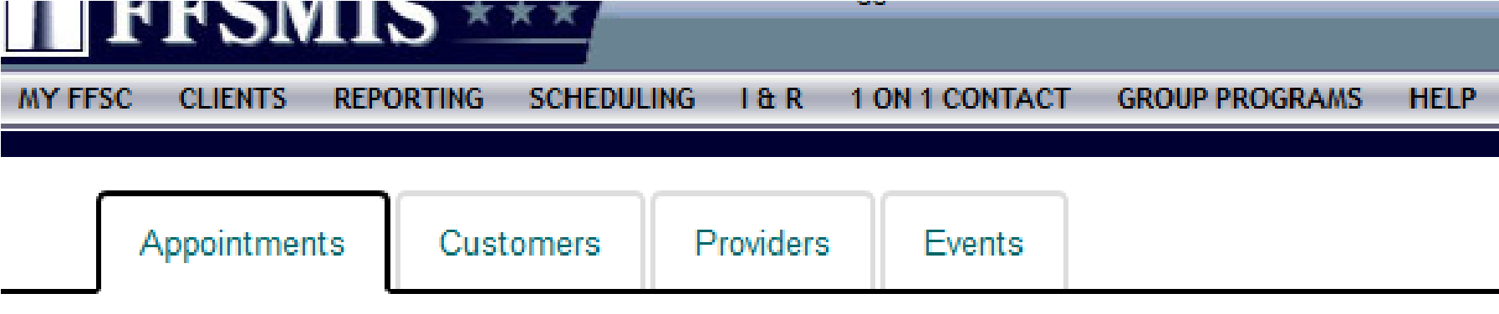
- Fill in each tab and click commit. It is very important to enter each one-on-one appointment to ensure you and your installation get credit for time spent with Service members.
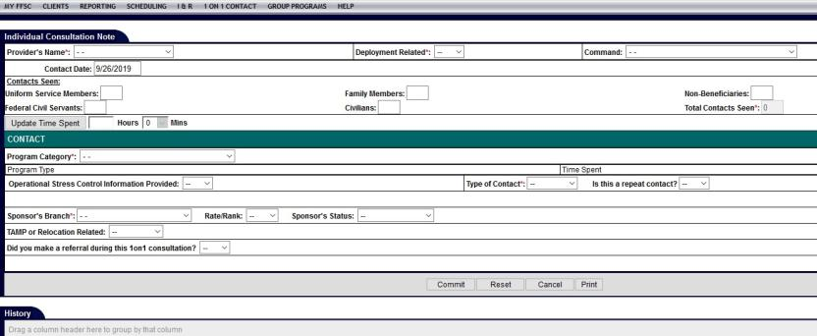

Entering Command Briefs and Trainings
Click on GROUP PROGRAMS to enter the information from your briefing. Having a copy of your roster is helpful when filling out this page. Be sure to enter in the number of Service members seen under Participant Information and Active Duty Participant Details. Next enter your time under Time Consumed During Training/Workshop. If the training you provided was a multiple-day workshop use the first day of the class as the date, and enter the total number of training hours. For Command Financial Specialist you should have one group entry for 40 hours, and Million Dollar Sailor should be entered as 16 hours. Only ONE staff member from the training should enter the information into groups. If there were multiple presenters from FFSP they can outcome their time spent teaching under the scheduling tab to get credit for their time. The goal is to ensure we don’t have multiple group entries for the same training. Once you’ve completed your time entry move to Program Requestor Information and Commit your entry to save it.
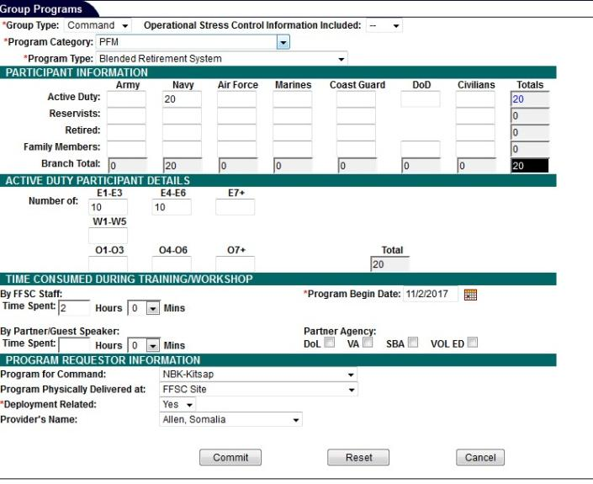

Entering I&Rs
I&Rs help us to track individuals from outreach events like resource tables, short phone calls, email contacts, and walk-ins where just a few minutes were spent with the individual. Track these numbers daily if possible, and at the end of the week enter your numbers info FFSMIS.

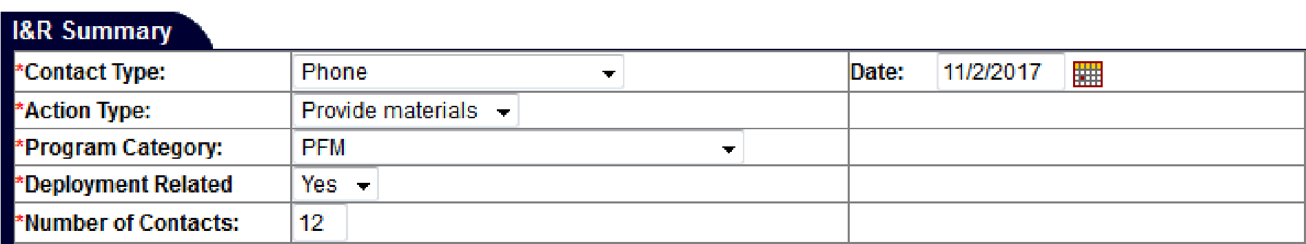

Scheduling/Outcome I&Rs
- After entering in your weekly I&R numbers you can add blocks of time into your schedule to account for that time. Under SCHEDULING click on NEW APPONTMENT and create a client. You can come up with a name that identifies your time spent (example: I&R Total Time). Once you create the client, use the same steps you would to input an appointment.
- In the Notes section include details of the I&R Contacts. See example below:
a. Phone: 10 contacts (Provided Materials), Email: 50 contacts (Provided Materials), Walk-in: 5 contacts (provided Materials). All Deployment Related.
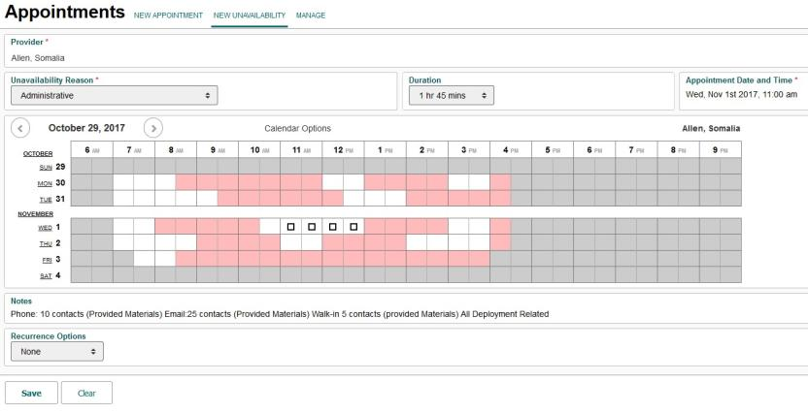
- Once you save the appointment remember to go back in and outcome your time so that you get credit for every minute spent communicating with individuals about your program.
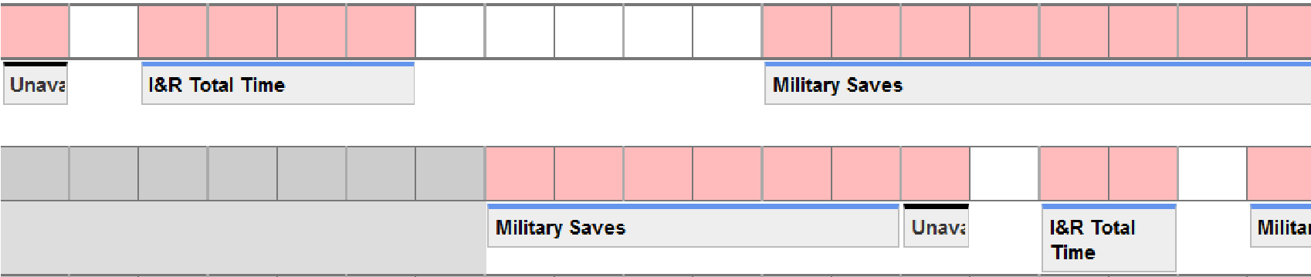

Scheduling an Individual Appointment or Command Brief
- Under scheduling click NEW APPOINTMENT. Next click CUSTOMER and search a name or class title. If nothing comes up as a match, select NEW CUSTOMER. Enter the customer information including name, email, and phone number then click save. Next use the drop-down boxes for Program, Appointment Type, and Duration. Click on your desired time slot within your schedule to block the time.
- Next use the drop down to establish how the training will be delivered. For an individual appointment be sure to include the Sailor’s rank and the reason for the appointment in the notes section. For a Command Briefing include details about the training (location, POC, materials needed).
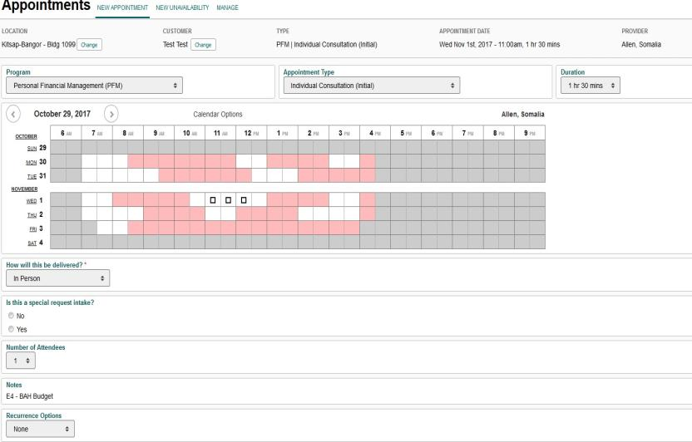

Outcomes
- It’s important to complete outcomes weekly (if time permits try to outcome your schedule daily). Click SCHEDULING which takes you to your APPOINTMENTS and select MANAGE. The Manage tab will pull up your appointments for that day, select OUTCOME (highlighted in green) and use the drop-down boxes to update your attendance and time spent.
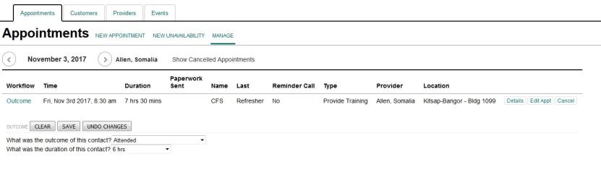
- Management staff will review your scheduling utilization to determine how much of your time was spent working with clients/providing PFM services. The utilization percentage is pulled from the scheduling outcomes you complete each month.

FINANCIAL LITERACY

Financial Literacy Touchpoint Training

Military Lifecycle Touchpoints
As a PFM or CFS it is important that you are aware of the procedure for conducting touchpoint training. Per the FY16 NDAA and Title 10, U.S. Code, section 992, Service members will receive Financial Literacy Training at mandated personal and professional touchpoints across the military lifecycle, beginning with recruit and officer accessions training and continuing throughout a Service member's career and transition to civilian life. The DTM signed Aug. 13, 2019 outlined the required Terminal Learning Objectives (TLOs) for each point in the Service member’s lifecycle.

Email Notification
Navy Service members will receive an email once they have reached one of these touchpoints and they will be advised to communicate with their CFS or PFM to complete the educational requirement (the email received does not specify the touchpoint). The email received by Sailors to the address in NSIPS may look as follows:
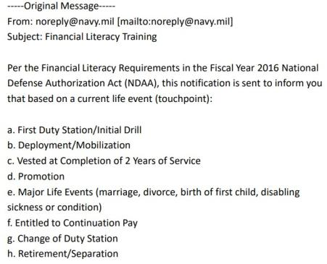
Your goal is to ensure that your Service member has received training or counseling required for that touchpoint. The training focuses on the Terminal Learning Objectives. TLOs are the base of knowledge and skills that Service personnel will receive training on and will need to master in order to be financially literate for that point in their life. Some TLOs may be addressed more than once during the military lifecycle.

What to Do When a Sailor Needs Touchpoint Training
Clarify with your client about the specific touchpoint they have reached. Find the appropriate Counselor and Counselee checklists for that event. Touchpoint Checklists are currently the fastest way to meet the touchpoint requirements.

The CFS or PFM would use the Counselor Checklist (titled PFM/CFS Checklist) to go over each topic in a counseling session with the Sailor. It has small notes for the counselor that can help guide the conversation and ensures all TLOs required are discussed.
The CFS or PFM would give the client the Counselee Checklist version (titled My Checklist). This does not have the notes that the PFM/CFS sheet does, but it has all of the required points and tasks so the Sailor can remember to do different financial activities necessary at that point in their career or life. It lists related handouts to give the Sailor. It also has a place for the PFM/CFS and Sailor to sign showing that they have done the required training/counseling with you. This can be returned to their command for recording completion. Your goal is to ensure that your Service member has received training tools required for that touchpoint.

Where Do I Find the Checklists?

CNIC Webpage
You can access the CNIC webpage hosting the PFM/CFS Checklist and the coordinating Counselee Checklist (titled My Checklist). They can be found at: https://www.cnic.navy.mil/ffr/family_readiness/fleet_and_family_support_program/work-and-family-life/personal_finances/pfm-touchpoint-checklists.html.

PFM MilSuite Page
You can also find the checklists on the PFM MilSuite page at https://www.milsuite.mil/book/groups/cnic-personal-financial-management-program-wfl. Following the link will lead you to request access to the page. CNIC will approve this request within a day or week, so please sign up before you have a client sitting in front of you. See the MilSuite section for more information on MilSuite.
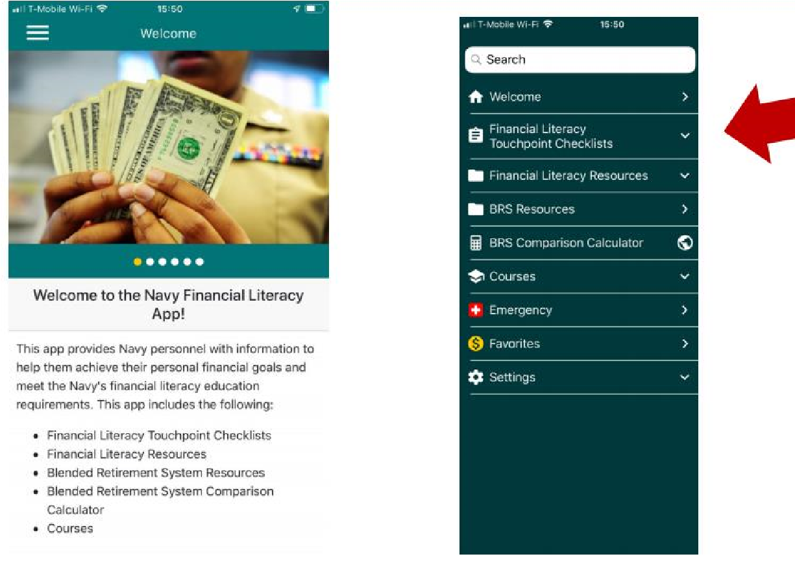
The app also has a link to the CNIC page with the checklists. If your client needs to access the information on their own, you can direct them here easily. The MyNavy Financial Literacy App is available to download free on Apple and Android devices.
The app will provide you with a breakdown of the touchpoint including required and recommended trainings.

What Other Materials Meet Touchpoint Requirements?
We are developing videos and class curriculum in a touchpoint format. The videos should be released May 2020, and the curriculum around October 2020. The videos will be available on Navy eLearning later in 2020 as well.
The current Navy PFM curriculum does meet the requirements, just in a longer format. There are charts that show which classes meet which touchpoints on My Navy Financial Literacy App and the MilSuite page.

Recording Completion of Required Training
Use the CFS/PFM Checklist and the Counselee Checklist (called My Checklist) for the appropriate touchpoint training. The Counselee Checklist has a place for the CFS/PFM and the Counselee to sign. Once you have completed your counseling session or class, provide your client with your signature on the counselee checklist (called My Checklist) that details the training topic. Your client will take this signed checklist to his/her training office to ensure the training is manually recorded in the member's Electronic Training Jacket (ETJ) by documenting in FLTMPS via a Learning Event Completion Form (LECF).
You may want to provide the pathway to your client just in case their training officer is unaware of the process for manual entry.
The path in FLTMPS to access the LECF module to enter course grads: Select Learning Events >Completion Form > GMT and Other Training > Category/Group/Course > FINANCIAL LITERACY TOUCHPOINT TRAINING > FINANCIAL LITERACY COURSES > click on the desired course CIN to make grad entries.

Touchpoint Requirements from DTM 19-009
TLOs are the base of knowledge and skills that Service personnel need to master in order to reach financial readiness for that point in their life or career. Some TLOs may be addressed more than once during the military lifecycle. A copy of the charts from the DTM 19-009 on the next pages can help you discover the learning objectives.
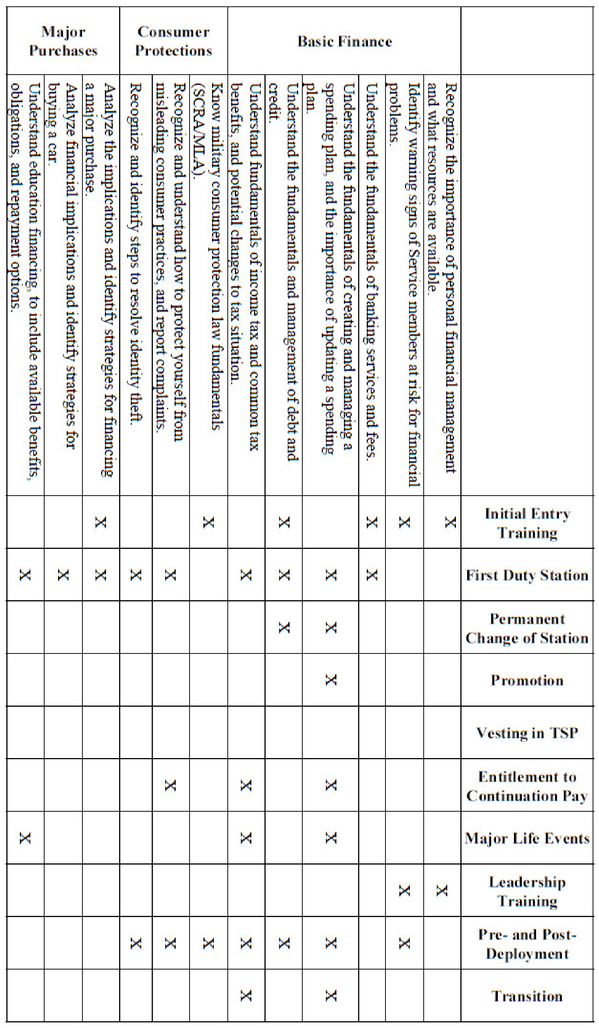
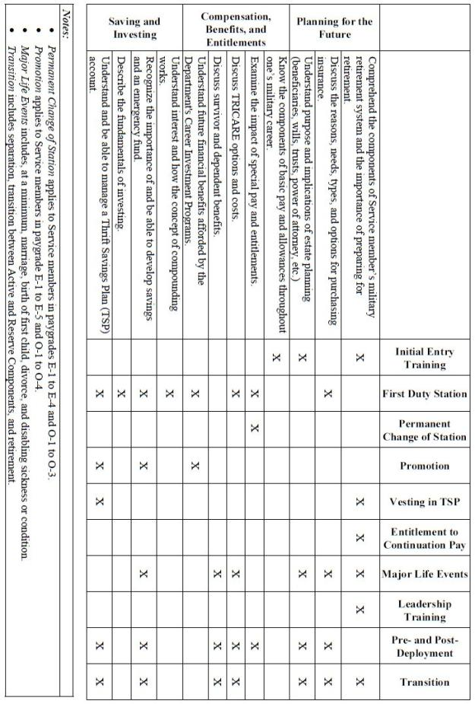

MilSuite
MilSuite is your one-stop shop for everything you need as a Personal Financial Manager or Command Financial Specialist. This interactive website provides you with up-to-date financial news regarding the Navy’s PFM Program, blogs authored by fellow PFMs, training opportunities, and a plethora of resources and curriculum. Be sure to save this site as a favorite: https://www.milsuite.mil/book/ groups/cnic-personal-financial-management-program-wfl/overview
If you have never been on the site, you may have to wait a day or so after trying to gain access to be added to the group. Once logged on, you will be taken to the Overview page which contains:
- Polls — Contributing to the polling information helps analysts better understand what PFMs want and need.
- Resources and Curriculum — All of the Personal Financial Management Standardized Curriculum is housed here.
- CEU Opportunities — As an Accredited Financial Counselor it is important that you stay on top of requirements for continuing education units. Here you are provided links to webinars that will help you maintain your certification.
- Money Minute Newsletter — Each month the newsletter is distributed with the latest content regarding the PFM program.
- Best Practices Blog — Learn best practices from your colleagues around the world to enhance your skills and your installations PFM program.
- Links and Tools — General links for clients and PFMs
- Policy and Instructions — You will find the instructions that govern the PFM program here.
- Outside News — Find outside financial news that has an impact on the military community.

Adding Your CFS Class Participants to the PFM MilSuite Site
Add the emails for the CFS in class to the PFM website through the PFM MilSuite site.
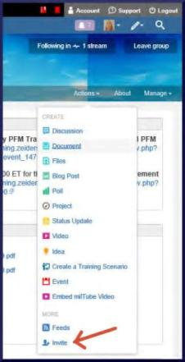
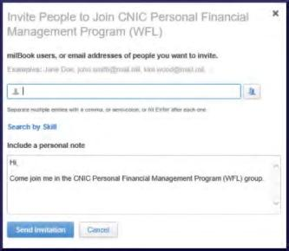
- Go to https://www.milsuite.mil/book/groups/cnic-personalfinancial-management-program-wfl.
- As shown here on the right, go to Actions on the blue bar at the far right of the page under the banner.
- Include the military email of the CFS Student — regardless of service — into the pop-up box. It is possible to add more than one email at a time.
Civilian email addresses are not recognized by MilSuite and will show an error that will prevent uploading all other addresses entered at the same time. Create a generic email inviting them to the group and reminding them what they were told in class and paste it in the personal note box.
Maybe say something like, "Hello, and welcome to the PFM MilSuite site. This is the place to go for CFS materials, resources, curriculum, training, news and updates." Then leave your email address. Type in, "Sent via MilSuite," under your name so there is no confusion if they contact you asking for more information. It will look like a regular email to them.
- The invitation will send a notice to the CNIC PFM Program Analyst to approve the new CFS. They approve these daily or weekly depending on workload.
- They will be able to see the MilSuite site and access resources when they log in.
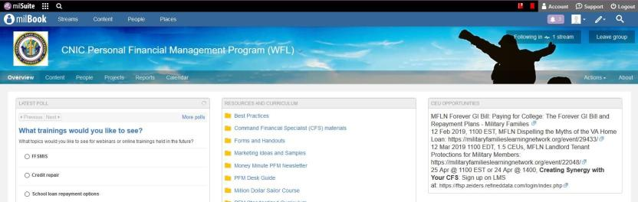

Navy Financial Literacy App
The Navy Financial Literacy App provides Sailors with the information they need to achieve their personal financial goals and meet the Navy’s financial literacy education requirement.
The National Defense Authorization Act (NDAA FY16) made significant changes to the military retirement system and mandated that Navy personnel obtain additional financial literacy training. This app supports that training via checklists, videos and a compendium of in-app and online resources. The application is divided into the following sections for ease of use:
Financial Literacy Touchpoint Checklists offers lists to track financial training topics required at each professional and personal touchpoint of a Service member’s career. Checklists include Initial Entry Training, Arrival at various duty stations, Promotions and Continuation Pay, Marriage and Divorce, Birth of a First Child, Pre- and Post-deployment, Separation or Retirement.
- Financial Literacy Resources includes information on Banking and Financial Management, Credit and Debt, Financial Planning and Spending Plans, Investments, Insurance, Military Pay and Entitlements.
- Blended Retirement System (BRS) Resources offers various types of information, links and videos. This includes information on the Navy Standard Integrated Personnel System (NSIPS), which allows Service members to view their BRS status, verify BRS election, elect Continuation Pay and acknowledge review of their Budget/Financial Plan at designated career touchpoints.
- BRS Comparison Calculator helps Opt-In eligible Service members make an educated decision on which retirement system is right for them (there are members that are still eligible to make the opt-in decision).
- Courses includes access to Opt-In Training for the BRS, Uniformed Services Blended Retirement System: Your Retirement System, Leader Training to Introduce the BRS, BRS Financial Counselor/Educator Course and Family Financial Planning.
Download the app today and be sure to pass along this resource to clients and commands.
Visit the website at www.applocker.navy.mil or download through Google Play App Store or Apple iTunes App Store.
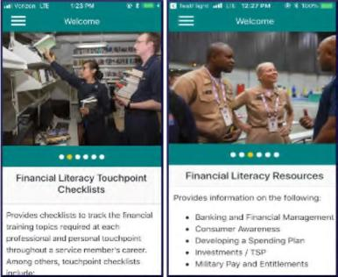

Updating Slides and Creating Curriculum
It is your responsibility as the PFM to ensure that your curriculum is up to date. All of the CNIC-provided PowerPoints should be updated to reflect current statistics and Navy trends. If the information within your slideshow is no longer relevant you can delete the information or find the current information to replace it. Review your curriculum annually to make necessary changes.
In addition to the core program areas, there may be additional financial topics presented at a particular FFSC site. These programs are usually developed in response to a current financial need between updates for the Personal Financial Management Standardized Curriculum. Use the tips below as guidance when developing your PowerPoint curriculum:
- Only design slides after the content has been written and activities have been determined.
- Use design templates found in PowerPoint.
- Standardize position, colors and styles of text.
- Include only necessary information (bullet points work best).
- Use colors that contrast.
- Be consistent with effects, transitions, and animations. Limit the use of these special effects.
- Limit the number of slides. Too many slides can outlast the attention span of the audience.
- Use larger font to indicate more important information.
- Use a sans-serif font for body text. Sans-serif fonts tend to be the easiest to read on the screen.
- Align text either left or right. Centered text is harder to read.
- Do not use all capital letters as they are harder to read.
- Limit punctuation marks.
- Use graphics to illustrate the main point.
- Balance the slide — graphics and words.
- Use quality graphic images.
- Dry run completed presentation to ensure PowerPoint graphics and slides are visible on the big screen.

CFS Refresher

CFS Recertification Requirements
OPNAVINST 1740.5D (Enclosure 6, Section 1, Paragraph f) requires that a CFS must successfully complete the CFS Refresher Training every three years, at minimum.
To be eligible to take the one-day CFS refresher course instead of the five-day CFS training to maintain certification every three years, a CFS must:
- Have any mix of the following (minimum of four per quarter): one-on-one financial counseling appointments, and/or Personal Financial Management (PFM) training or briefs for the command, division, department, or branch;
- And attend at least two quarterly area wide CFS Awareness Forums per year. Installation PFM courses, CNIC PFM webinars, and Military Family Life Network webinars pre-approved for AFC CEU credits also count.
The CFS requesting to recertify with the one-day course must have a current CFS certification that has yet to expire. They will need to provide documentation to the Fleet and Family Support Center (FFSC) Personal Financial Management (PFM) staff showing that they have met the minimum activity requirements to take the one-day refresher (through their quarterly reports), and that they have completed the pre-work for the one-day recertification course available from the FFSC.
If they have not met the minimum contact requirements, their certification has already expired, or if they would prefer the full review, the CFS can attend the five-day standard course to recertify.
Below is an example recertification form provided by Navy Region Northwest. This form is to be completed and returned prior to attending the Refresher course.
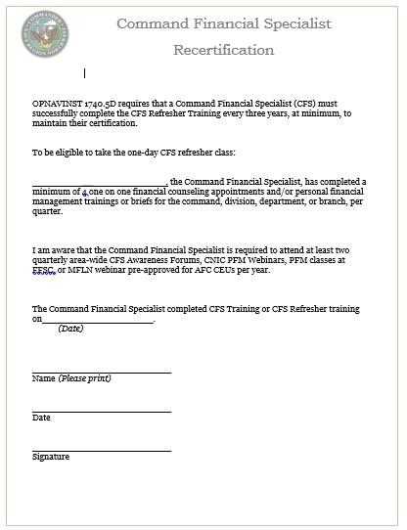
Command Financial Specialists can use the CFS "Quarterly Activity Report" to track the number of trainings and one-on-one counseling sessions provided.
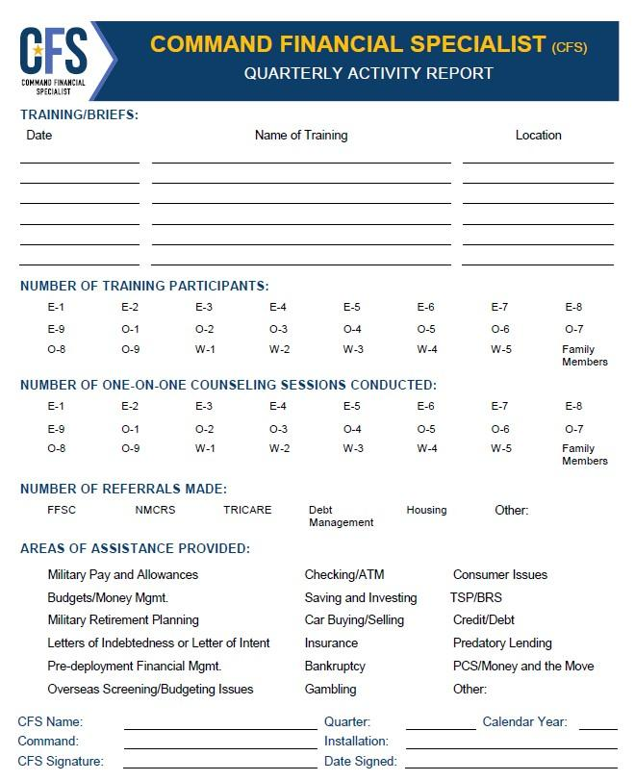

Waiver Requests

CFS Waiver Request (US Coast Guard)
To be appointed as a Command Financial Specialist (CFS), COMDTINST 1740.8A requires that service personnel be in pay grade E6 or E5 with at least 6 years of service. Commands can request a waiver for E5 Personnel with less than 6 years of service to become a CFS under set conditions. CG civilians are not authorized to become a CFS. Commandant (CG-1112), Personal Financial Management Program is established as the single point waiver authority for commands seeking to appoint a CFS at the E-5 level. Waiver requests should be forwarded directly to: HQS-SMB-FamilySupportServices@uscg.mil. Waivers must be granted from CG-1112 before an E5 Service member can be registered to attend a CFS class.
Step 1: Gain approval from CG-1112, Personal Financial Management Program.
COMMANDANT (CG-1112)
ATTN: OFFICE OF WORK LIFE
US COAST GUARD STOP 7907
2703 MARTIN LUTHER KING JR AVE SE
WASHINGTON DC 20593-7907
Work: 202-372-1594, Fax: 202-372-8467
HQS-SMB-FamilySupportServices@uscg.mil
Step 2: USCG PFMP will forward approval to CNIC
Dana Carlyle, AFC
PFM Program Analyst
716 Sicard Street, SE Suite 1000
Washington Navy Yard, DC 20374
Phone: 202-433-1888
Email: dana.carlyle@navy.mil
Information Updated 3/3/2020

CFS Waiver Request (Marine Corps)
Qualifications of the Command Financial Specialist (CFS):
The CFS shall function as the command's principal advisor on policies and matters related to financial education. The following qualifications apply:
a. Per reference (a) military members in the rank of E-6, and above shall be appointed a CFS upon approval of the application and completion of the CFS Course as designated on enclosure (6) of MCO 1700.37. The Director, Marine and Family Programs Division (MF), HQMC, is the waiver authority for commands seeking to appoint a CFS at the E-5 level. Waivers will not be granted below E-5. MCO 1700.37 11 DEC 2014 (Page 2-1) (Enclosure (2)
Your Commander should request and confirm in writing by email on Command Letterhead (Note: Name of CFS Candidate should be specified.) that:
- You are command approved
- Your Rank is E-6 or above
- You are highly motivated
- You are financially stable
- You meet the financial overseas screening standards, if applicable
- You have no record of Letters of Indebtedness (LOI) or non-sufficient funds (NSF)
- You have no (NJP) or poor performance counseling above the rank of LCpl
- You have at least one year remaining at the command at time of CFS course completion
- You have successfully completed the Leading Marines course and the current MCI 3420 and 3422 Personal Financial Management courses
We encourage you to complete the "Introduction to the Command Financial Specialist (CFS) Program" course offered by the Personal Financial Management Curriculum. Gain access by contacting Curriculum Specialist Katrina Laskowsky at katrina.laskowsky@usmc.mil. Once you are approved as CFS, please contact us for all your CFS Resources.
Command should send request for CFS Appointments to POC Jim Robinson-Program Manager - PFMP at James.M.Robinson@usmc.mil Phone:703-784-9550.
Please do not send Marine CFS Waiver request to NAVY.

CFS Waiver Request (Navy)
To be appointed as a Command Financial Specialist, OPNAVINST 1740.5D requires that Service personnel be in pay grade E6 or above including frocked to E6 Personnel, or E5 with at least 6 years of service. Commands can request a waiver for E5 Personnel with less than 6 years of service to become a CFS under set conditions. Please refer to page two of this document for the excerpt from the Instruction pertaining to E5 waiver requirements. The PFM Program Analyst is Dana Carlyle at CNIC. Waiver requests should be forwarded directly to her at: DSN 288-1888 or e-mail: dana.carlyle@navy.mil. Waivers must be granted from CNIC before we can register E5 Service members for CFS class.
Dana Carlyle, AFC
PFM Program Analyst
Navy Fleet & Family Support Programs (N911) Commander, Navy Installations Command
716 Sicard St., SE, Suite 1000
Washington Navy Yard, DC 20374-5140
(202) 433-1888
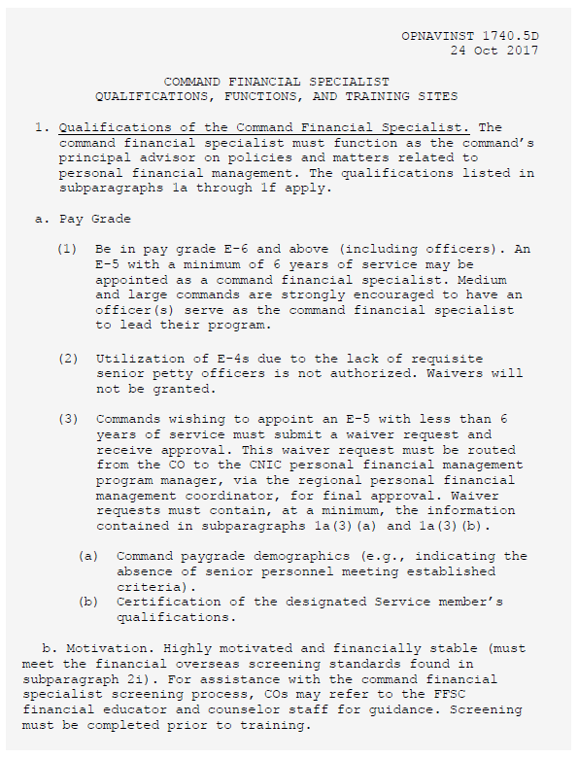

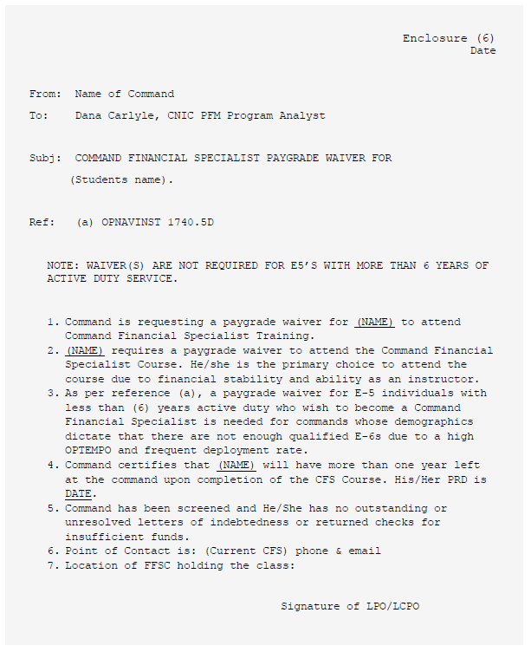

Child and Youth Program Waiver Request
(For Navy, Army, Marine Corps) *Coast Guard does not participate in CDC hardship screenings.
Hardship exceptions allow CYP’s to adjust fees to accommodate temporary situations that arise for families. Regional Child and Youth Program Managers have the sole discretion to grant case-by-case exceptions to an individual’s fee range based on hardship or any special circumstances (e.g., divorce, illness, loss of employment) that affect total family income. Command Hardship Exceptions must be documented in writing, maintained in the family’s Fee Agreement and re-evaluated at least every 90 days (or more frequently, depending on the circumstances).
Hardship waiver request requires a full financial review and budget. This can only be completed by a Personal Financial Manager (PFM) from Navy, Marine Corps, Army or equivalent military branch association unless there is no PFM at a duty station and a designee is appointed to complete the budget requirement. Encl: Sample NRSW Child and Youth Program Hardship Waiver Request. Form is provided for your info only: (This is controlled form and to be given only by the CDC Director, forms may vary across services)
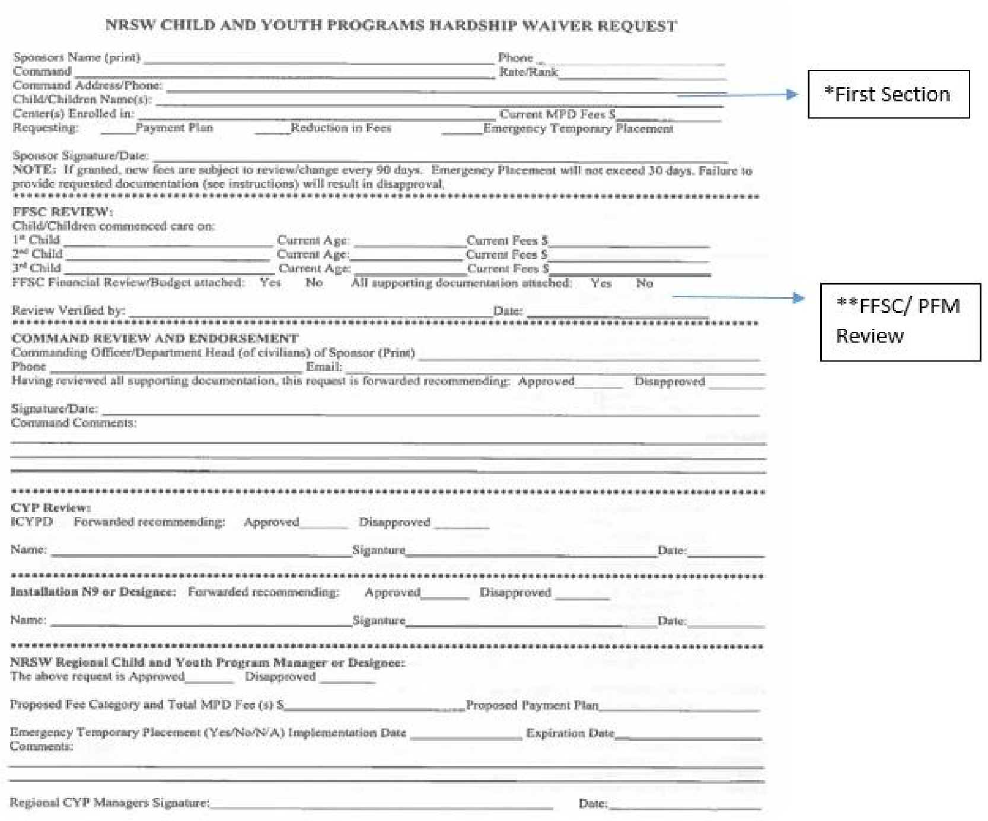
Sponsor will need to provide the following documentation to support their application:
- Written statement of what is being requested and why
- Supporting documentation (from sponsor or spouse if deployed) that supports the request for a reduction in fees or payment plan as outlined in the written statement. For example divorce documents, employment layoff documentation, disability documentation (state or private insurance), unemployment documents, temporary child custody and a basic medical note if the request is due to a temporary medical problem that prohibits work – similar to what is provided to an employer for long-term medical leave (actual medical details not required)
- Copy of current LES and spouse proof of income (if applicable)
- Copy of current CYP fee agreement
- Additionally, for PFM financial and budget review, sponsor must also bring in current bank statement, list of liabilities (minimum payment, interest rate, balance on accounts)
Process:
- Sponsor to complete the *first section of the waiver request form
- Sponsor to contact FFSC PFM if requesting a reduction in fees or payment plan. Sponsor has to complete a full financial review and budget with PFM with information from documentation provided. The PFM will need to review all supporting documents for this request to ensure the budgeting form (EFPW) is completed correctly.
- Once budget is completed, ensure that all supporting documentation and completed budget is attached with the waiver request. PFM or designee to sign and date **FFSC review before returning it to the Service member.
- Service member will route completed packet (supporting documentation and completed budget) up his/her chain of command for approval before returning packet to CYP for further consideration.
Tips for PFMs:
- Ensure that the actual column of the budget reflects actual spending according to the bank statement and bill / debt payment amounts are verified.
- Projected column should include recommended changes in budget that can be completed in a 30-day time frame. (Example: Eating out, entertainment, travel expenses – propose a 75% reduction from current spending in those categories if able. If not, explain in remarks column of budget)
- Projected grocery budget should reflect family size, age using USDA estimates (Explain higher food cost expenditure in remarks column of budget — e.g. gluten free due to illness)
- Enter current child care payments as reflected in the CYP fee agreement in both actual and projected columns.
- Current utility cost (cable, internet bundle) – Review possibility of going internet only, canceling cable altogether or removing premium channels. If this is not possible, due to contract, cancellation fees or cost of going internet only is more expensive than the bundle, explain in remarks column.
- Provide recommendations and referrals on Recommendation page of EFPW

